
Pixel Time
Training Manual: new features
Employee record · Leave · Pay rules · Reports · Payroll export · Alerts · Roster planning · Report audit · Clocking integrity · Overtime requests · Leave balances · Timesheet sign-off · Management reports · Reconciliation · Data retention · Working-time rules · System health · ID cards · Mappings & history · Excel downloads · Document expiry
October 2026. Screens come from a demo company (Acme Trading), so names and amounts are examples.

What is new
Area | What you can now do
Team > Employee record | Store employee number, ID, address, emergency contact, contract dates, contracted hours, hourly rate and status (active, suspended, on leave).
Leave | South African leave types, paid or unpaid, monthly earning, carry-over, supporting documents, cancellation requests, decline reasons.
Settings > Pay rules | Overtime, Sunday, public holiday and night multipliers, with a start date.
Reports > More reports | Over 60 extra reports, including labour cost, contracted vs actual hours and leave reports.
Payroll export | Pay codes, warnings before export, a reason for exporting a period again, export history and a check for changes made after export.
Reports & money > Alerts | 27 automatic checks (missing clock-in, late, absence, overtime, rest, contract expiry, offline devices and more) by app or email, with escalation.
Scheduling > Roster planning | Coverage against minimum staffing, availability and days off, publishing, and a history of every roster change.
Reports & money > Report audit | Delivery history of emailed reports, an audit trail, reconcile totals and reports on the payroll cut-off day.
Time & leave > Overtime | Ask for overtime before working it, approve or change it, monthly limits and budgets, budget warnings and approver performance.
Time & leave > Leave balances | Balances on any date, history for each person, carry-over and expiry, reconciliation, forecast, liability estimate and eligibility rules.
Time & leave > Timesheet sign-off | Employees submit their week; managers approve or send it back with a reason; levels, deadlines, reopening and a full history.
Reports & money > Labour budgets | Monthly labour budgets, compared with estimated cost in Reports > More reports, plus payroll variance, staffing shortage, availability, forecast against actual, cost per hour, six-month history and correction resolution time.
Reports > More reports > Reconciliation | Hours reconciliation (clocked, payroll, last export), data retention review, and a search box on report results.
Scheduling > Working-time rules | Rule sets for overtime, weekly limits, meal intervals, flexi-time and bargaining council details; assign by employee, contract, department or company with start dates; recalculate attendance; change history.
Reports & money > System health | Your records, whether the automatic checks are running, quiet devices, failed emails, slow pages, retention settings and a safe clean-out of old audit entries and notifications; plus alerts for weekly hours near the limit and stopped reports.
Team > Document expiry | Expiry dates and reminders for employee documents; Excel (.xlsx) downloads for reports and payroll; actual vs payable hours report; overtime decline needs a reason.
Reports & money > Mappings & history | Payroll mapping (cost centres, leave codes, categories), audit-event alerts and keep times, settings history with restore; kiosk wrong-PIN limit.
Team > ID cards | Register RFID / proximity cards, mark lost or disabled, clock at the kiosk or a card terminal with a card; failed report emails retry automatically.
Time & leave > Clocking integrity | Finds duplicate, conflicting, out-of-sequence and late-synced clockings; event history; device sync status.
Time & leave > Leave balances > Personal rules | Give one person their own days per year, carry-over limit or eligibility period for a leave type.
Payroll export > Reconcile | Upload the hours your payroll system holds and see every difference against Pixel Time.
Reports > Prepare in background | Ask for a long report, carry on working and download it when ready (Excel or CSV).
Clocking integrity > Held clockings | A clocking a rule refused is kept, shown and can be accepted or dismissed; missing clock-outs are listed on the dashboard and in Data checks.
Night shifts and checks | A shift that runs past midnight now stays on the day it started: clock out after midnight and the hours land on the start day. Stricter checks on site, correction and team forms.
System health > Data checks, payroll API, backup check | Automatic data checks, a read-only payroll feed for other software, and a backup verification job.

1. Employee record
Who: administrators. Managers can see the status badge but cannot open the record.

Open an employee's record
- Go to Team > Employee records in the menu.
- Press Open record on the person. (It is also under Team > Everyone > Edit > Employee record, the section with the small arrow.)
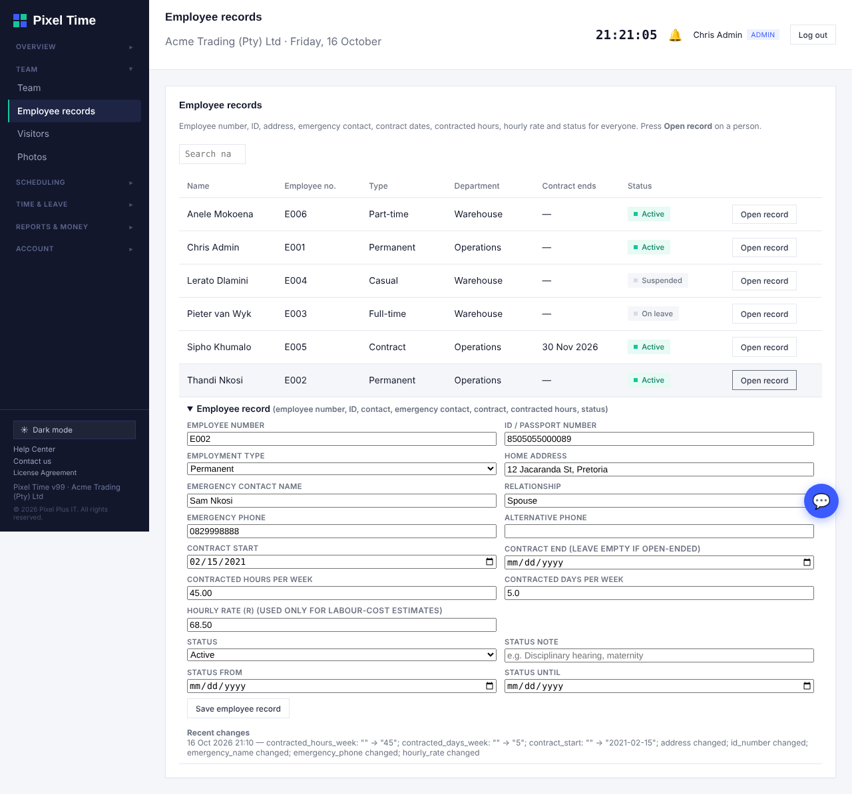
Team > Employee records: press Open record on a person.
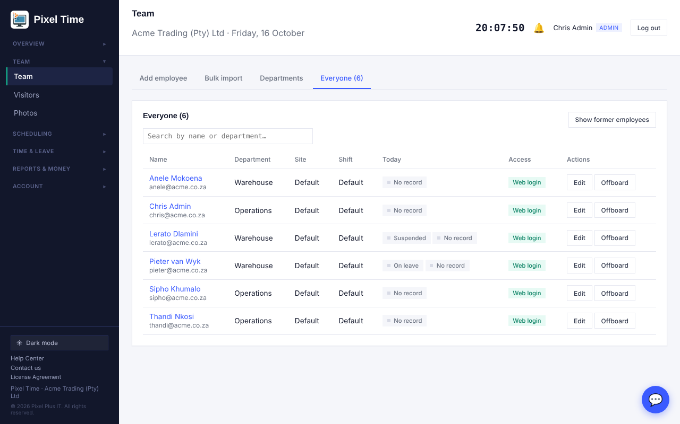
Team list. The grey badges show Suspended and On leave next to Today.
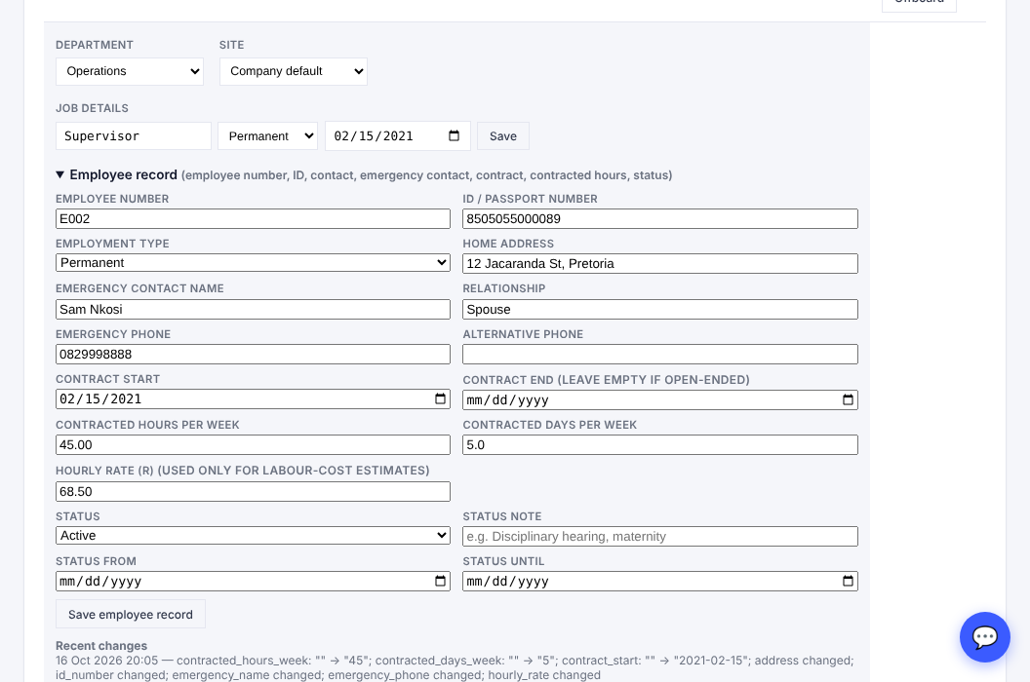
Employee record: employee number, contact details, contract, hourly rate and status.

Fields
- Employee number: must be unique in your company. Payroll exports use it.
- ID or passport number, address and emergency contact: needed for HR files and emergencies.
- Contract start and end: a report lists contracts ending in the next 60 days.
- Contracted hours and days per week: used by the Contracted versus actual hours report.
- Hourly rate: used only for the labour-cost estimates. Leave it empty if you do not want costs.
- Status: Suspended or On leave, with a note and dates. It shows on the Team list. It does not stop the person clocking in; to remove access, use Offboard.
- Recent changes: shows what was changed and when. ID, address, emergency contact and rate changes show as "changed" without the value, to protect personal information.

2. Leave

Employees: request leave
- Go to My leave > Request leave.
- Choose the leave type and the dates. Weekends and public holidays are not counted, unless your company's leave type counts them.
- Attach a supporting document (PDF, JPG or PNG, up to 5 MB) when the leave type needs one, for example a medical certificate for sick leave over 2 days.
- Submit. Your manager is notified.
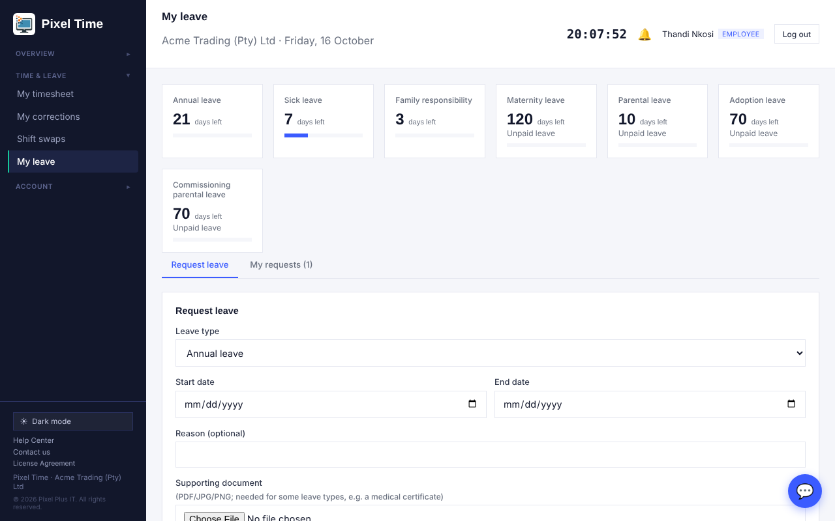
Request leave, showing balances and the supporting document field.
- You cannot request leave that overlaps leave you already have pending or approved.
- To cancel: open My requests. Pending leave cancels at once. Approved leave that has not started becomes a cancellation request that your manager approves or refuses. Leave that has started must be cancelled by your manager.

Managers and administrators: approve, decline, cancel
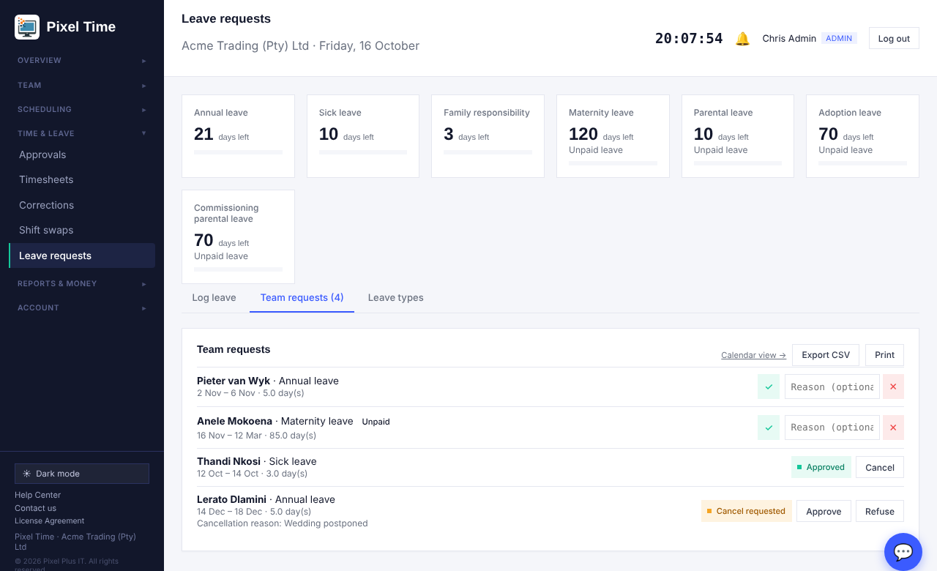
Team requests: approve or decline (with an optional reason), and cancellation requests from employees.
- Approve with the tick, or decline with the cross. The optional reason is shown to the employee and in their email.
- Unpaid leave types show an Unpaid label.
- When an employee asks to cancel approved leave, press Approve to return the days to their balance, or Refuse to keep the leave.
- An administrator or manager can cancel approved leave directly. The days go back to the balance.

Administrators: leave types
- Go to Leave requests > Leave types.
- Press Add South African statutory types to add annual, sick, family responsibility, maternity, parental, adoption, commissioning parental, study, unpaid and other leave where you do not have them yet. The days are starting points: check them against your policy and contracts.
- Edit a type: days per year, carry-over limit, earned at the start of the year or monthly, document needed after N days, paid or unpaid, count weekends.
- Tick "Also change this year's balances by the difference" if a change to the days should apply to current balances as well.
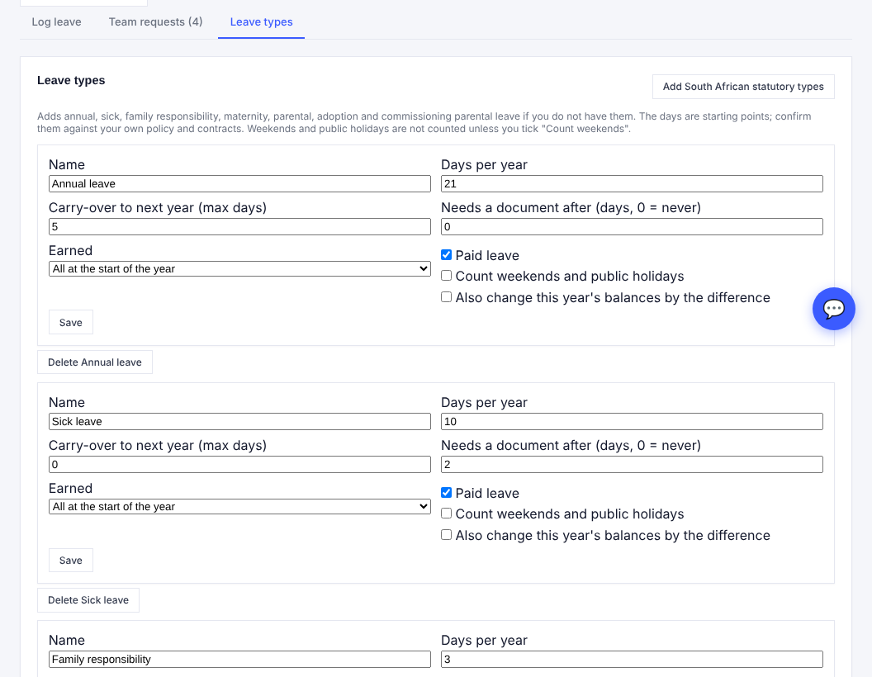
Leave types: each type has its own rules.
- A leave type that has requests against it cannot be deleted. Set its days to 0 instead.
- New-year balances are created automatically on 1 January, with carry-over added up to the limit.

3. Pay rules and labour cost
Who: administrators set the rules. Administrators and auditors see labour-cost reports. Managers do not see pay rates.

Set the pay rules
- Go to Settings > Pay rules.
- Choose the date the rules start from and the four multipliers. 1 means no extra pay.
- Save. Each rule applies from its date until the next rule starts. Saving a rule for a date that already has one replaces it.
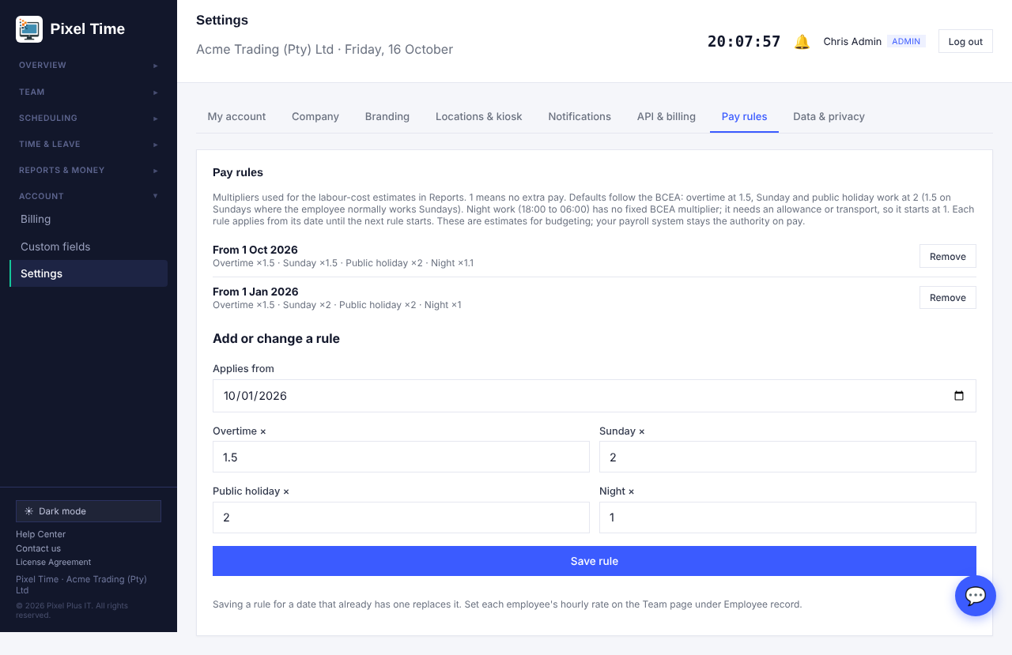
Pay rules with two rules in force (from 1 January and from 1 October).
- BCEA starting point: overtime 1.5, Sunday and public holiday work 2 (1.5 where the employee normally works Sundays). Night work (18:00 to 06:00) has no fixed multiplier, so it starts at 1.
- Set each employee's hourly rate in Employee record. Employees with no rate cost R0 in the reports and appear in "Employees with no hourly rate".
- These are estimates for budgeting. Your payroll system remains the authority on pay.

How a day is costed
- Ordinary hours are paid at the hourly rate. On a Sunday or public holiday they use that day's multiplier.
- Overtime hours use the overtime multiplier, or the Sunday or holiday multiplier if it is higher.
- Night hours add the night multiplier's extra on top.
- Example: R100 an hour, 9 hours on a normal Monday with 1 hour overtime = 8 × R100 + 1 × R150 = R950.

4. More reports

Where to find them
- Go to Reports and open the More reports tab.
- Choose a report from the list (grouped by topic), set From and To, and press Show.
- Use Export CSV or Print.
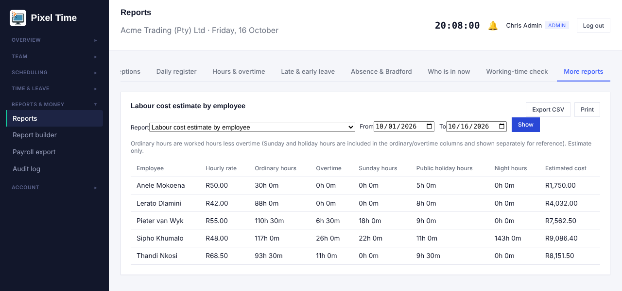
Labour cost estimate by employee (administrators and auditors only).

Reports added with these features
Report | What it shows
Labour cost estimate by employee, department, branch | Hours, overtime and estimated cost from rates and pay rules.
Employees with no hourly rate | Who is missing a rate.
Overtime, Sunday, public holiday and night hours | Premium hours per employee. No pay rates, so managers can use it for their department.
Contracted versus actual hours | Weekly contracted hours scaled to your date range against hours worked.
Employee register | Number, type, start date, contracted hours, status.
Missing or duplicate employee numbers | Fix these before a payroll export.
Employees with no emergency contact | Who still needs one.
Contracts ending soon or already ended | Next 60 days and any past end date.
Suspended and on-leave employees | Current status with dates and notes.
Unpaid leave days by employee | For payroll deductions.
Cancelled leave and cancellation requests | With the reasons given.
Leave that needs a document but has none | For example sick leave over 2 days with no certificate.
Leave types and rules, Pay rules in force | A printable copy of your current setup.
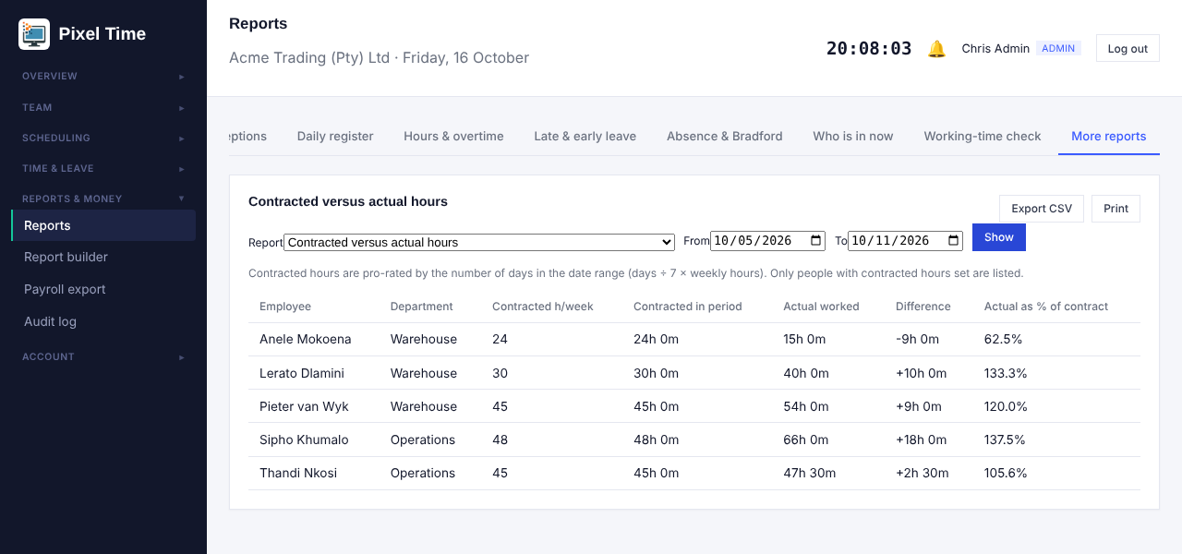
Contracted versus actual hours for the week 5 to 11 October.
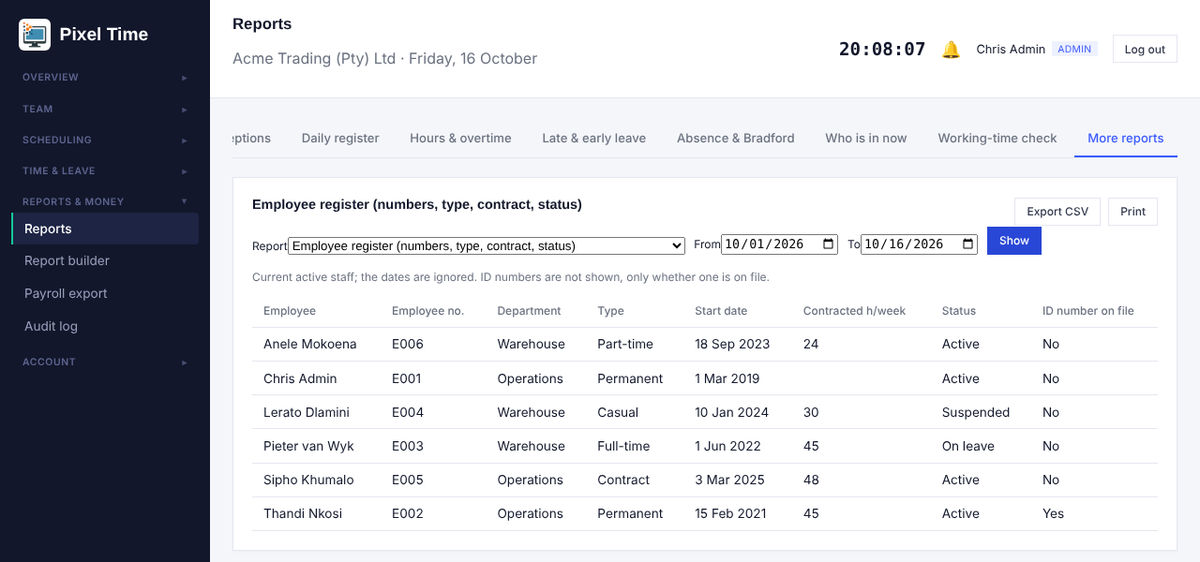
Employee register.
- Managers only see people in their own department in every report.
- The night-hours report counts 18:00 to 06:00, the period the BCEA treats as night work.

5. Payroll export controls
Who: administrators set pay codes. Administrators, managers (own department) and auditors can see the page. Auditors cannot change settings.

Warnings before you export
Open Payroll export and choose the dates. The page now checks the range before you download.
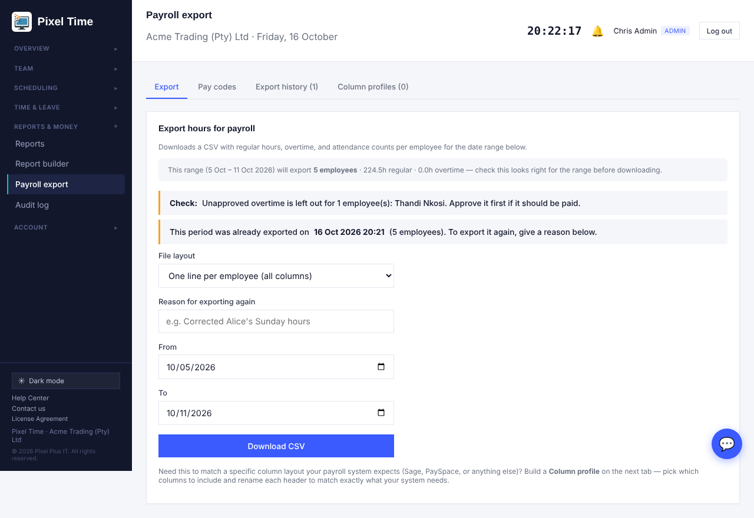
A red "Fix before export" item stops the download. A "Check" item is a reminder.
- Fix before export: an employee with no employee number, two employees with the same number, or hours with no pay code (pay-code layout only).
- Check: unapproved overtime is left out of the file. Approve it first if it should be paid.

Set pay codes
- Open Payroll export > Pay codes.
- Type the code your payroll system uses for regular, overtime, Sunday and public holiday hours.
- Save. Two hour types cannot share one code.
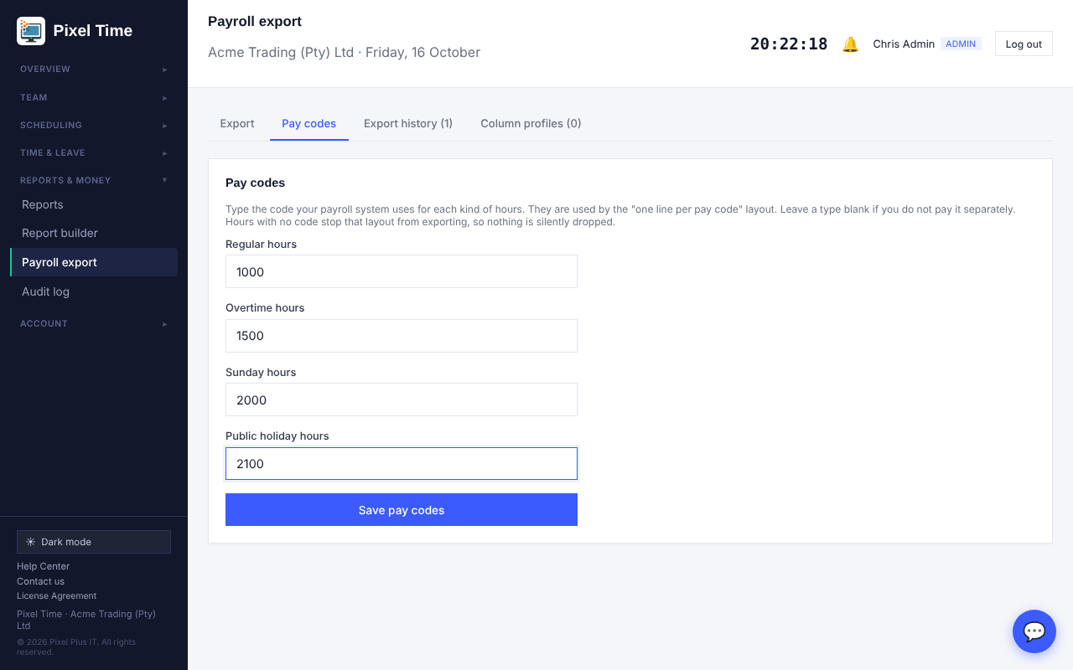
Pay codes tab.
Then choose File layout: One line per pay code. The file has Employee No, Employee, Pay code and Hours, one line for each code an employee has hours for.

Exporting the same period twice
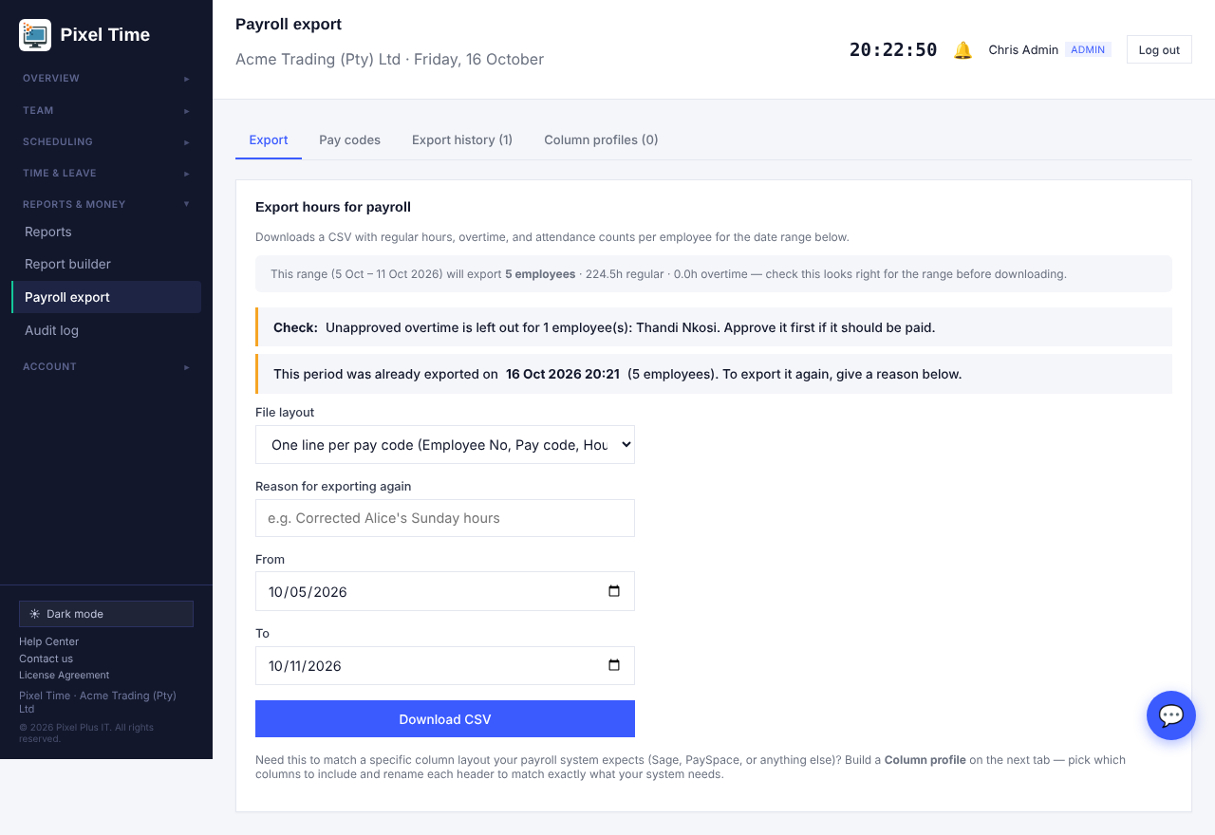
A period that was already exported asks for a reason before it can be exported again.
- The reason is saved in the export history and in the audit log.

Export history and changes after export
- Open Payroll export > Export history.
- Press Check for changes next to an export.
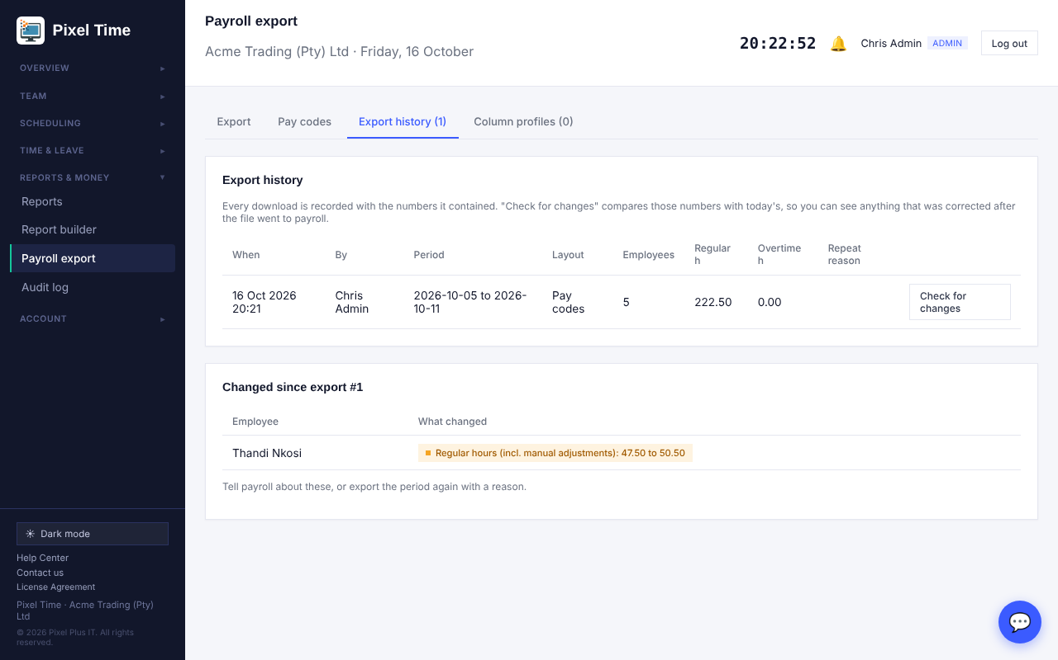
Each export keeps a copy of its numbers. The comparison names anyone whose hours changed afterwards.
- Tell payroll about the changes, or export the period again with a reason.

6. Alerts
Who: administrators set the rules and see every alert. Managers are told about their own department.

Switch checks on and set the numbers
- Open Alerts in the menu (Reports & money), then the Alert rules tab.
- Tick each check you want. Set the number (for example 30 minutes after shift start).
- Choose who is told: the manager and admins, admins only, or the employee. Choose app, email or both.
- Optional: add an extra email address (for example a payroll clerk) and an Escalate after time, in hours. An alert nobody resolves is then sent to every admin again.
- Set the payroll cut-off day of the month at the bottom, then press Save alert rules.
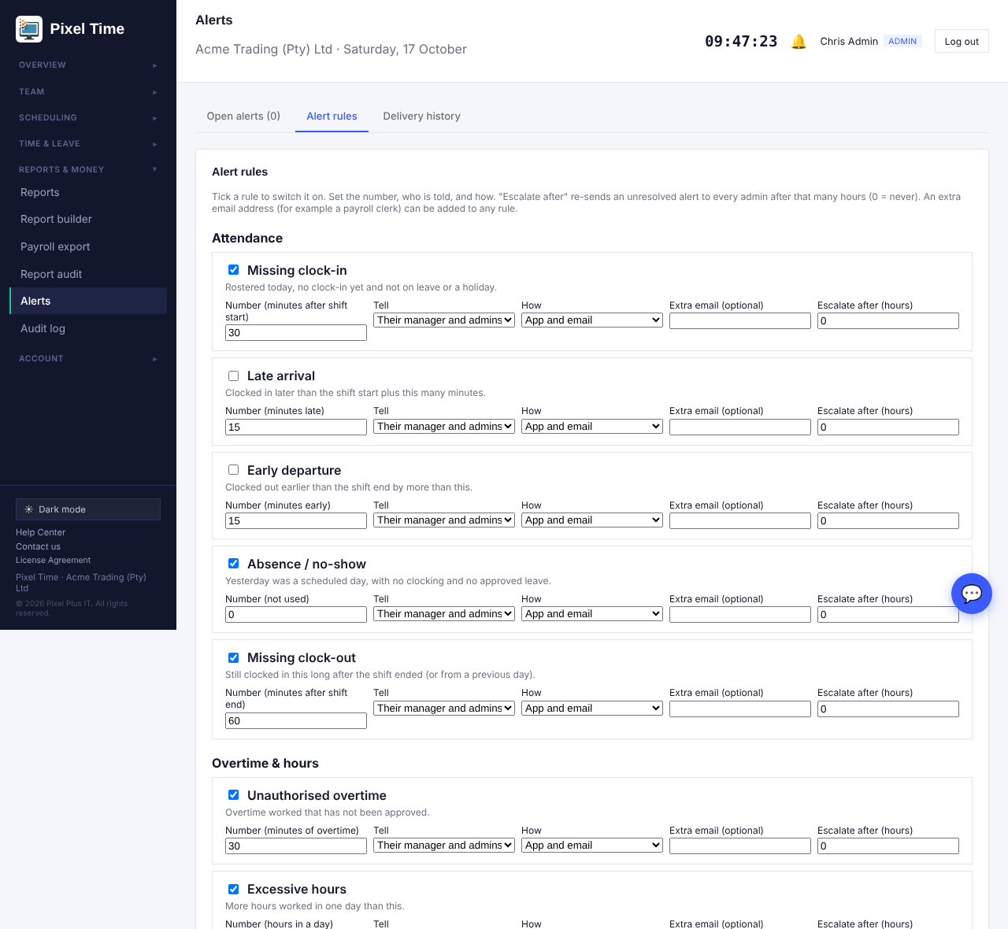
Alert rules: one row per check with its number, who is told and how.

Work through open alerts
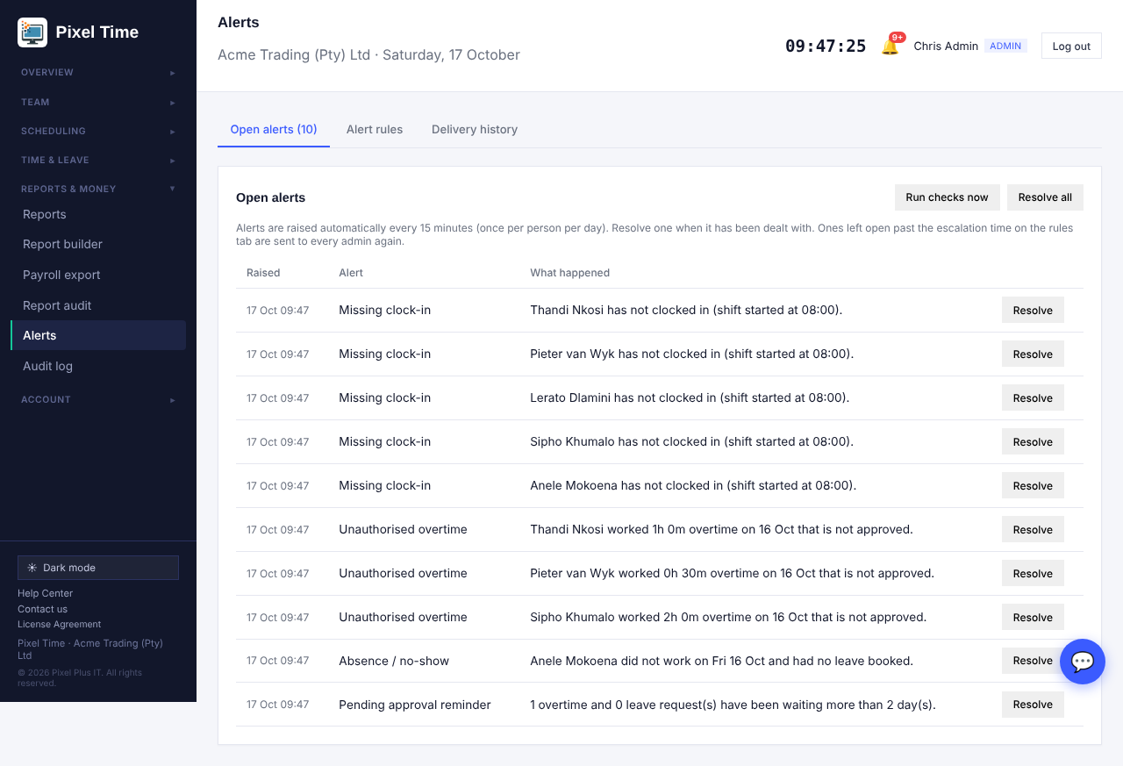
Open alerts. Resolve one when it has been dealt with, or use Resolve all.
- Checks run every 15 minutes and raise each alert once per person per day. Run checks now does it straight away.
- The checks cover missing clock-in and clock-out, late arrival, early departure, absence, unauthorised and excessive overtime, rest period, missed break, pending approvals, payroll cut-off, contract expiry, upcoming shifts, roster changes, uncovered shifts, failed reports, clocking exceptions and offline devices.
- The Delivery history tab shows what was sent, to whom and when.
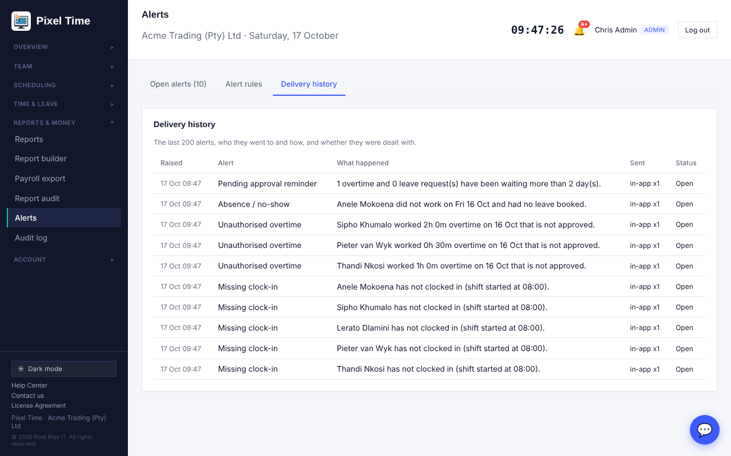
Delivery history.

7. Roster planning
Who: administrators and managers (own department). Only administrators set staffing levels.

Coverage and staffing
- Open Roster planning (Scheduling menu, or the link at the top of the Roster page).
- On Coverage & staffing choose one week, two weeks or a month.
- Type the minimum and maximum people each shift needs, then save (administrators).
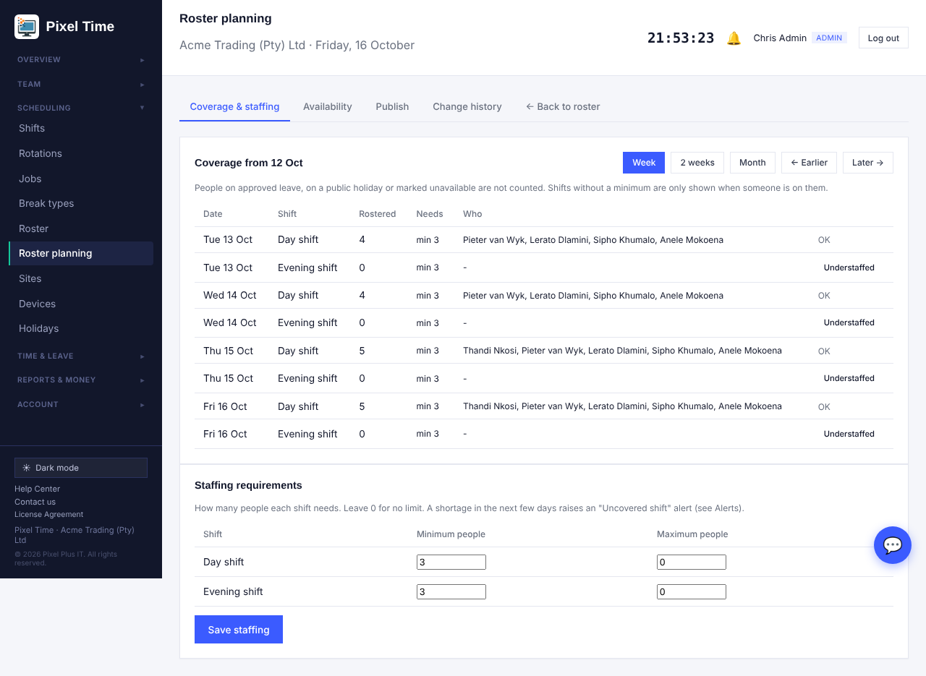
Coverage: red means below the minimum, amber means over the maximum.
- People on leave, on a public holiday or unavailable are not counted.
- A shift that is short in the next few days also raises an Uncovered shift alert.

Availability and days off
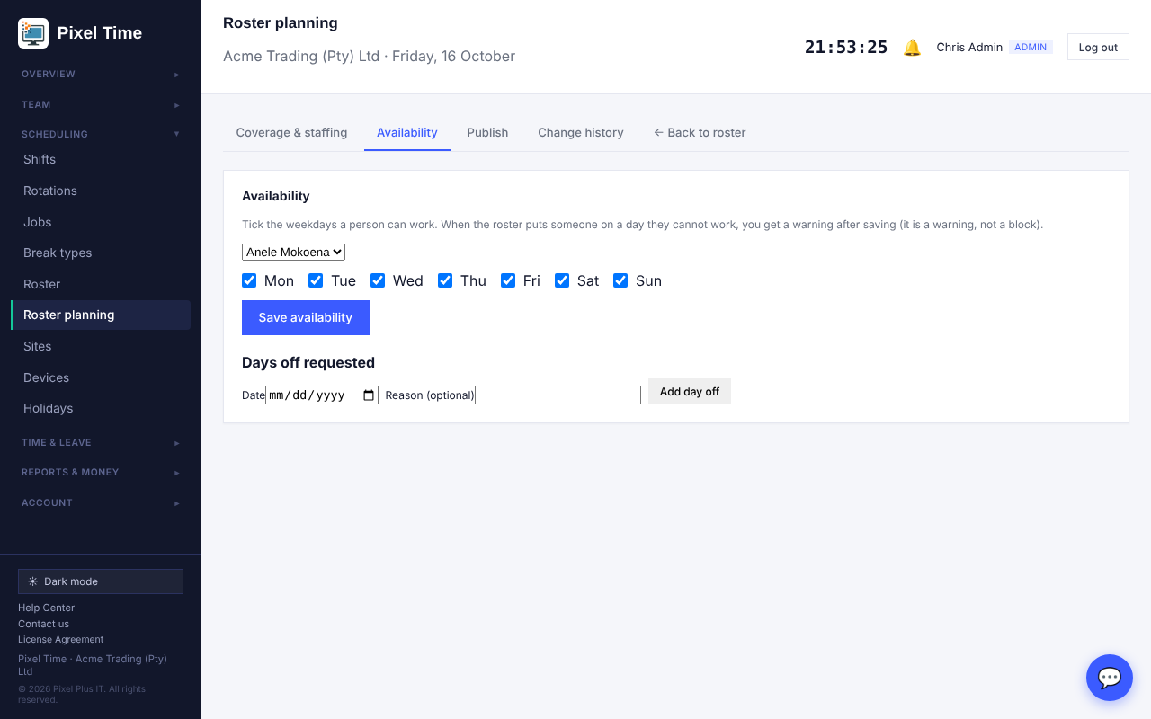
Availability: tick the weekdays a person can work and add days off they asked for.
- If you roster someone on a day they cannot work, the Roster page saves it but warns you: "Check availability".

Publish and change history
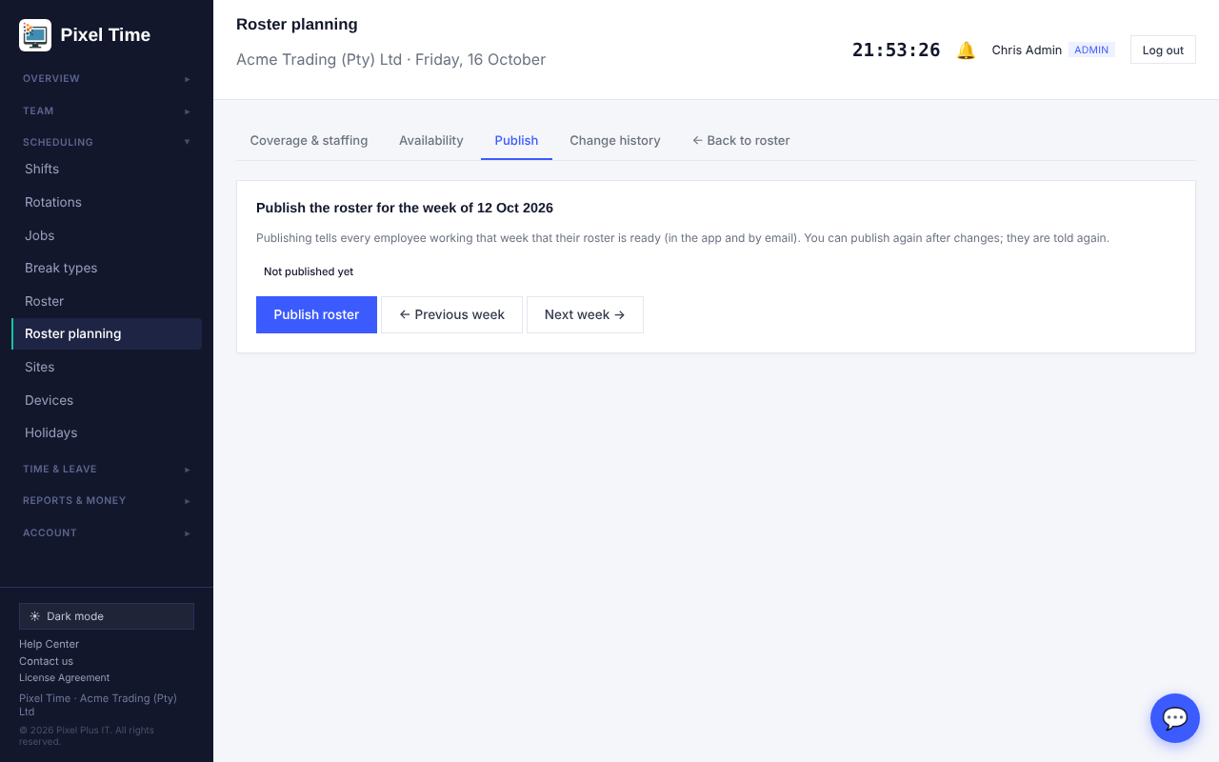
Publish tells every employee working that week that their roster is ready.
- Change history lists every roster change: who changed it, which day, and from what to what.
- An employee whose shifts change after publishing gets a Roster change notice.

8. Report audit and delivery
Who: administrators only.

Delivery history
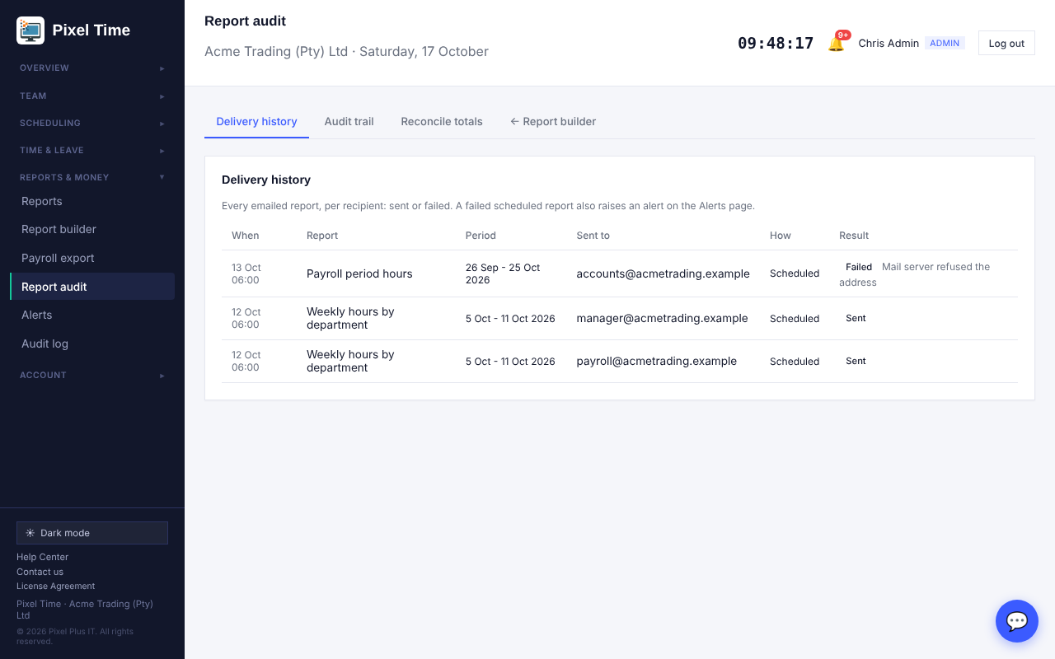
Every emailed report, per person: sent, or failed with the reason.
- A failed scheduled report also raises a Report failed alert.

Audit trail
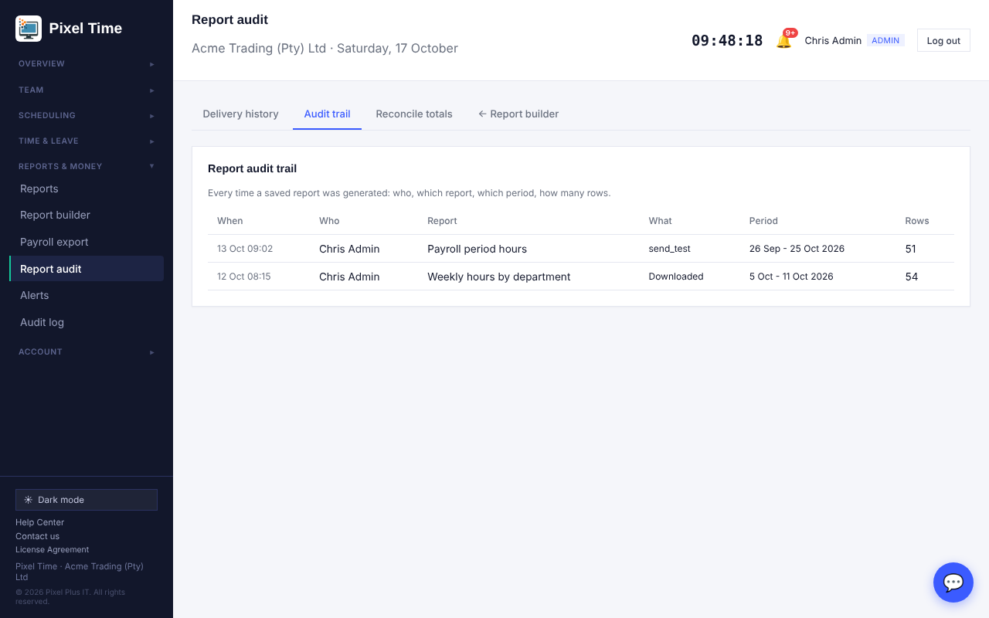
Who ran which report, for which period, and how many rows it had.

Reconcile totals
Pick a period. The page compares the hours in the payroll export and in reports with the attendance records and tells you if they differ.
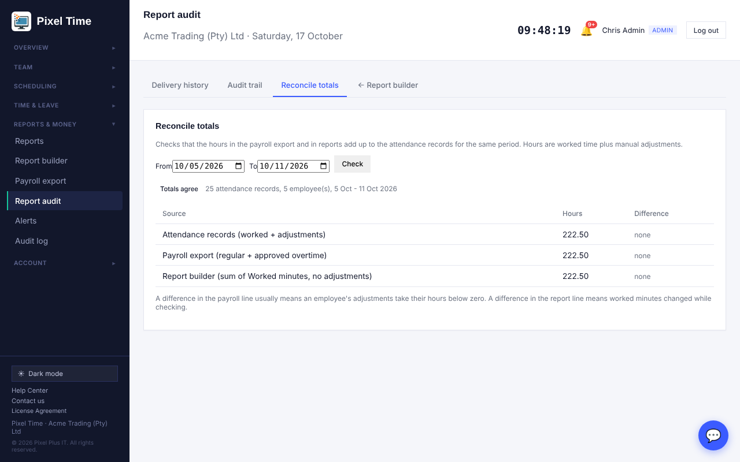
Reconcile totals.

Send a report on payroll cut-off day
- Open Report builder and save the report you want.
- In the schedule list choose On the payroll cut-off day (pay period).
- The report is emailed for the pay period that just ended. The cut-off day is set on the Alerts page.

9. Clocking integrity
Who: administrators see everyone. Managers see their own department.

Exceptions
- Open Clocking integrity (Time & leave). Choose the dates and press Check.
- Each line is a problem found by checking every raw clocking in time order.
- Press Events to see the person and day in full, then fix a mistake in Corrections. The original clocking stays on record.
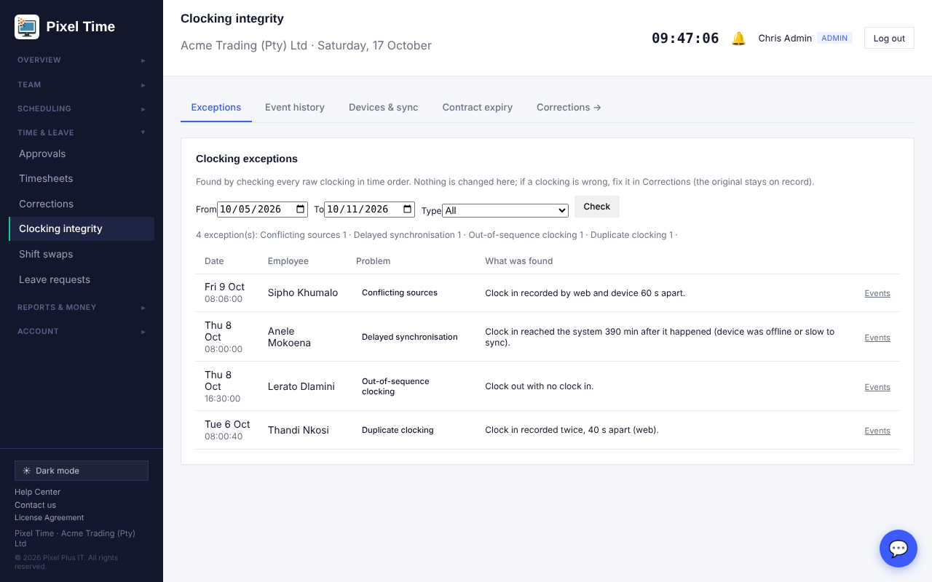
Exceptions found for the week 5 to 11 October.
Problem | What it means
Duplicate clocking | The same clocking twice within 2 minutes (a double tap or a retried device message).
Conflicting sources | The same clocking from two places, for example a device and the web.
Out-of-sequence clocking | A clock-out with no clock-in, a clock-in while already in, or a break problem.
Clock-out before clock-in | The times are the wrong way round.
Delayed synchronisation | A device clocking that reached the system more than 10 minutes late.

Event history
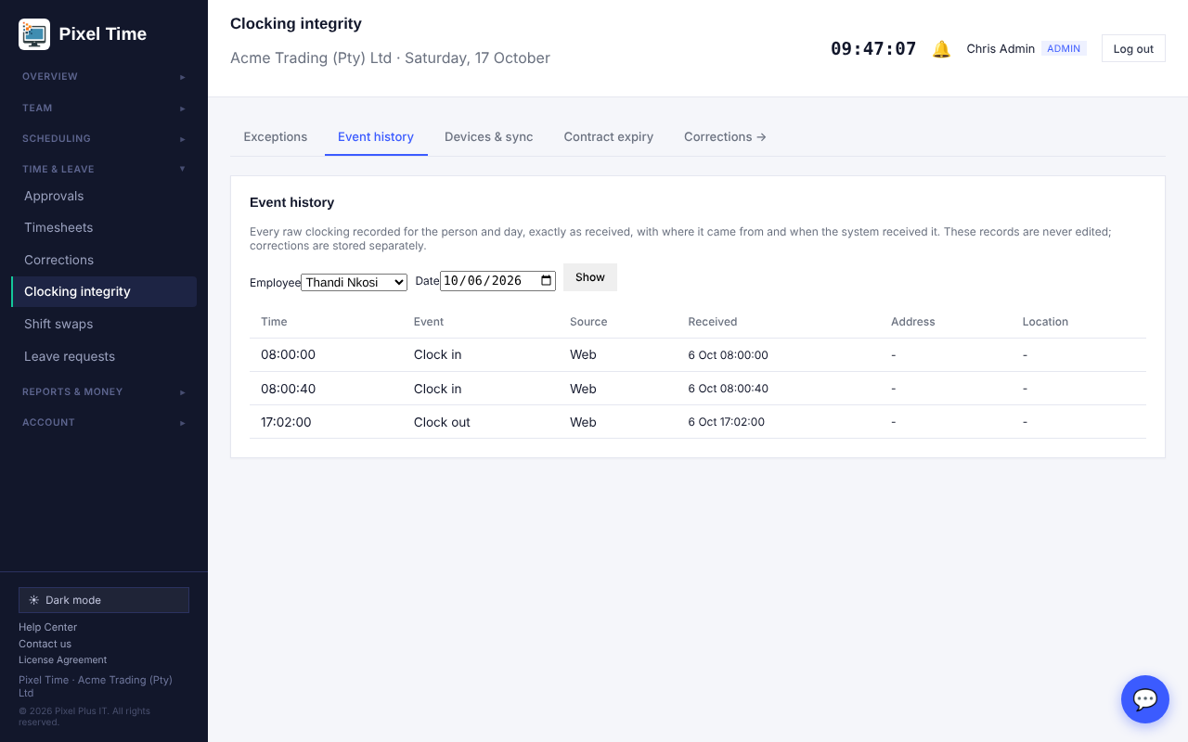
Every raw clocking for a person and day, with its source and when it was received. These are never edited.

Devices and sync
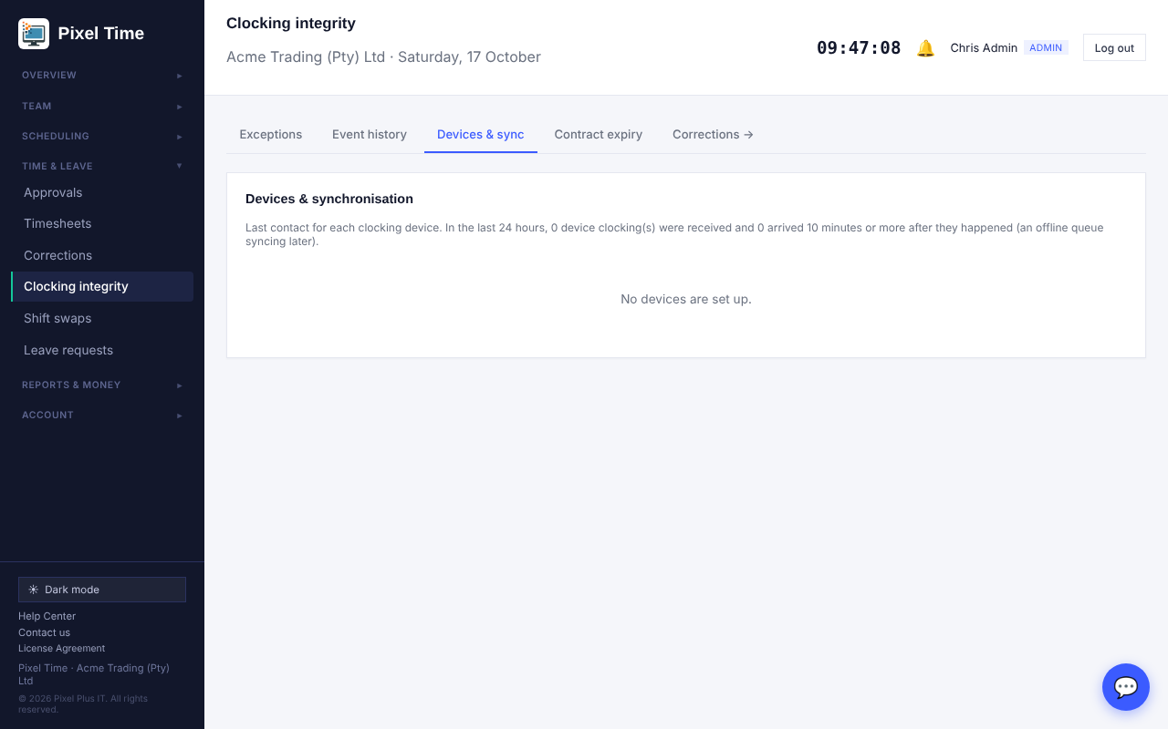
Last contact for each device and how many clockings arrived late.
- Contract expiry lists contracts ending in the next 90 days.

10. Overtime requests
Who: employees ask. Managers and administrators approve, change or decline. Administrators set limits and budgets.

Employees: ask before you work it
- Open My overtime (Time & leave).
- Choose the day, the hours and a short reason, then press Send request.
- Your manager and the administrators are told. You are told when it is approved, changed or declined.
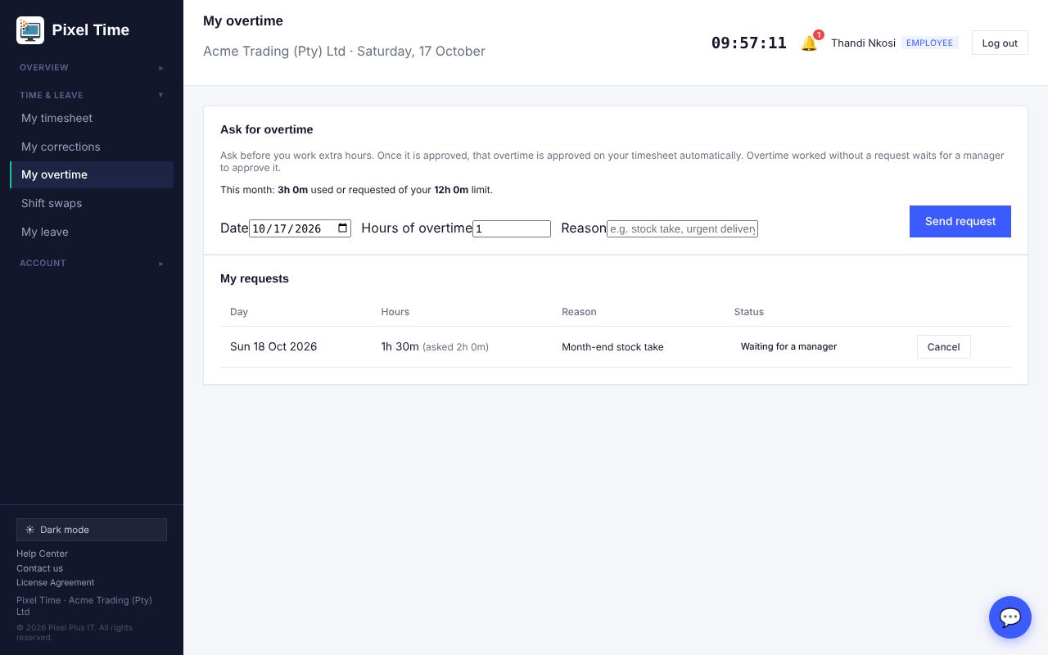
My overtime: ask for overtime and follow your requests. You can cancel until the day has passed.
- Once a request is approved, the overtime you work that day is approved on your timesheet automatically, up to the hours approved.
- Overtime worked without a request still waits for a manager to approve it.
- If a monthly limit is set and the request would go over it, the page says so and the request is not sent.

Managers and administrators: decide
- Open Overtime, or Approvals, where requests appear with leave and corrections.
- Press Approve or Decline. Type a reason when declining; the employee sees it.
- To change the hours, type the new hours and a reason, then press Change hours. The change is kept in the history.
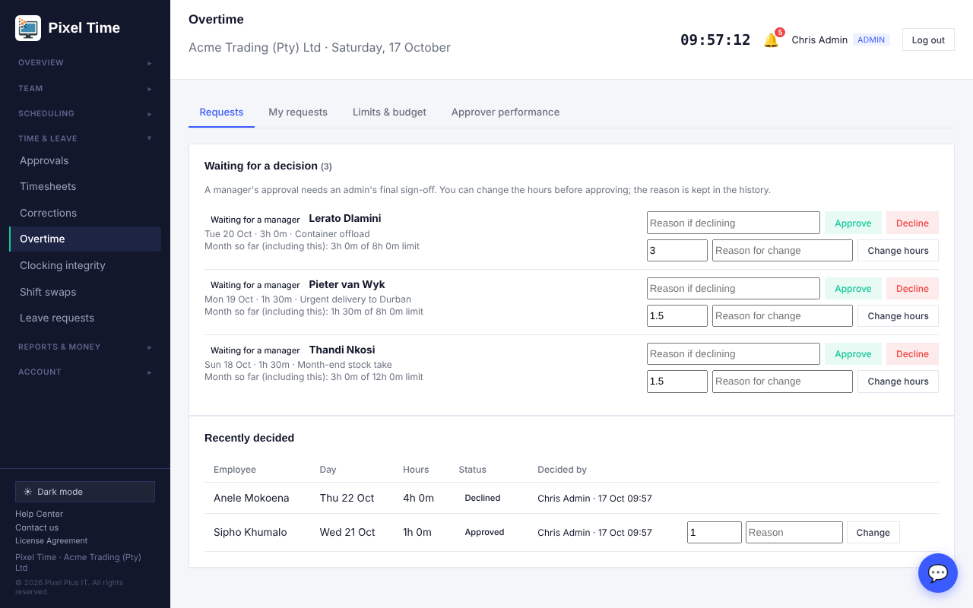
Requests: approve, decline or change the hours.
- A manager's approval needs an administrator's final sign-off, the same as corrections.
- Only an administrator can change a request that is already approved.

Limits and budget
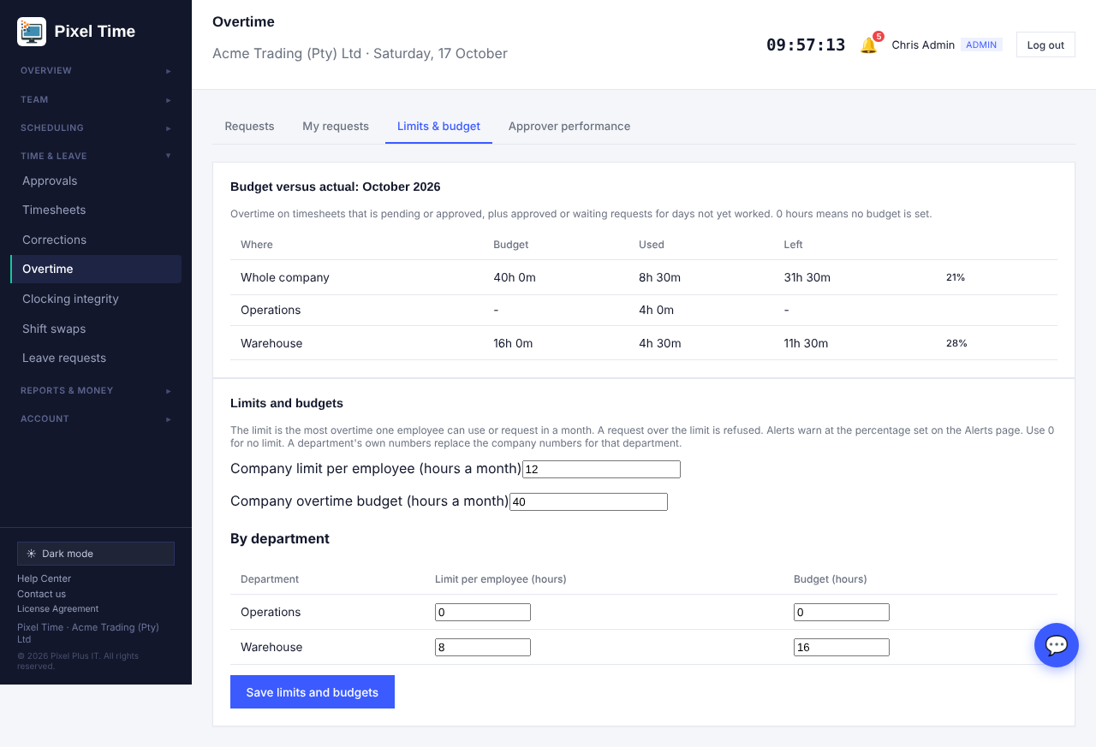
Limits & budget: used versus budget for the month, with limits for the company and each department.
- The limit is the most overtime one employee can use or request in a month. A department's own numbers replace the company numbers for that department. Enter 0 for no limit.
- The budget is the overtime hours the company, or a department, plans to spend each month.
- On the Alerts page, Overtime near monthly limit and Overtime budget warning tell you when 80% (or the percentage you choose) is reached. Pending approval reminder now includes overtime requests nobody has decided.

Approver performance
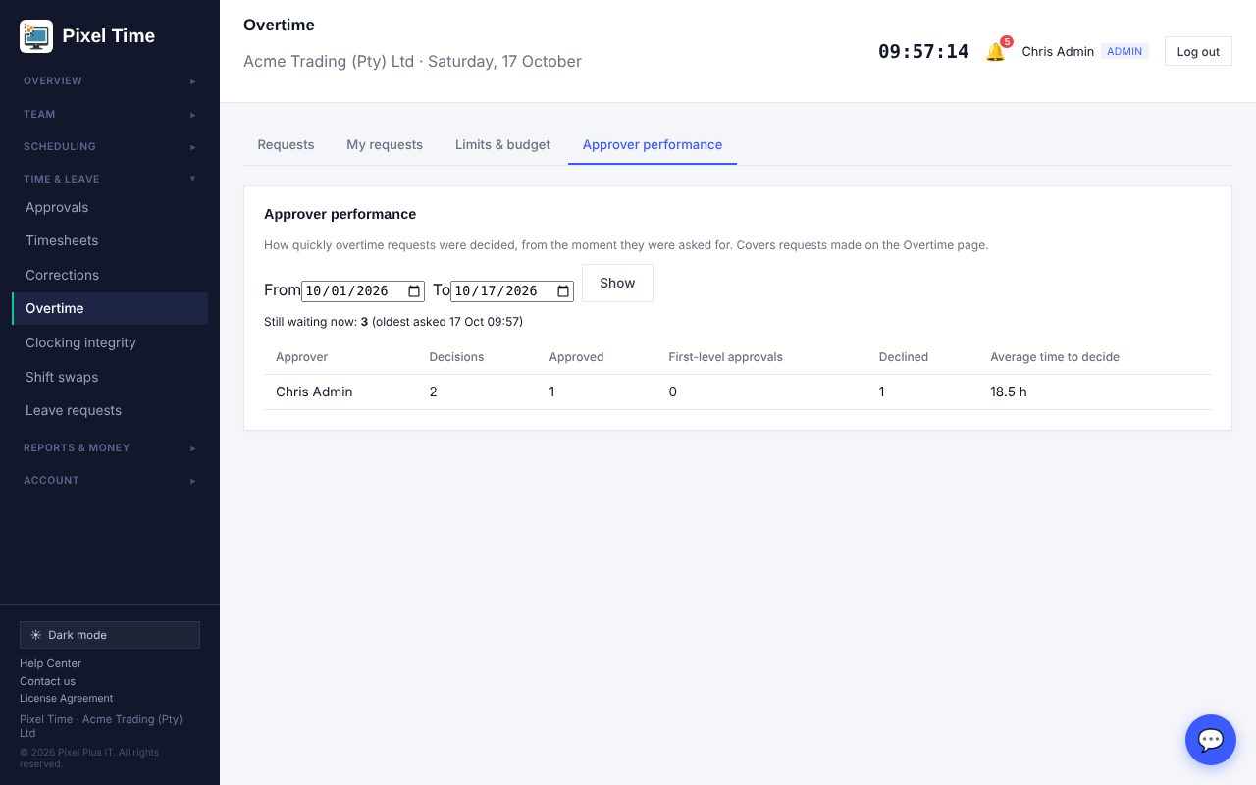
Approver performance: decisions made and the average time taken.

11. Leave balances, history and rules
Who: administrators change things. Managers see their own department. Auditors see everyone. The liability estimate is for administrators and auditors only.
Open Leave balances (Time & leave). The tabs are described below.

Balances on any date
- Choose a date and, if you like, one leave type, then press Show.
- Each person shows what they had earned, taken and left on that day. Leave booked after the date is not counted.
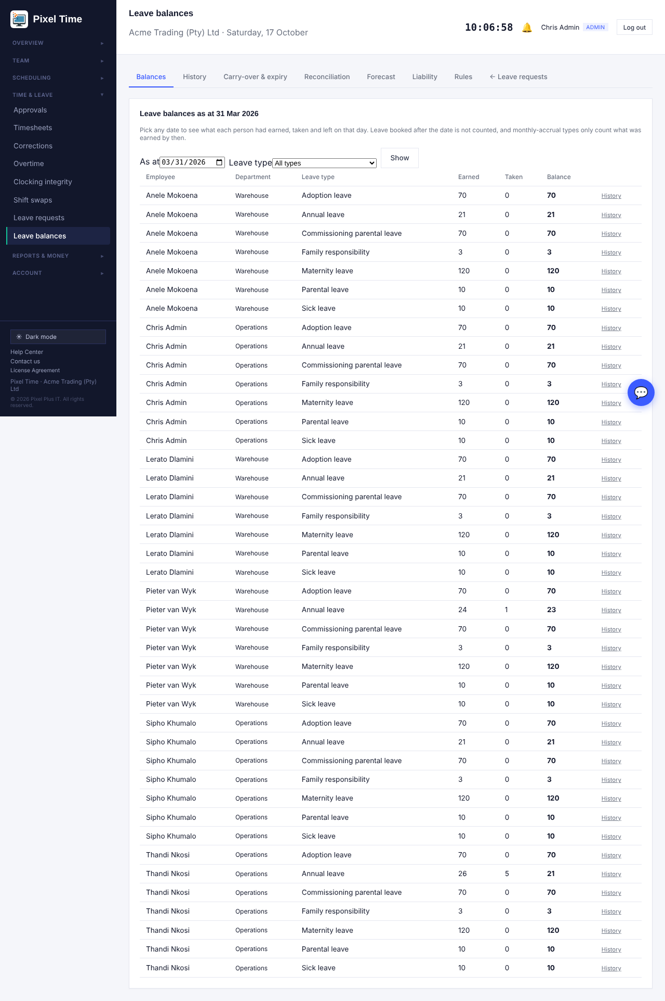
Balances as at 31 March 2026. Press History to see how a balance was made up.

History for one person
- Choose the employee, leave type and year.
- Every line is shown with the balance after it: yearly days (or monthly earnings), carry-over, adjustments, leave taken and expired days.
- Administrators can add or remove days at the bottom. A reason is required and stays on the history.
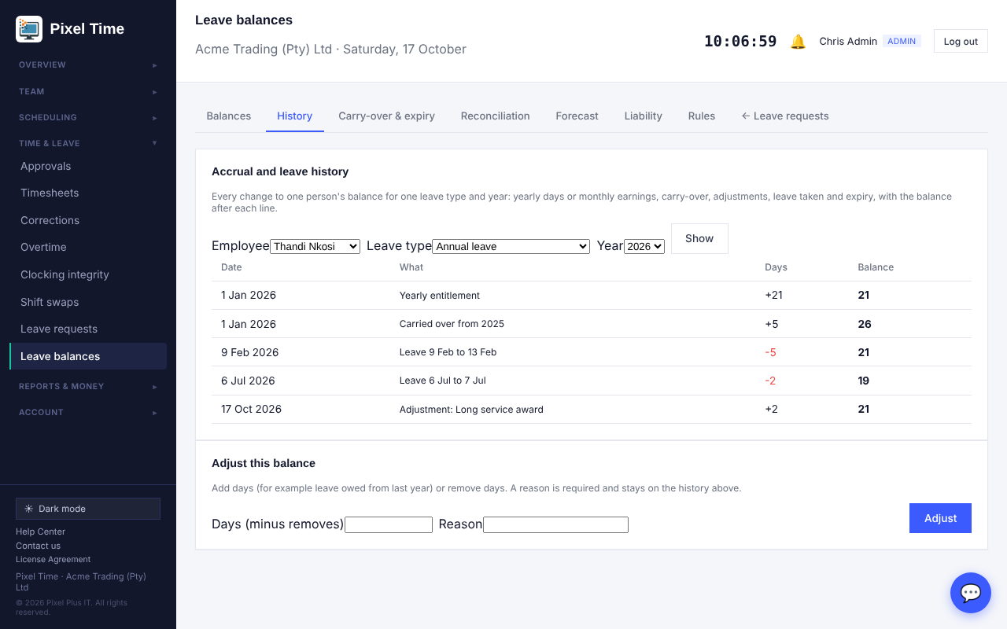
History: nothing changes a balance without showing up here.

Carry-over and expiry
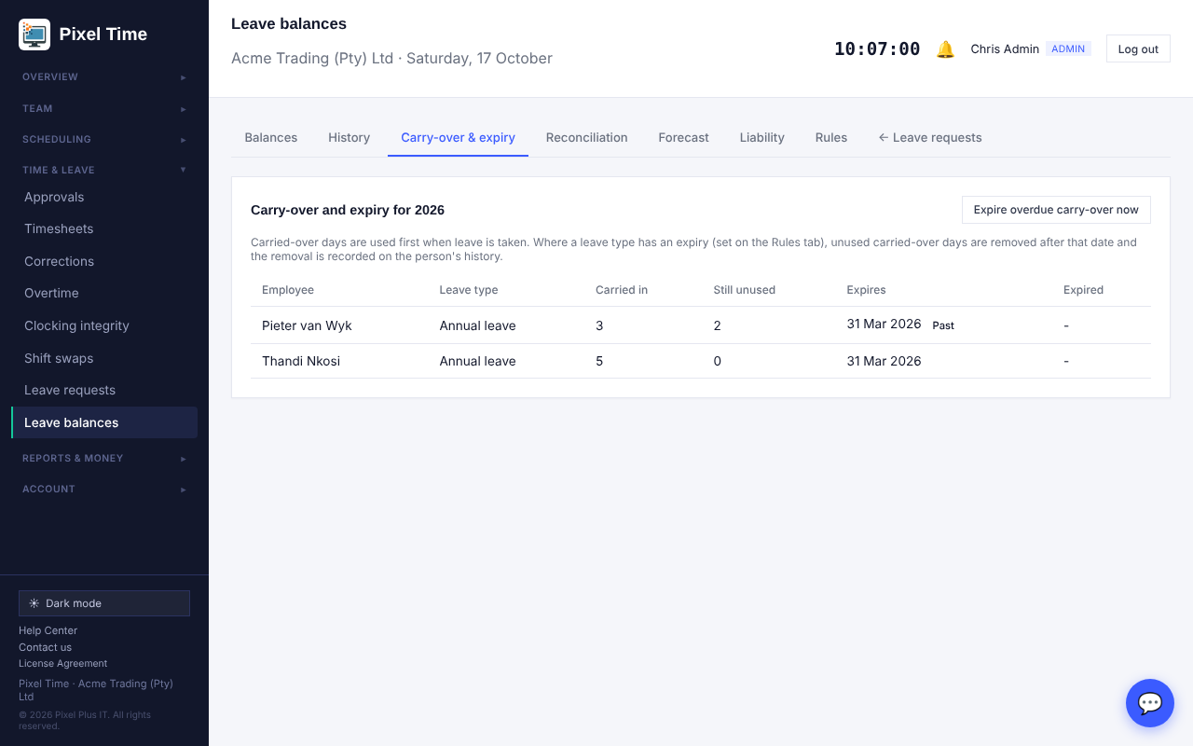
Carry-over: days brought in, days still unused and the date they expire.
- Carried-over days are used first when leave is taken.
- Set how many months after 1 January carried-over days expire on the Rules tab. After that date, Expire overdue carry-over now removes the unused days. It is recorded on the person's history.
- The Alerts page has a Leave about to expire check that warns before the date.

Reconciliation
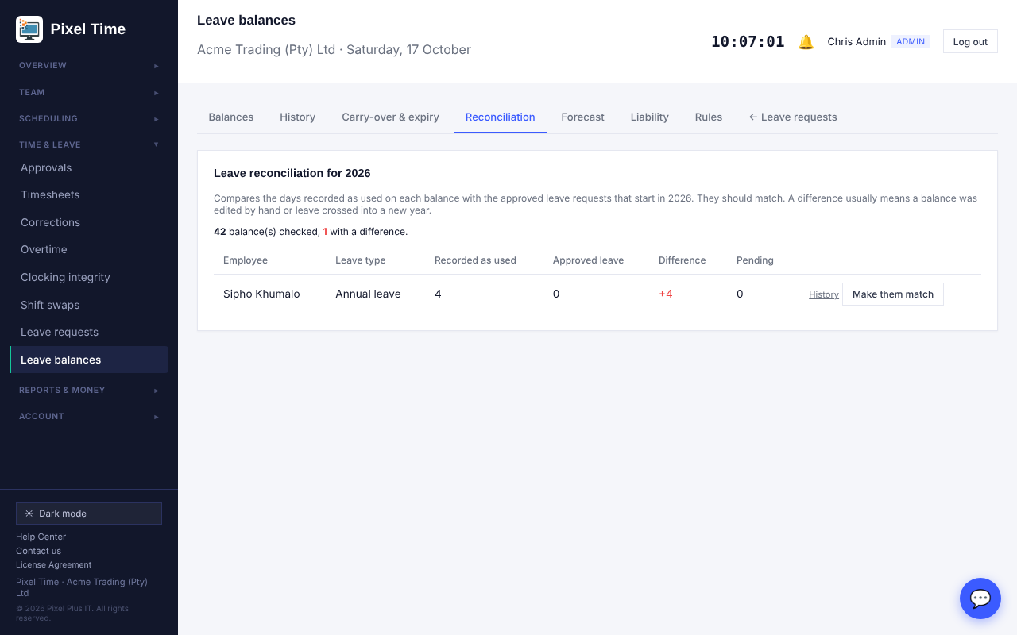
Reconciliation: the days recorded as used compared with the approved leave.
- The two should match. A difference usually means a balance was edited by hand or leave crossed into a new year.
- Make them match sets the used days to the approved leave. Check the history first.

Forecast
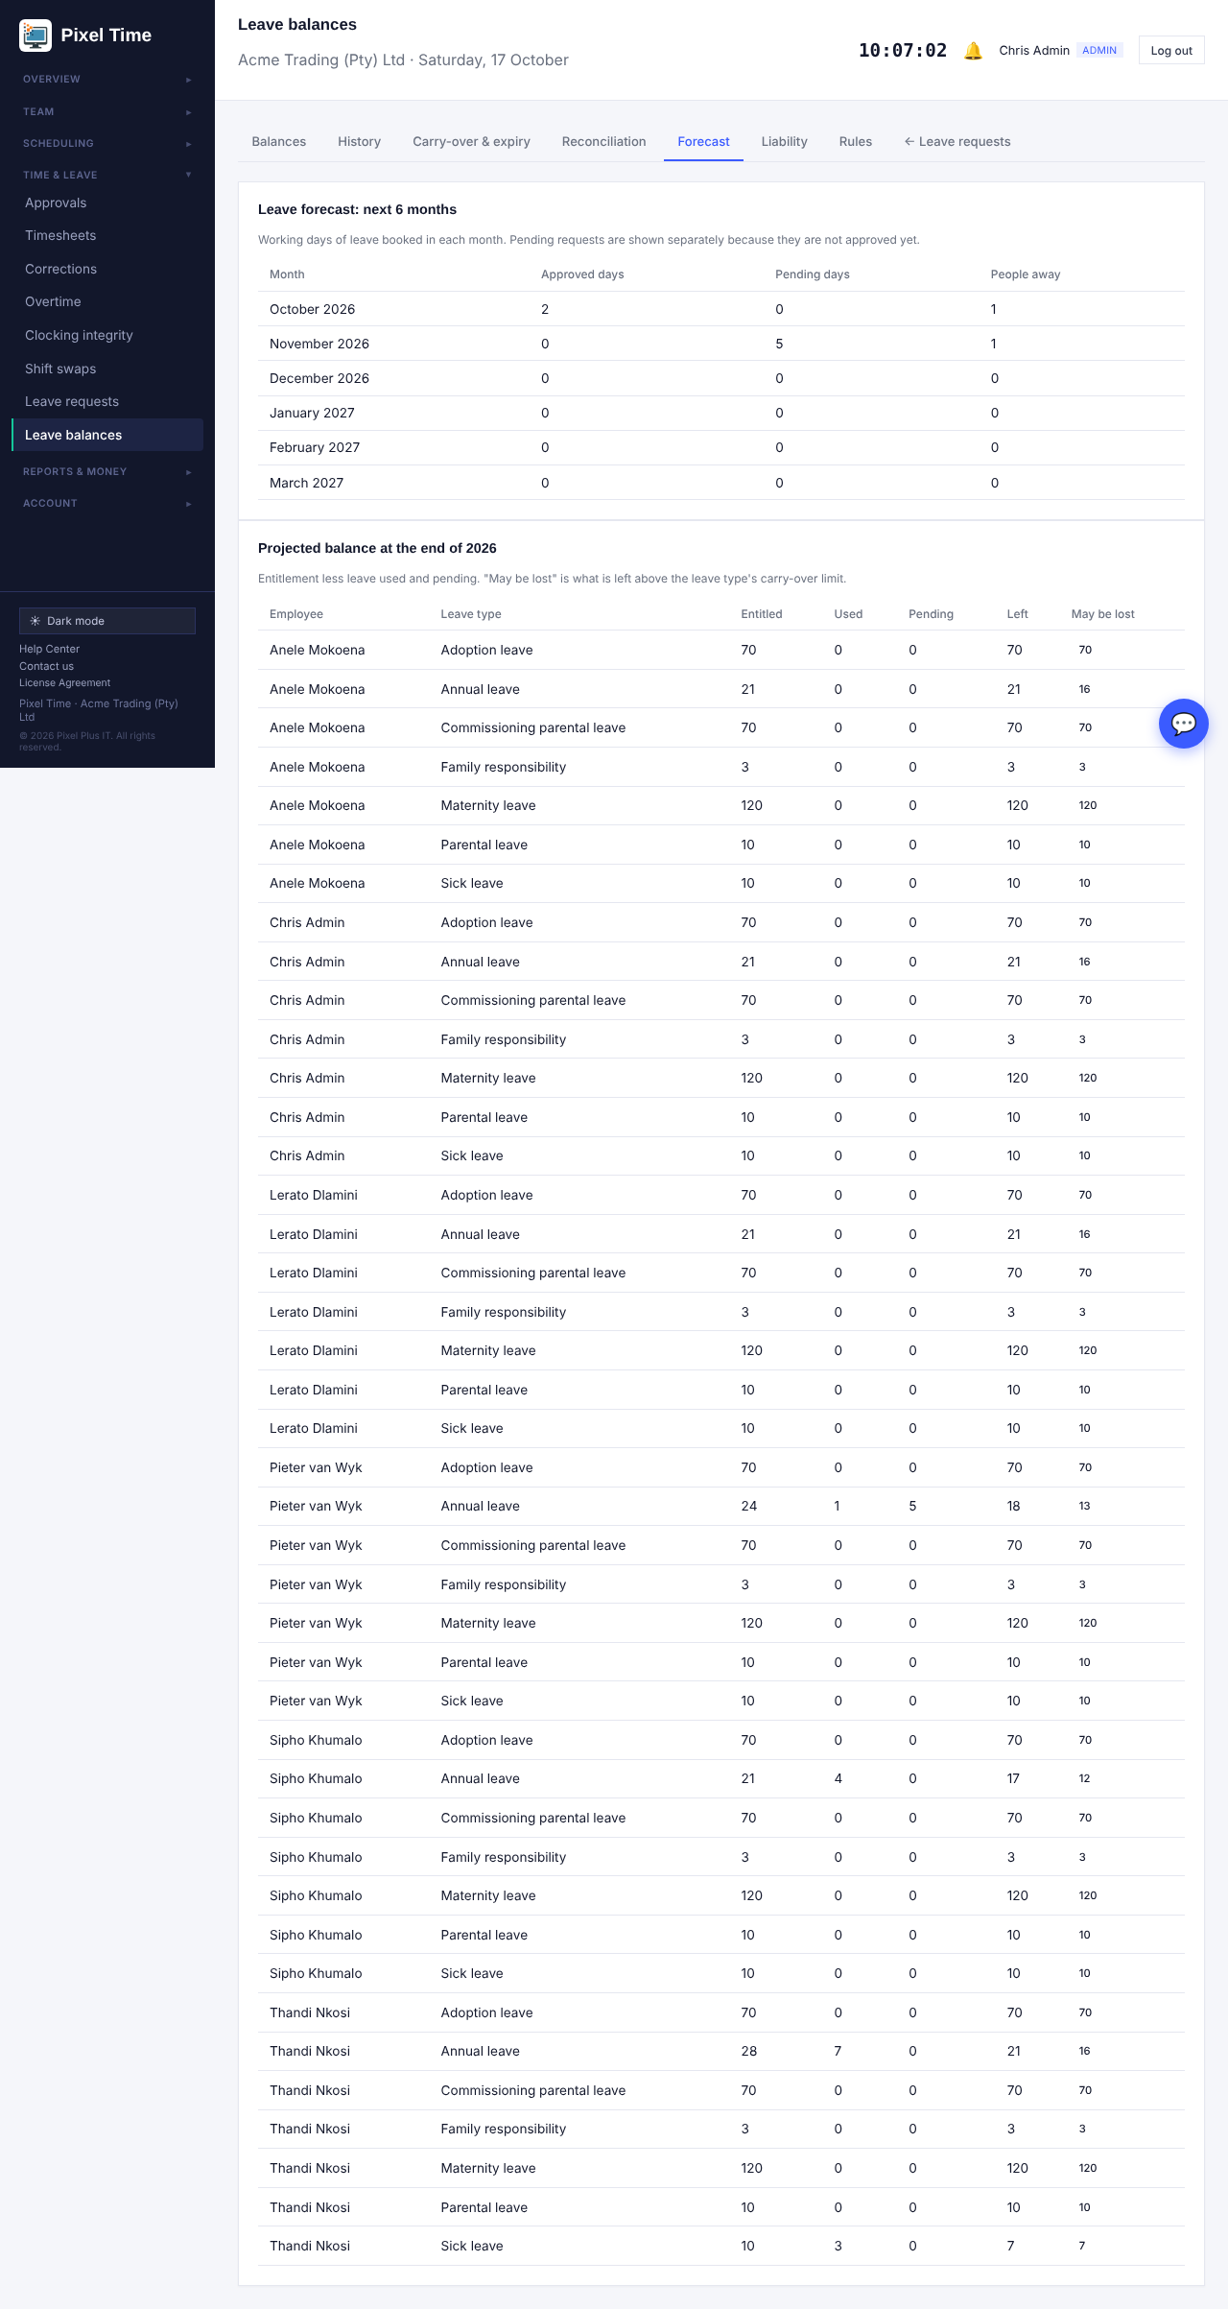
Leave booked for the next six months and the projected balance at year end.
- May be lost shows days left over the leave type's carry-over limit.

Liability estimate
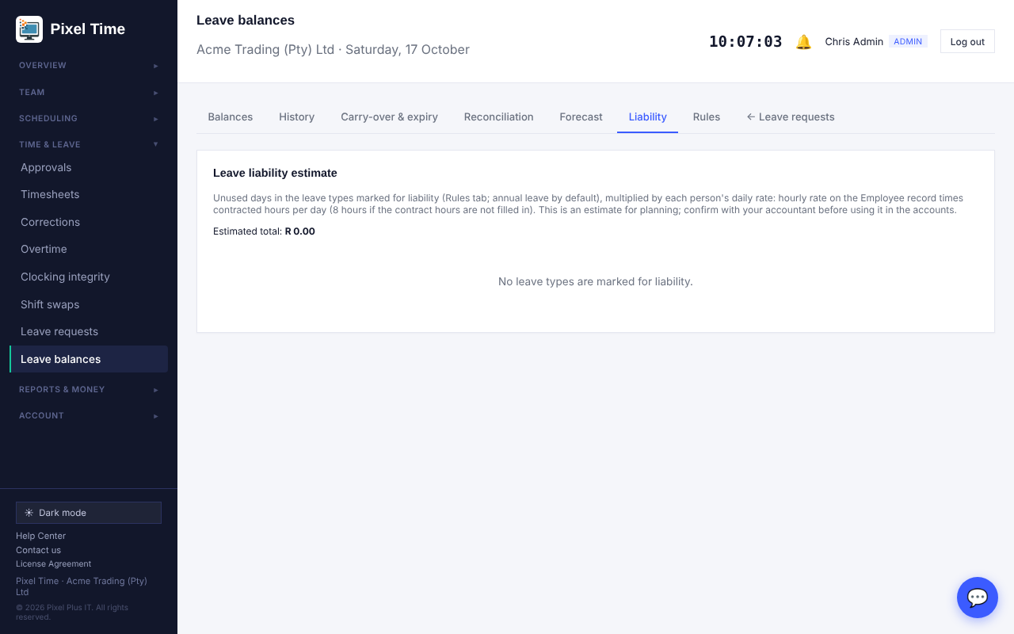
Unused days times each person's daily rate.
- The daily rate is the hourly rate on the Employee record times the contracted hours per day (8 hours is assumed when contract hours are blank).
- People with no hourly rate are left out and counted. This is an estimate for planning, not an accounting figure.

Rules
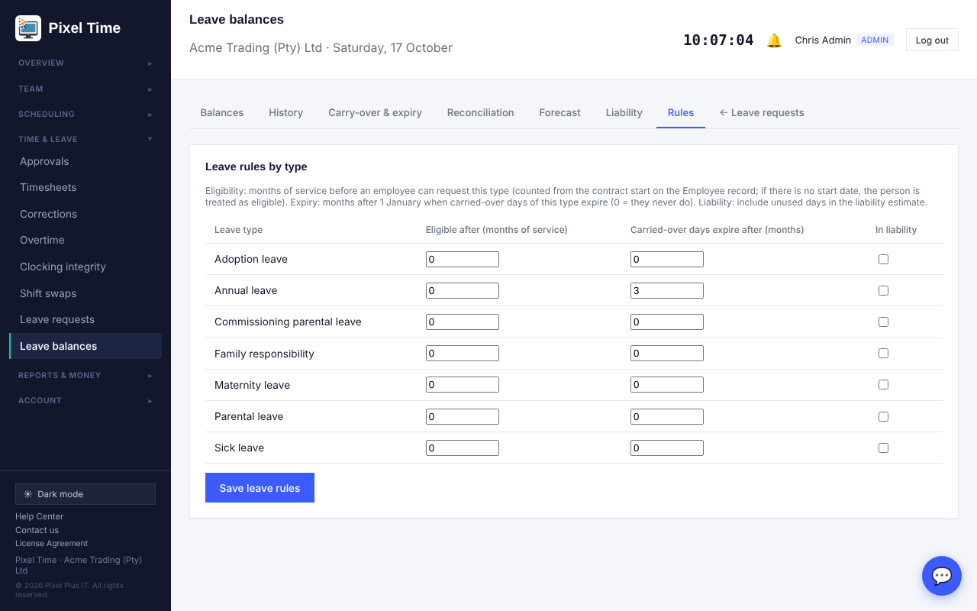
Rules for each leave type.
- Eligible after: months of service before an employee can request this type. It uses the contract start date on the Employee record. If there is no start date, the person is treated as eligible.
- Carried-over days expire after: months after 1 January. 0 means they never expire.
- In liability: tick the types to include in the liability estimate. Annual leave is ticked by default.

12. Timesheet sign-off
Who: employees submit their week. Managers and administrators approve or send it back. Administrators set the levels and deadlines and can reopen a week.

Employees: submit your week
- Open My sign-off (Time & leave).
- Check the hours for the week. If a day has a missing clock-in or clock-out, ask for a correction first.
- Press Submit. A manager approves the week or sends it back with a reason.
- If it is sent back, fix the problem (usually a correction) and press Resubmit.
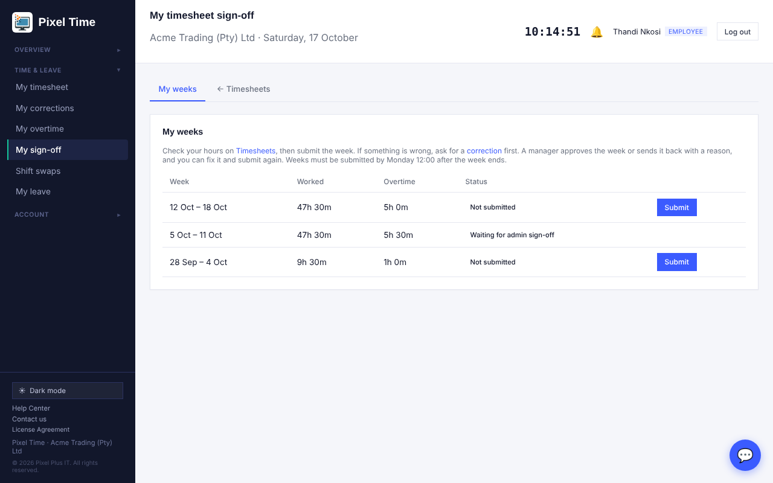
My weeks: submit, and see what stage each week is at.

Managers and administrators: approve or send back
- Open Timesheet sign-off, or Approvals, where submitted weeks appear with leave and overtime.
- Open the timesheet if you want to check it. Then press Approve, or type what needs fixing and press Send back.
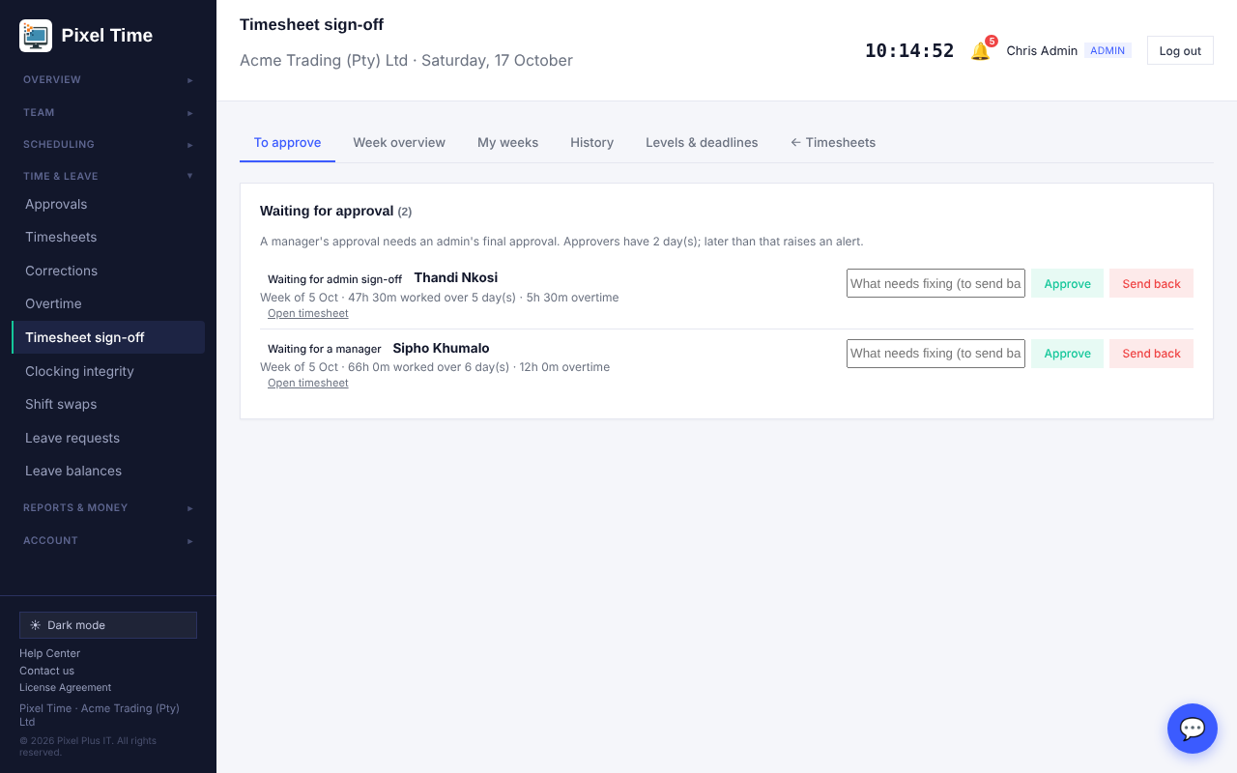
To approve: approve, or send back with a reason the employee will see.
- When two levels are on, a manager's approval waits for an administrator's final approval.
- Sending a week back from the Approvals page uses a standard message. Use this page to write your own.

Week overview and history
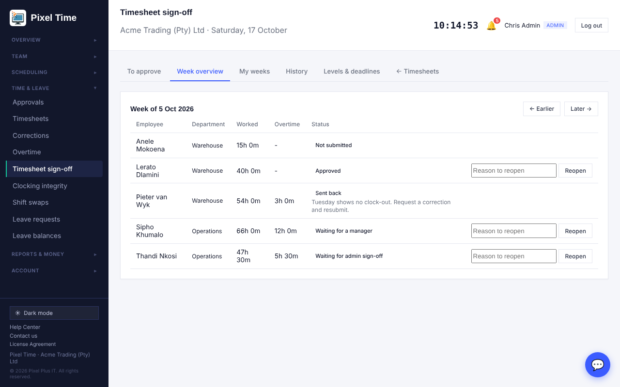
Week overview: everyone's status for the week. Administrators can reopen a submitted or approved week.
- If hours change after a week was approved, the overview says so, with the difference.
- Reopening needs a reason and is recorded as its own event. If the week is inside a locked payroll period, unlock the period on Timesheets first.
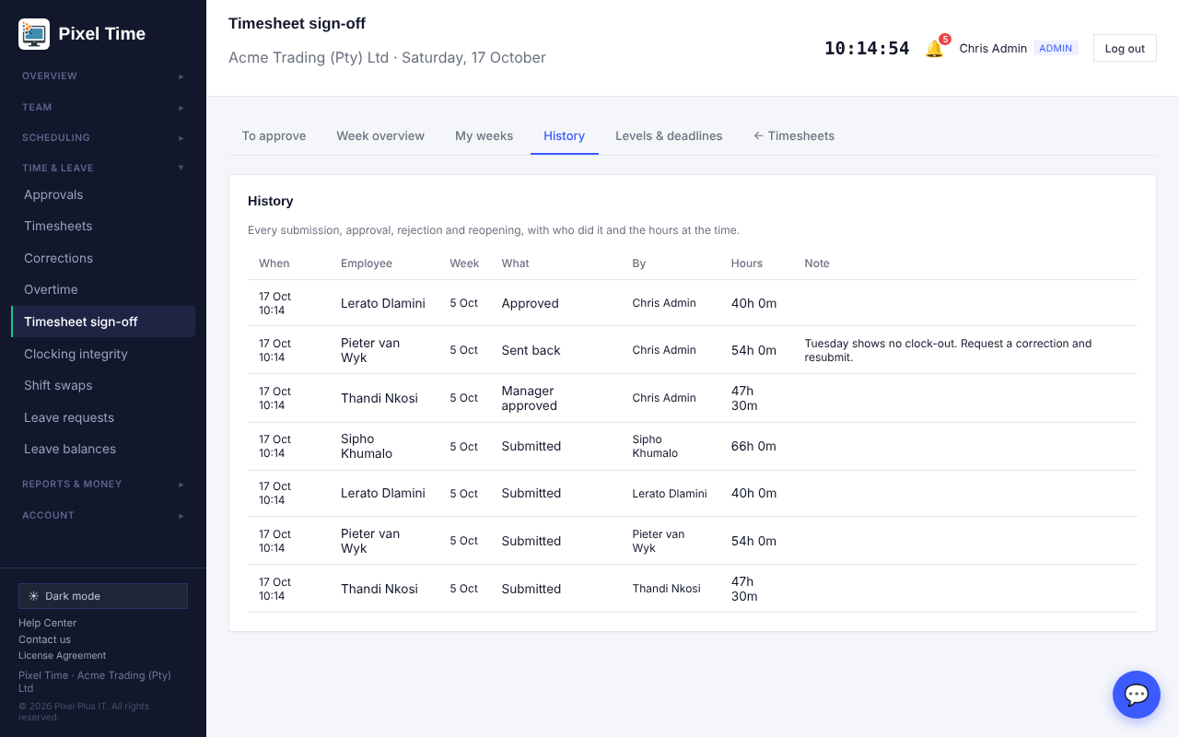
History: every submission, approval, rejection and reopening, with who did it and the hours at the time.

Levels and deadlines (administrators)
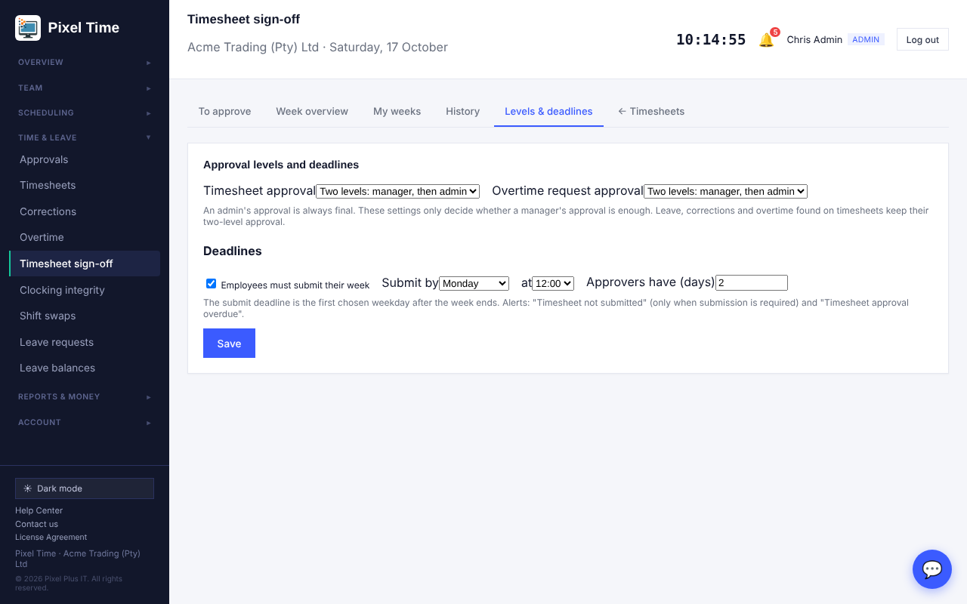
Levels and deadlines.
- Approval levels: choose whether a manager's approval is final, or needs an administrator. This is set separately for timesheets and for overtime requests. Leave, corrections and overtime found on timesheets keep two levels.
- Deadlines: tick Employees must submit, then choose the day and hour after the week ends. Choose how many days approvers have.
- The Alerts page has Timesheet not submitted and Timesheet approval overdue.

13. Management reports and labour budgets
Who: administrators and auditors see every report. Managers see the reports that do not show money, for their own department. Where: Reports > More reports, group "Management". Administrators set budgets under Labour budgets.

The reports
- Payroll variance against the previous period: each employee's estimated cost this period against the period of the same length just before it.
- Staffing shortage and over-staffing: every date and shift where the planned numbers are under the minimum or over the maximum.
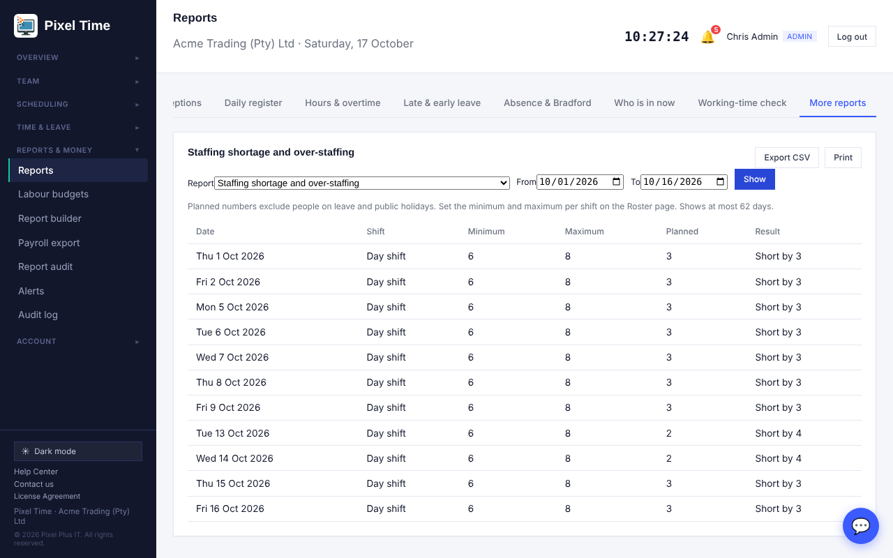
Staffing shortage: each day and shift that is short, and by how many.
- Staff availability: each person's days they cannot work, and one-off days off in the range.
- Attendance forecast against actual: who was expected to work each day against who clocked in.
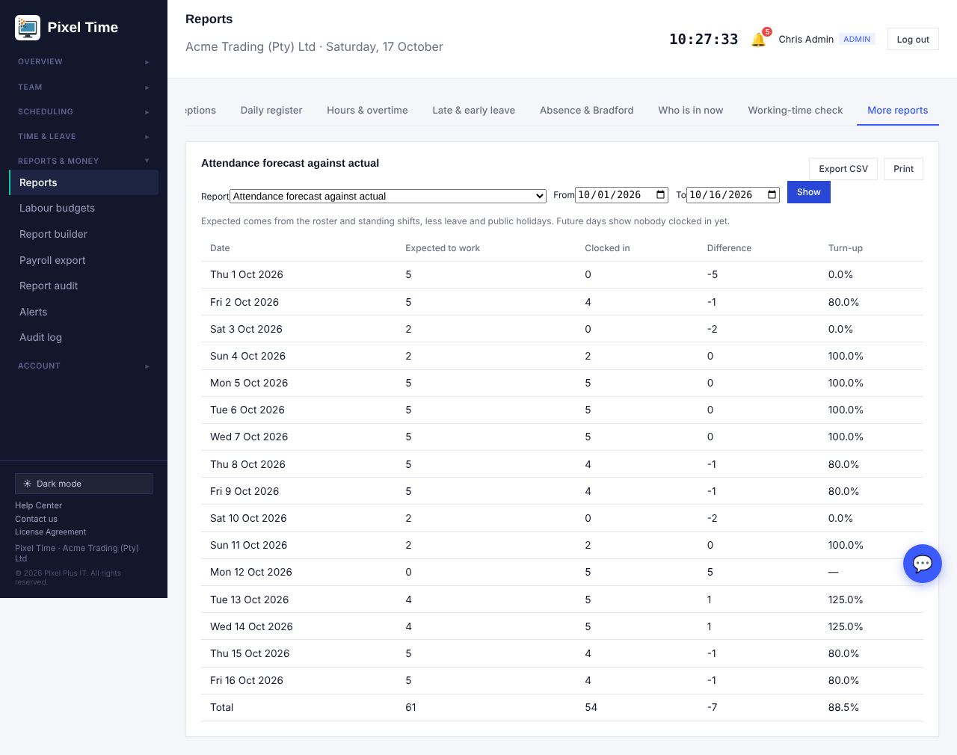
Forecast against actual, with turn-up per day.
- Cost per working hour: total cost divided by hours worked, per department, including overtime and premium rates.
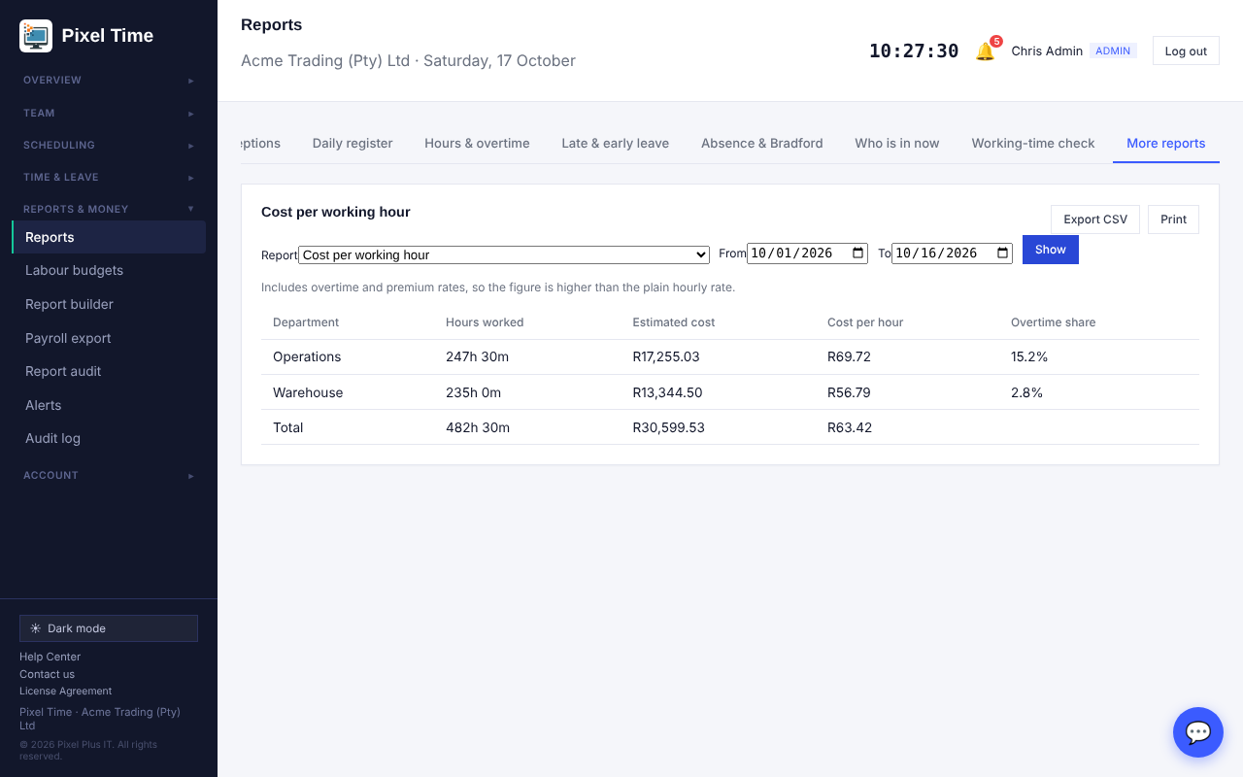
Cost per working hour by department.
- Labour cost, last six months: hours, overtime and estimated cost for each month, with the change on the month before.
- Time correction resolution time: how long each correction request took to decide, and the average. Decision times come from the audit log.
- Costs are estimates from clocked hours, hourly rates and your pay rules. Payroll stays the authority.

Labour budgets (administrators)
- Open Labour budgets (Reports & money).
- Choose the month, whole company or one department, type the budget in rand and press Save budget. An amount of 0 removes it.
- Open Reports > More reports > Labour budget against actual cost. Use a full month for a fair comparison.
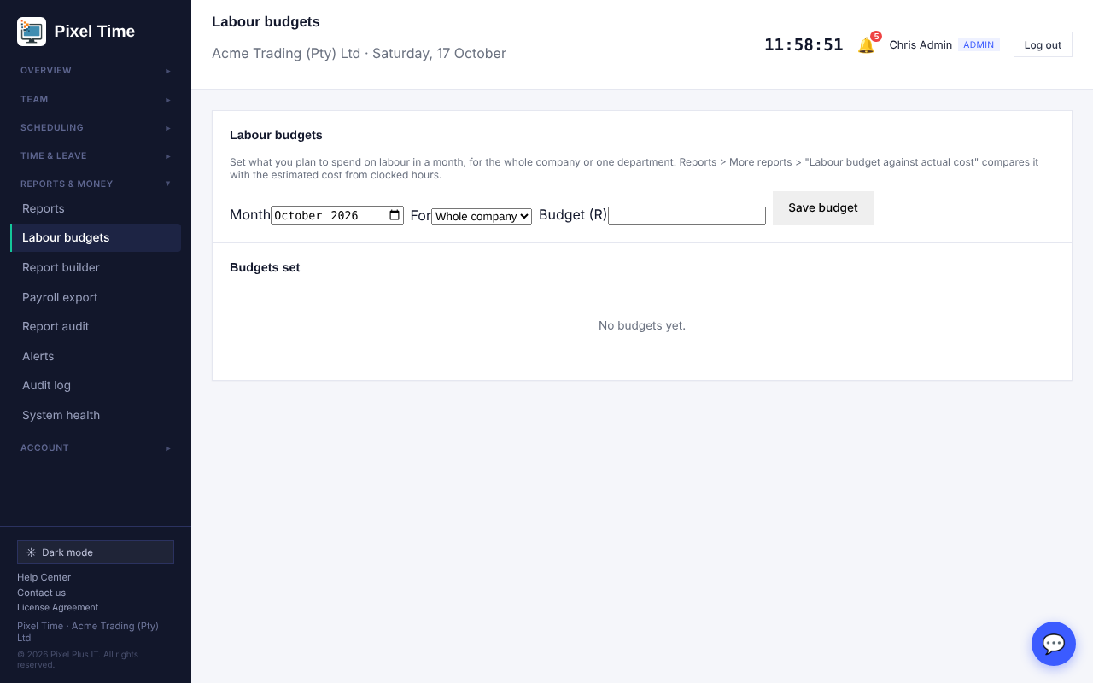
Labour budgets: one amount per month for the company or a department.
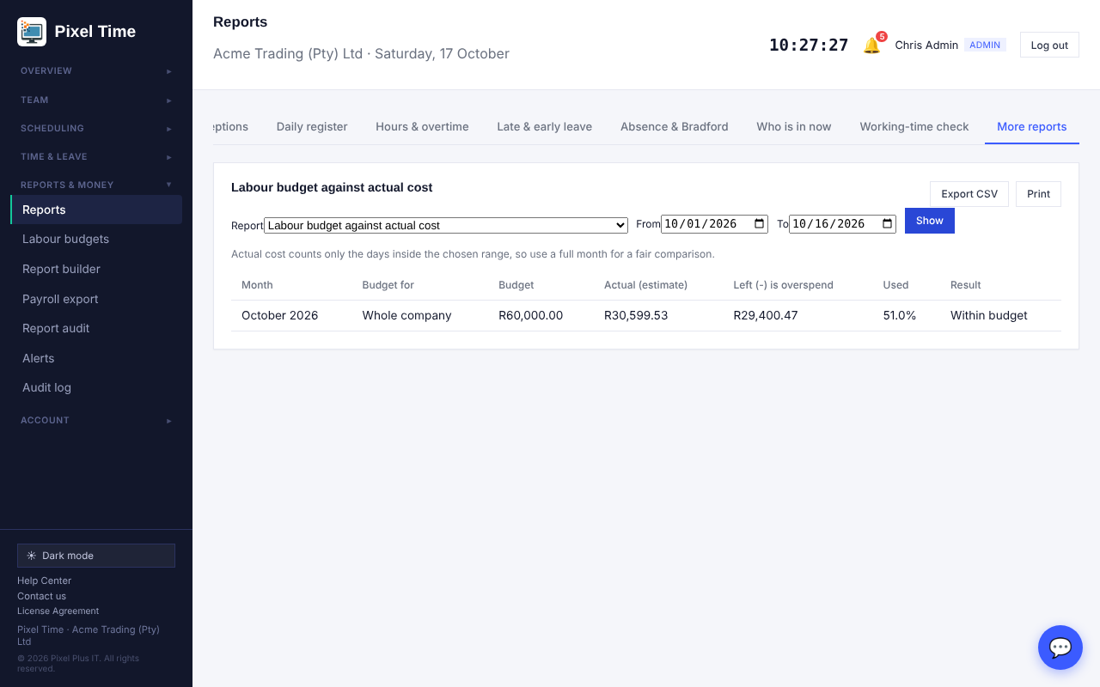
Budget against actual: what is left, the share used, and whether you are over.

14. Reconciliation, data retention and searching results
Who: administrators and auditors. Managers can use the hours reconciliation for their own department. Where: Reports > More reports, group "Reconciliation".

Employee hours reconciliation
- Open Reports > More reports and choose Employee hours reconciliation.
- Choose the same dates you will use for the payroll export, then press Show.
- Read the Check column. "Agrees" means the clocked hours, payroll hours and last export match with nothing outstanding.
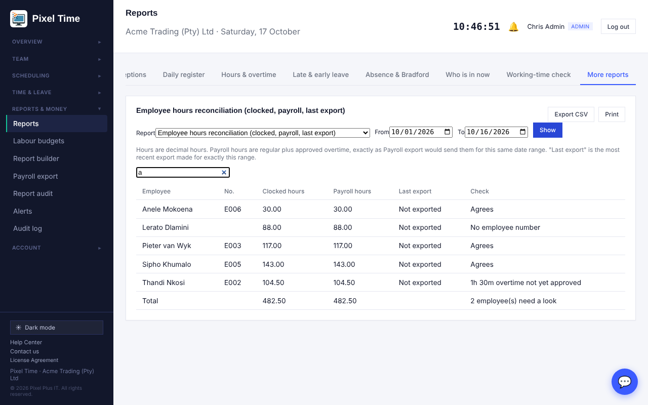
Hours reconciliation: clocked hours, payroll hours, the last export, and what needs a look.
- It flags days missing a clocking, overtime not yet approved, pending adjustments, a missing employee number, and hours that changed after the export.
- The Last export column only fills in when an export was made for exactly the same dates.

Data retention review
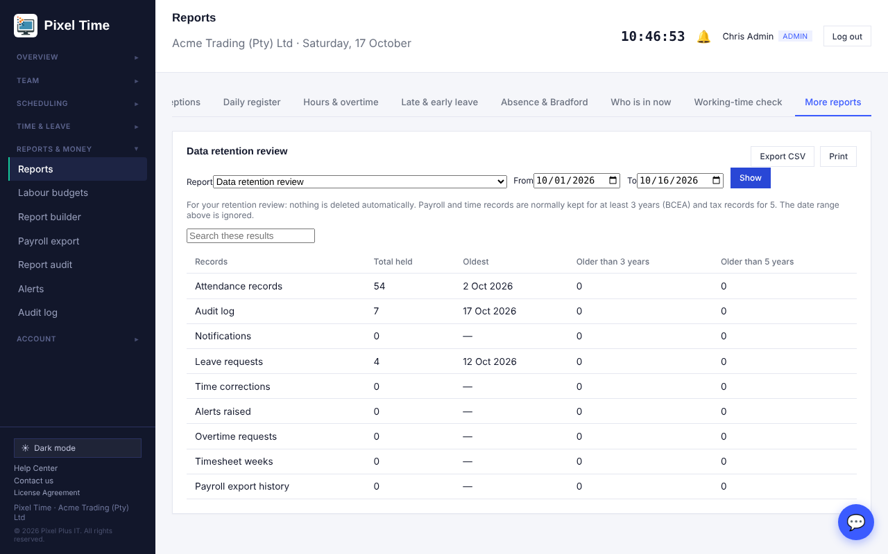
Data retention review: how much is held, the oldest record, and how much is older than 3 and 5 years.
- Nothing is deleted automatically. Use this to decide what to archive or remove. Payroll and time records are normally kept at least 3 years, tax records 5.

Search inside results
- Any report with more than five rows shows a Search box above the table. Type part of a name or value and only matching rows stay visible. Clear the box to see everything again.

15. Working-time rules
Who: administrators set rules; managers (own department) and auditors can look. Where: Scheduling > Working-time rules. Reports are under Reports > More reports, group "Working-time rules".

Rule sets
- Open Working-time rules and fill in New rule set. Anything you leave empty uses your company settings.
- Overtime after: the hours per day before overtime starts. Weekly hours limit: used by the weekly limit report.
- Meal interval: how many hours a person must work before a meal interval is required, and how long it is. Tick "Deduct automatically" to remove the missing time from paid hours when nobody took it.
- Flexi-time: tick it, set the daily target and (optionally) the core hours people must be in.
- Bargaining council or agreement: record which agreement the rules come from, and its reference.
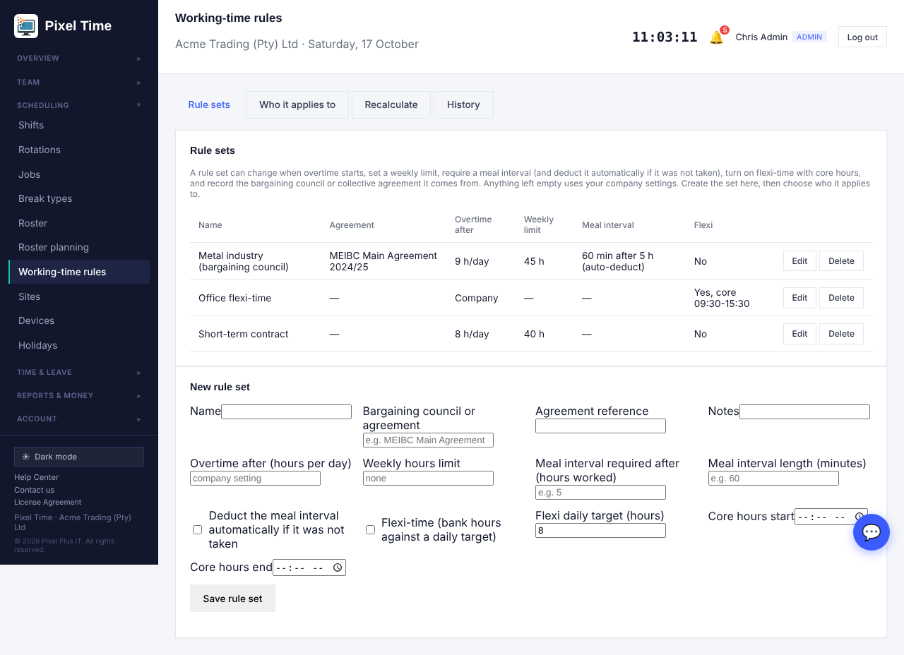
Rule sets and the form to create or edit one.

Who it applies to
- Open the Who it applies to tab, choose the rule set, who it is for (a person, a contract type, a department or everyone) and the date it starts, then press Assign.
- The most specific rule in force on the day wins: employee, then contract type, then department, then the whole company.
- Because each assignment has a start date, earlier days keep the rule that applied then. Assign a new rule from a later date to change things going forward.
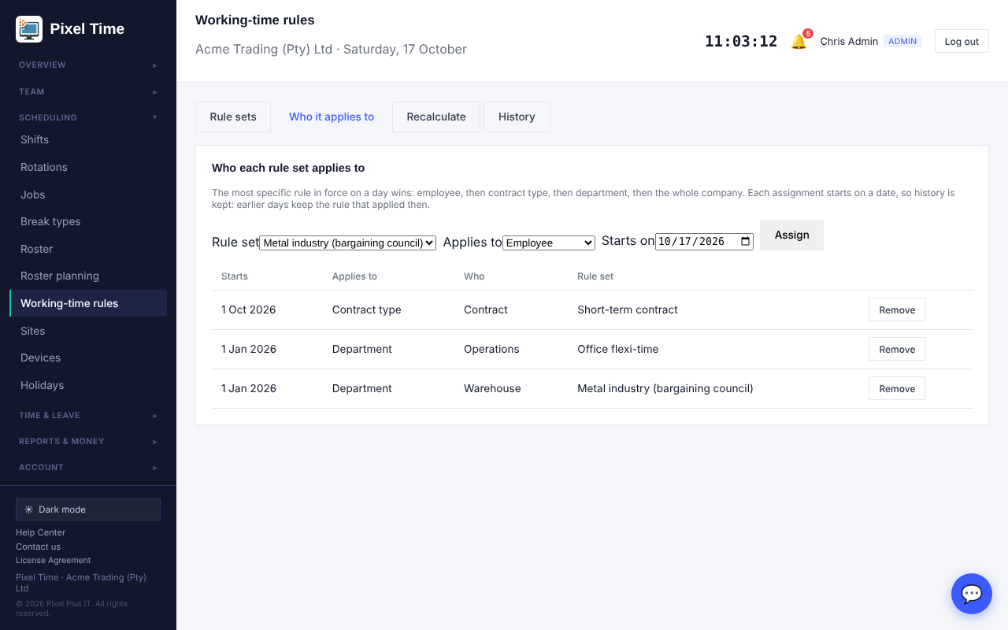
Assignments, newest first. Remove one with the Remove button.

Recalculate
- Open the Recalculate tab. Choose the dates (up to 62 days) and, if you like, one employee.
- Press Recalculate. Hours, overtime and meal deductions are worked out again from the raw clockings under today's rules.
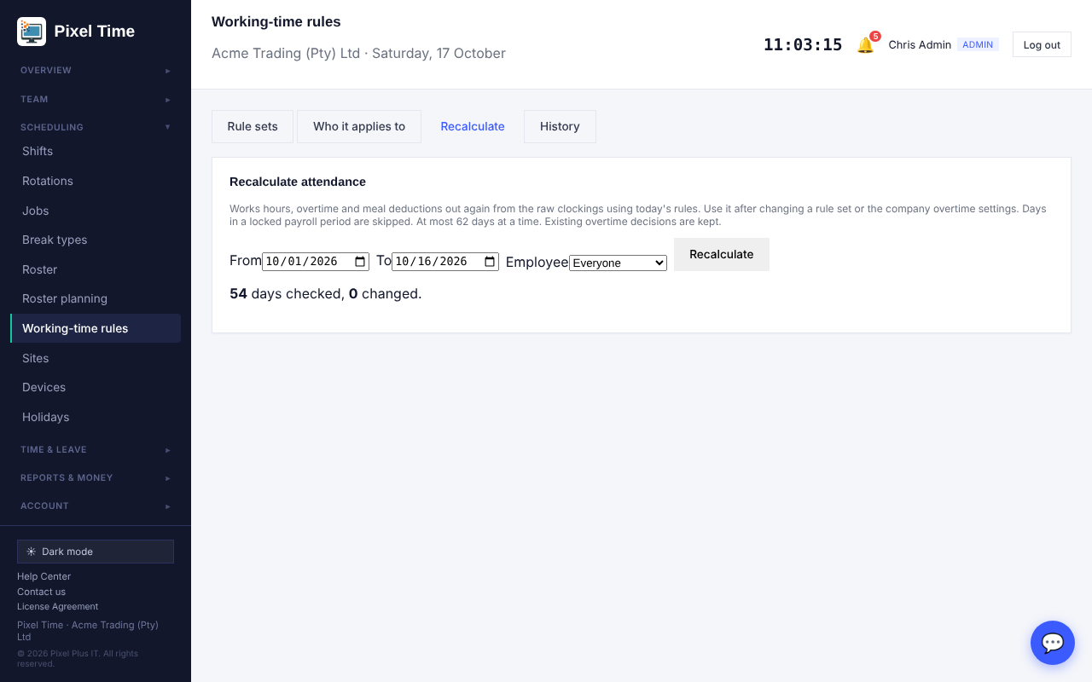
The result says how many days were checked and changed, and lists each change.
- Days inside a locked payroll period are skipped. Overtime decisions already made are kept.
- Recalculate after you change a rule set, or assign one that starts in the past.

History
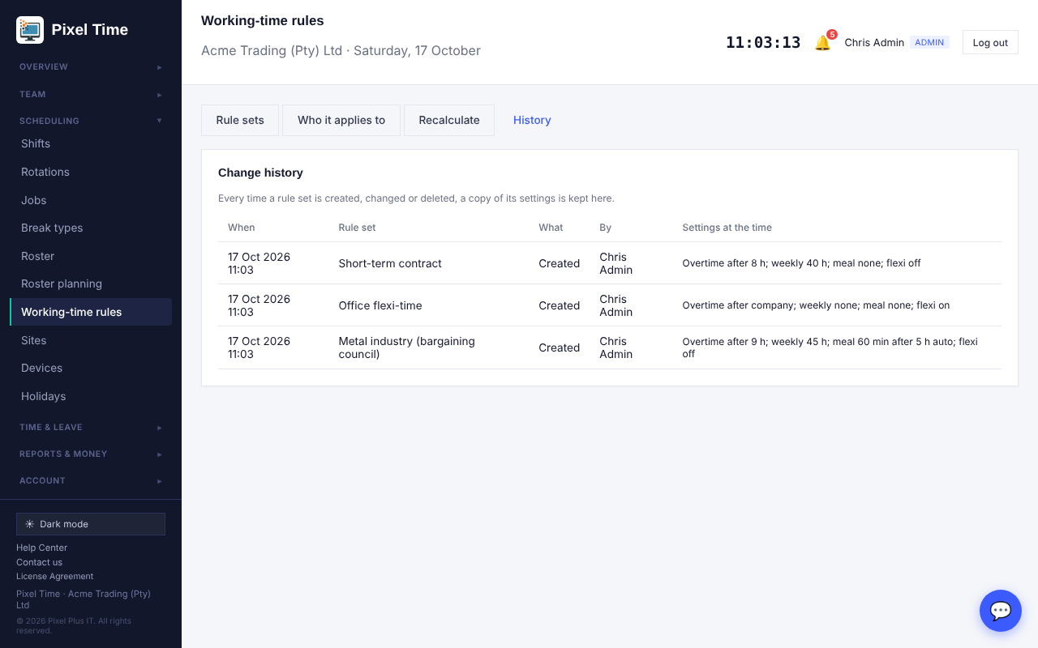
Every time a rule set is created, changed or deleted, its settings are kept with who did it and when.

Reports
- Working-time rule in force for each employee: which rule applies to each person, and why.
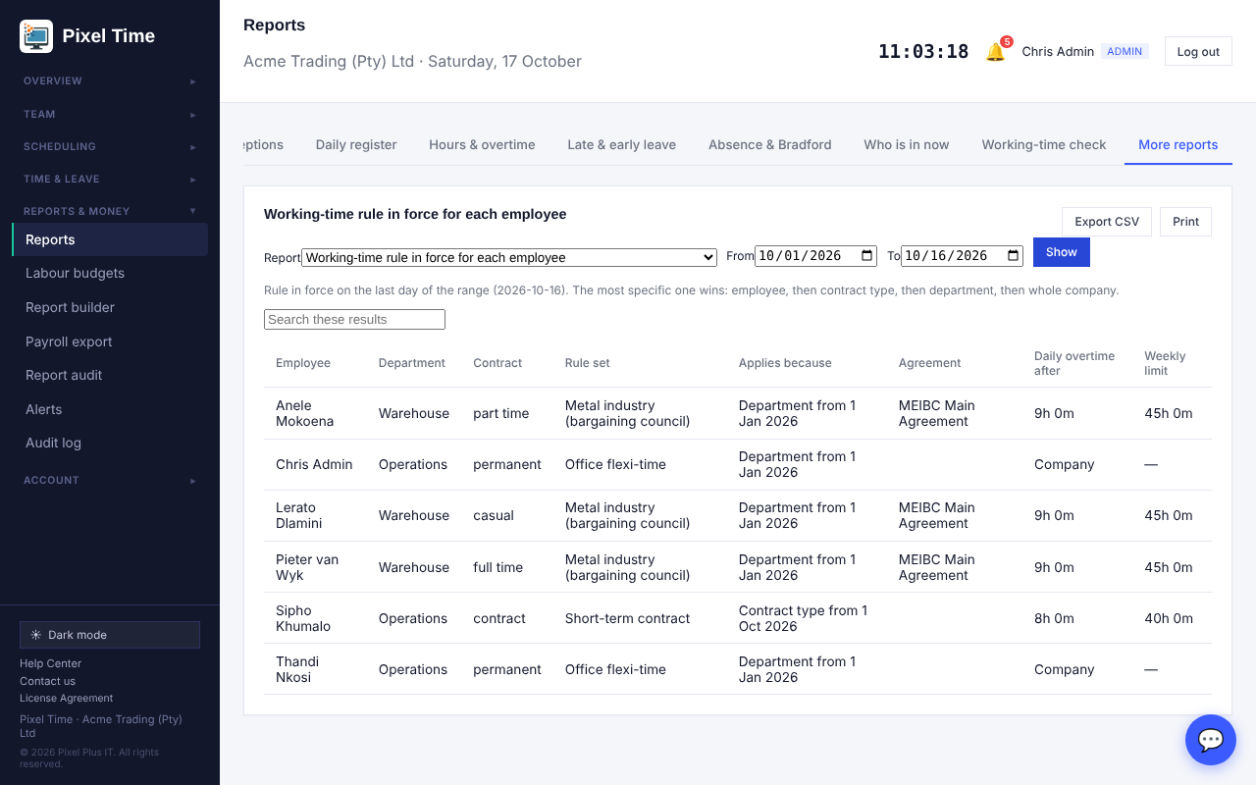
The rule each employee works under, and where it comes from.
- Flexi-time balance and core-hours check: hours banked or owed against the daily target, and days outside core hours.
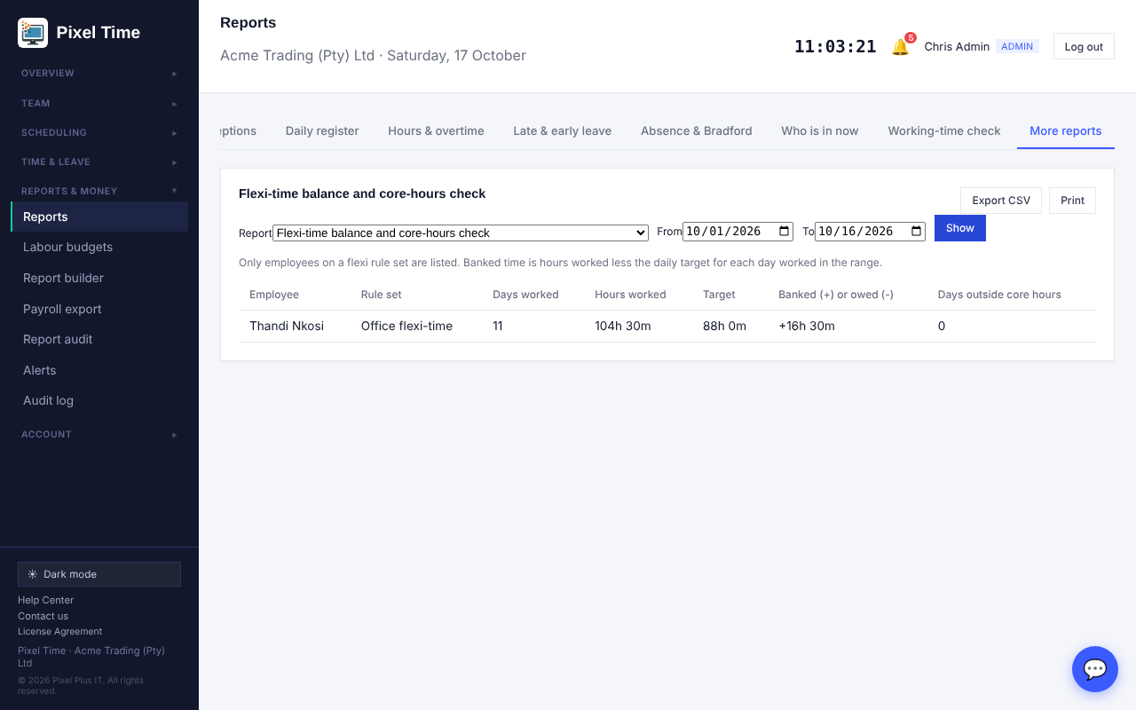
Flexi balance per employee.
- Meal interval compliance: days someone worked past the limit without taking the full meal interval.
- Weekly hours against each rule's limit: weeks over or near the limit.

16. System health, retention and new alerts
Who: administrators and auditors can look; only administrators change settings or remove records. Where: Reports & money > System health.

System health
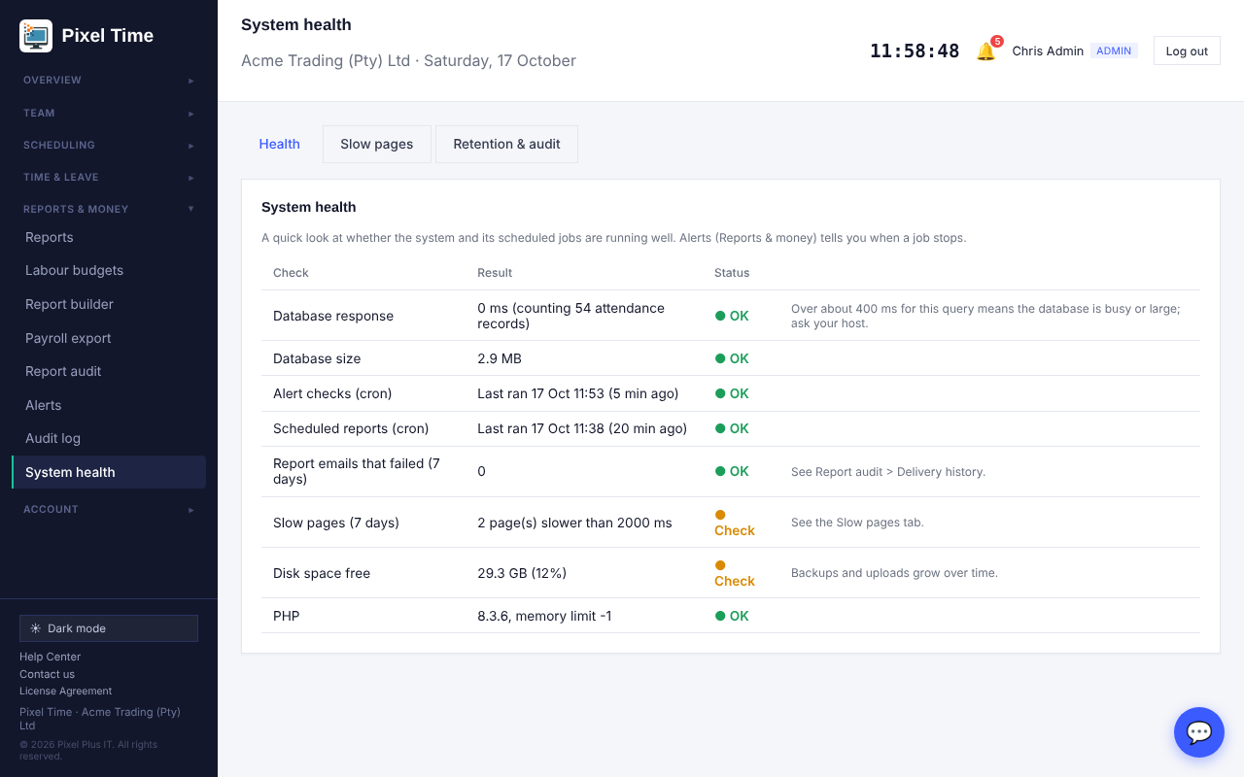
Health: your records, whether the automatic checks are running, quiet devices, failed emails and slow pages. Only your own company is shown.
- Automatic alert checks and Scheduled reports show when each last ran. If one stops, the Alerts page raises "Scheduled job not running" so you find out.
- These run by themselves. If one stays red, contact Pixel Plus support.

Slow pages
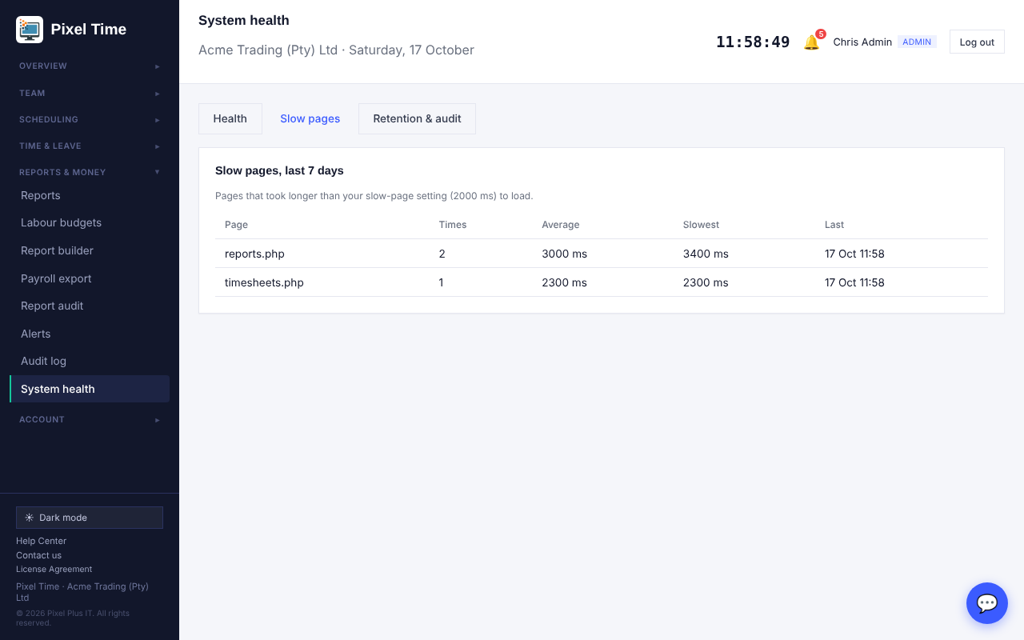
Pages that took longer than your slow-page limit, with how often and how slow.

Retention and audit
- Open the Retention & audit tab.
- Set how many months to keep audit-log entries (12 to 240), how many days to keep read notifications, and what counts as a slow page. Press Save.
- The table shows how many records are past their retention. Press Remove them now only when you are sure; it cannot be undone and the removal is written to the audit log.
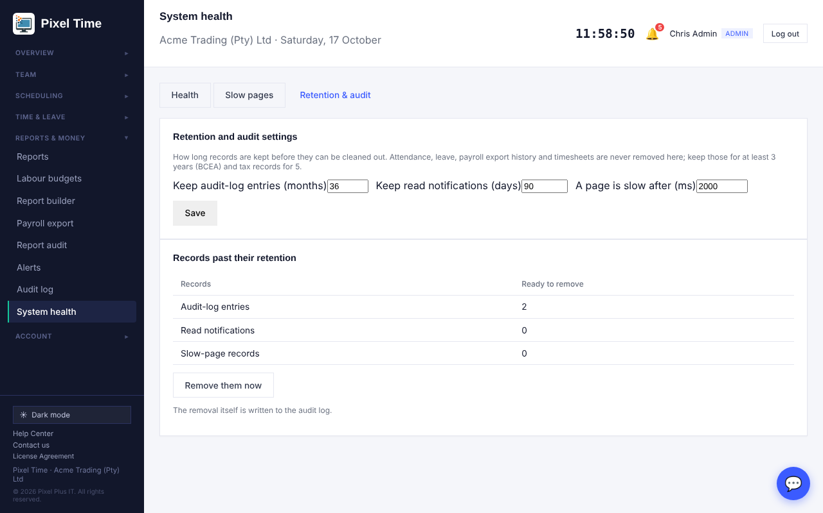
Retention settings and what is ready to remove.
- Only audit-log entries, read notifications and slow-page records can be removed here. Attendance, leave, timesheets and payroll history are never removed.

New alerts
- Weekly hours near the limit: tells managers when someone has reached 90% (you can change this) of their weekly limit. The limit comes from their working-time rule, or 45 hours if they have none.
- Scheduled job not running: tells administrators when the alert checks or the scheduled reports have stopped.

Labour budgets page
Labour budgets (Reports & money): set the monthly amount for the company or a department.

17. ID cards (RFID) and email retry
Who: administrators and managers register cards (managers for their own department). Where: Team > ID cards. Employees use their card at the kiosk.

Register a card
- Open ID cards. Choose the employee.
- Click in Card number and scan the card with a USB card reader (it types the number and presses Enter), or type the number printed on the card.
- Press Register card. Each person can have up to 3 active cards.
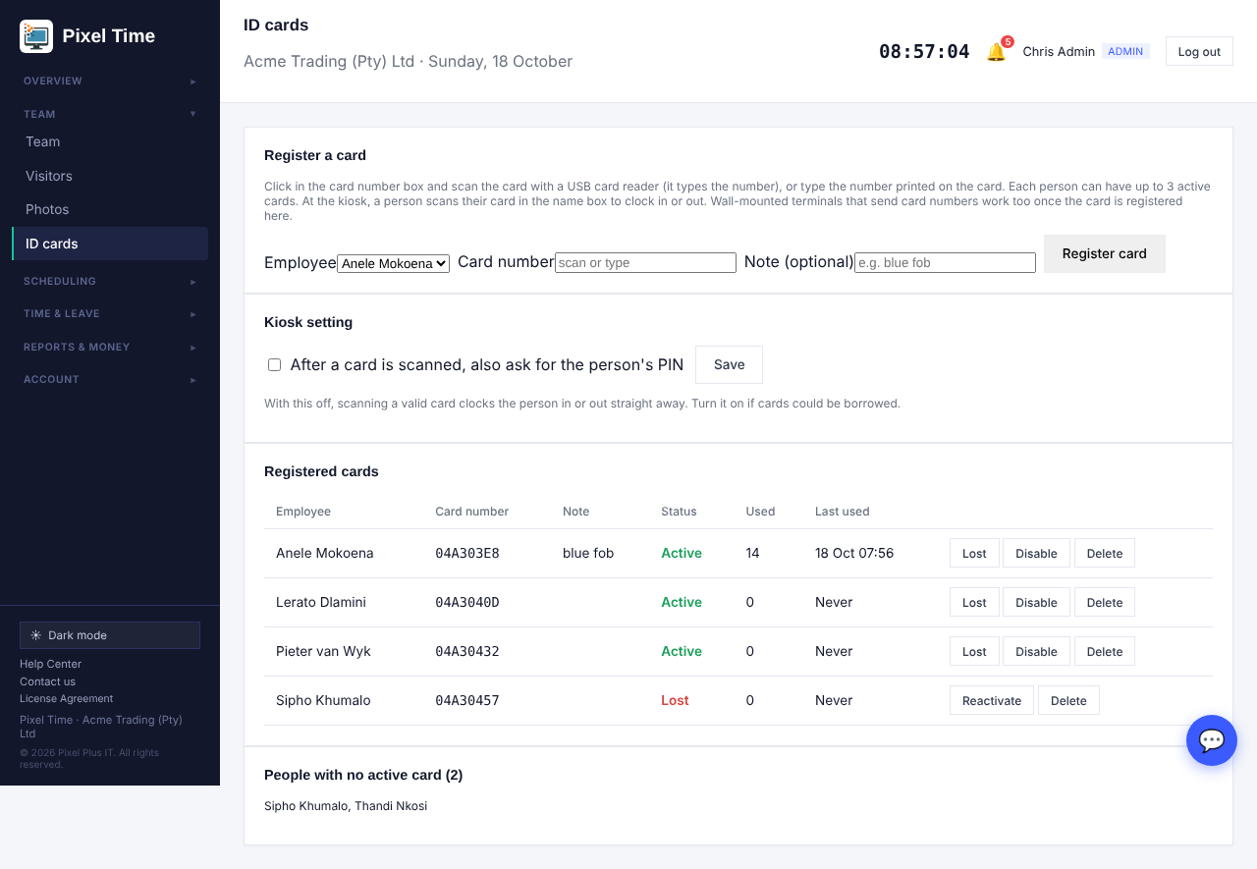
ID cards: register cards, see who has which, mark lost or disabled, and who has no card yet.
- Lost and Disable switch a card off straight away without deleting its history. Reactivate switches it back on. Only administrators can delete a card.
- A card number can belong to one person only. If a card is reissued, delete the old entry first.

Clocking with a card at the kiosk
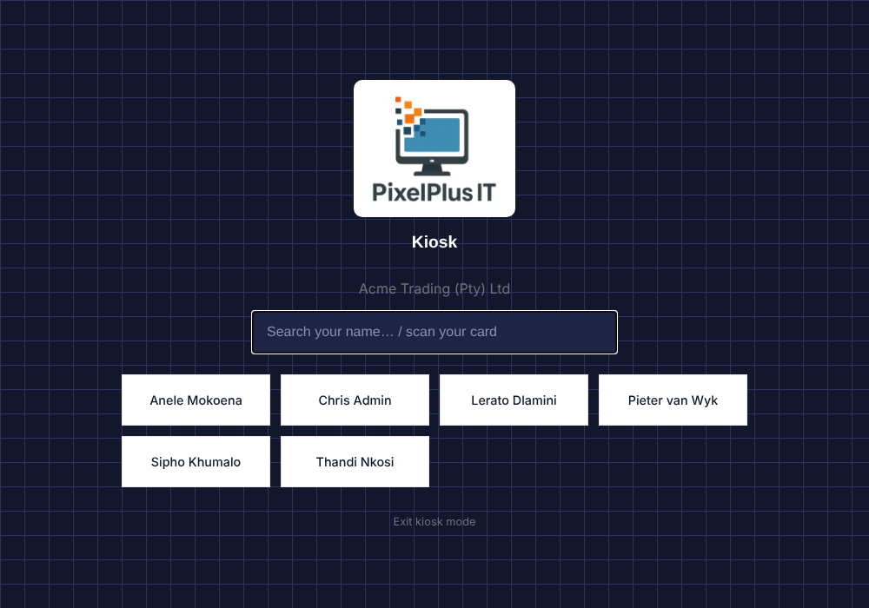
The kiosk name box also accepts a card scan.
- At the kiosk, scan the card. (If the cursor is not in the name box, tap it first.)
- The kiosk clocks the person in, out or on and off a break, exactly as it does after a PIN.
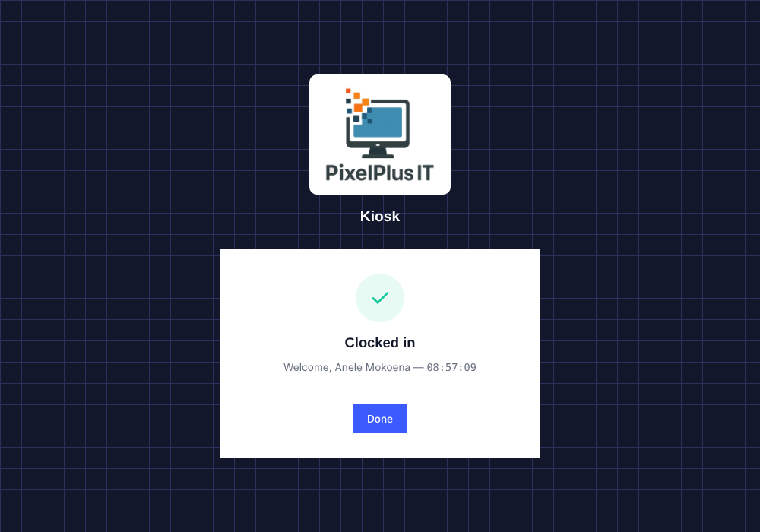
The kiosk confirms who clocked in.
- A lost, disabled or unregistered card shows "Card not recognised".
- If cards could be borrowed, tick "After a card is scanned, also ask for the person's PIN" on the ID cards page.
- Wall-mounted terminals (ZKTeco and similar) that send the card number work once the card is registered here.

Failed report emails are retried
- If a scheduled report email fails, the system tries again every 30 minutes or more, up to 3 more times, for 24 hours.
- Report audit > Delivery history then shows "Sent on retry 1/2/3". After the last try it stays Failed and the alert remains.
- This happens automatically on the hour.

18. Mappings, audit events and settings history
Who: administrators change; auditors can view. Where: Reports & money > Mappings & history.

Payroll mapping
- Open the Payroll mapping tab.
- Type the code your payroll system uses for each department (cost centre), each leave type (leave code) and each contract type (category). Leave a row blank if it is not needed.
- Press Save under each block.
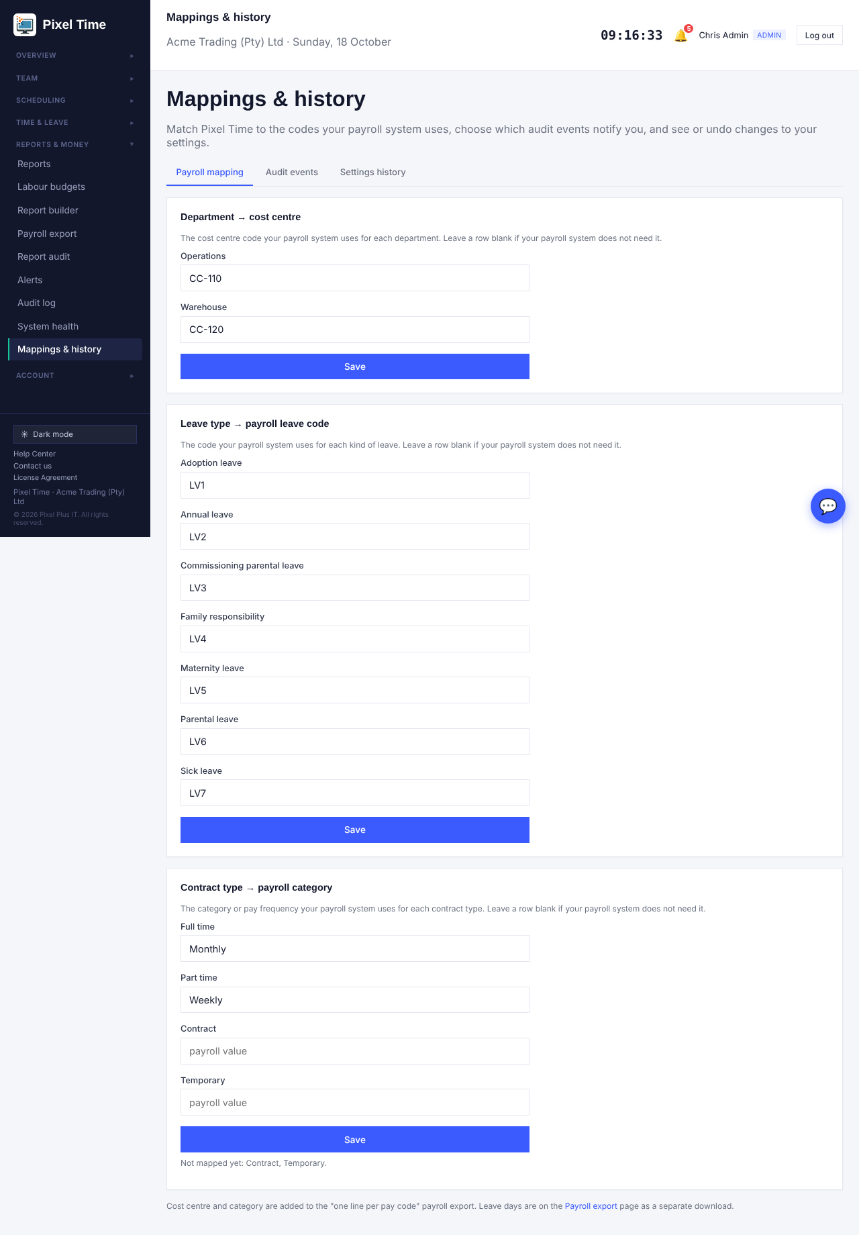
Payroll mapping: cost centres, leave codes and contract categories.
- Cost centre and category are added as two extra columns to the "one line per pay code" payroll export once any department or contract mapping exists.
- On Payroll export > Pay codes there is a download of approved leave days in the period, with each leave type's payroll code. Leave that spans the period boundary is counted only for the days inside the period.
- Two leave types cannot share one payroll leave code.

Audit events
- Open the Audit events tab.
- Tick Tell me for the kinds of event you want an alert about. Administrators get the alert within 15 minutes.
- Optionally enter a shorter keep time (6 months or more) for the less sensitive kinds.
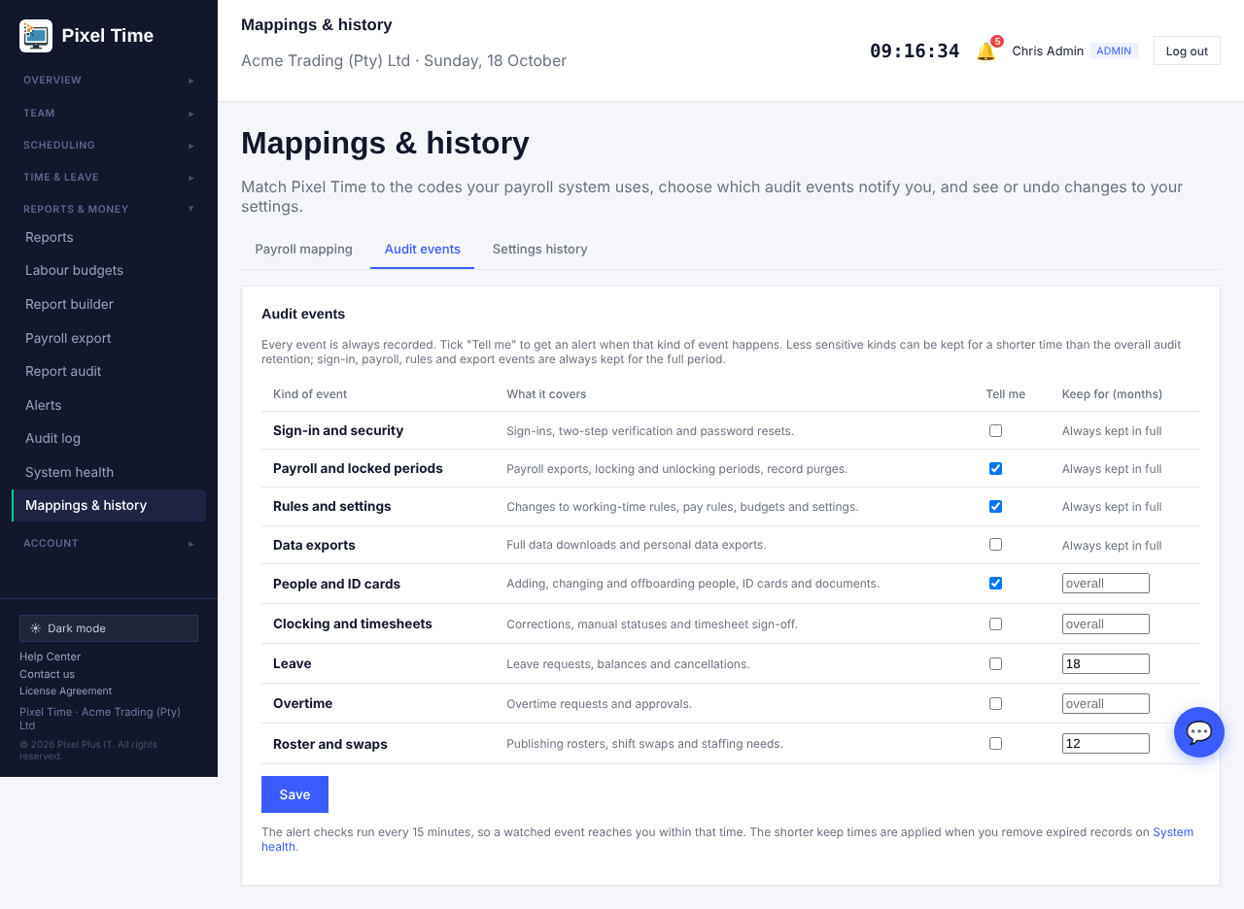
Audit events: which kinds to be told about, and how long the less sensitive ones are kept.
- Every event is always recorded. Sign-in, payroll, rules and export events are always kept for the full audit retention and cannot be shortened.
- Shorter keep times are applied when you remove expired records on System health > Retention & audit, which lists them separately.

Settings history
- Open the Settings history tab. Each change to company settings, pay codes, payroll mapping or audit-event settings is a numbered version with who and what.
- Choose Restore on a version. The page lists exactly what would change.
- Press Restore this version to put those settings back. The restore itself is recorded as a new version and in the audit log.
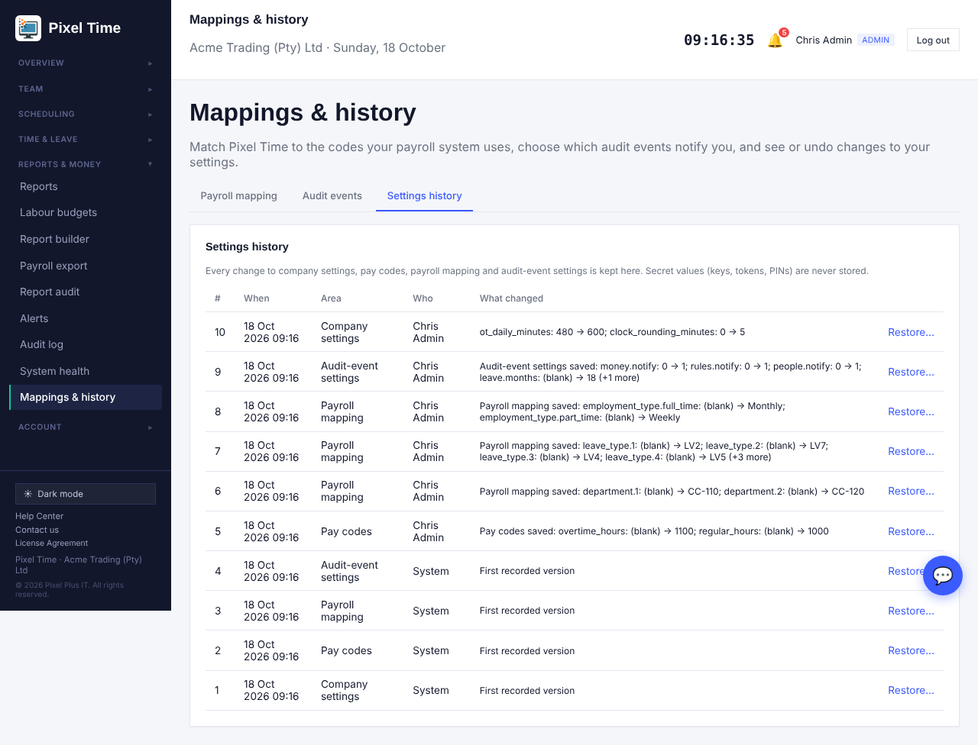
Settings history: every change with who, when and what.
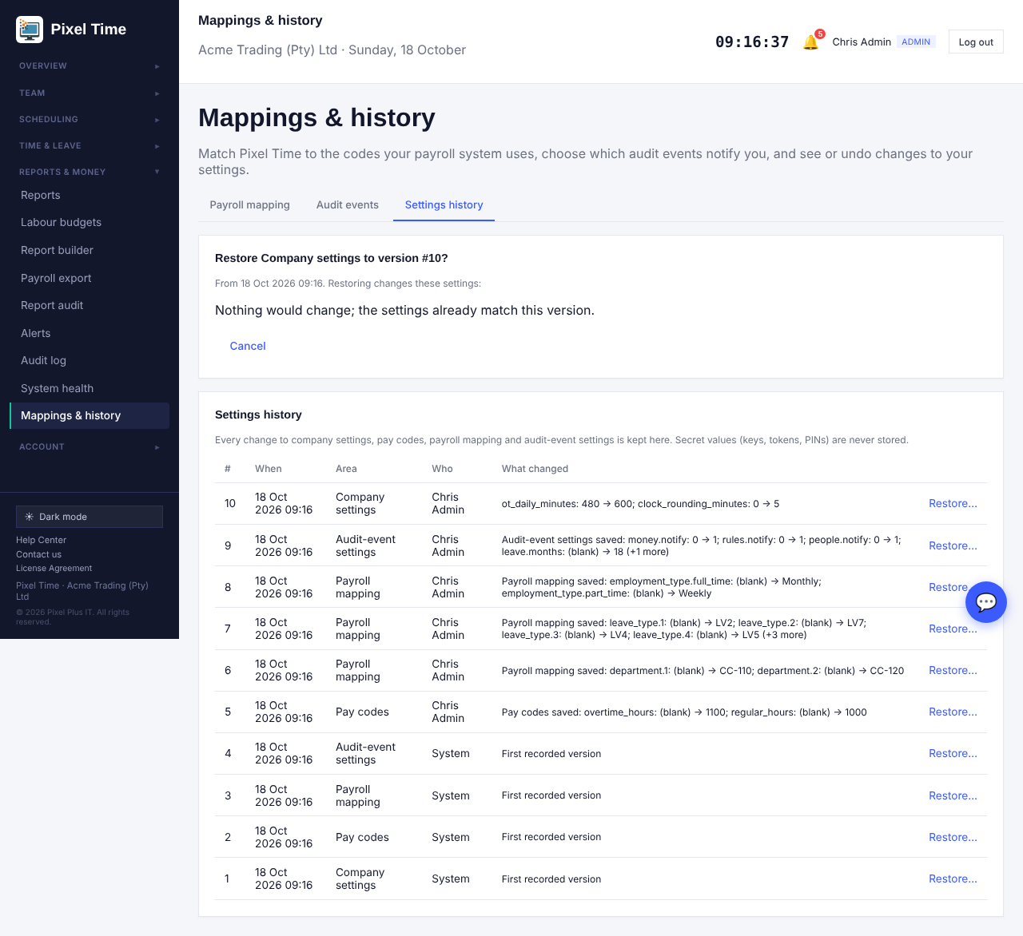
Restore shows what will change before anything is touched.
- Keys, tokens, PINs and passwords are never stored in the history.
- Changes are noticed the next time an administrator opens any page, so the history shows the person who made the change.

Security incident report
- Reports > More reports > Audit & security > Security incident report (administrators and auditors) lists resets, unlocked periods, exports, removed records, restored settings, kiosk PIN locks and hand-overs in the dates, marked High or Medium, plus accounts locked right now.

Kiosk wrong-PIN limit
- After 5 wrong PINs within 15 minutes a person is locked at the kiosk for the rest of the 15 minutes; the lock is written to the audit log. The kiosk unlock and exit PINs lock the device the same way.

19. Excel downloads, document expiry and payable hours
Who: administrators and managers (auditors can view). Where: Reports, Payroll export, Team > Document expiry.

Download as Excel
- On Reports (including More reports) press Export Excel next to Export CSV.
- On Payroll export press Download Excel instead of Download CSV. The same checks apply: blocked exports and the "already exported" reason still work.
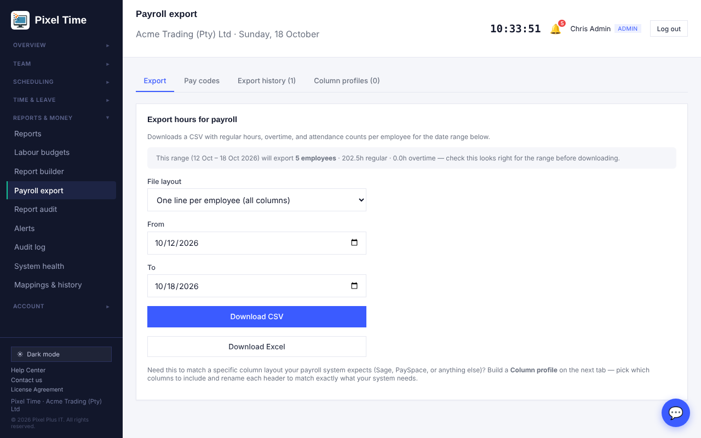
Payroll export: Download CSV or Download Excel.
- You get a real .xlsx file: bold header row, filter buttons, frozen header and sensible column widths.
- Employee numbers and pay codes stay as text, so 007 keeps its zeros. Hours are real numbers you can add up.

Document expiry
- Upload the document on the employee's profile as before.
- Open Team > Document expiry, find the document and choose the expiry date, then Save.
- Use the tabs to see what is expired, expiring soon or still without a date.
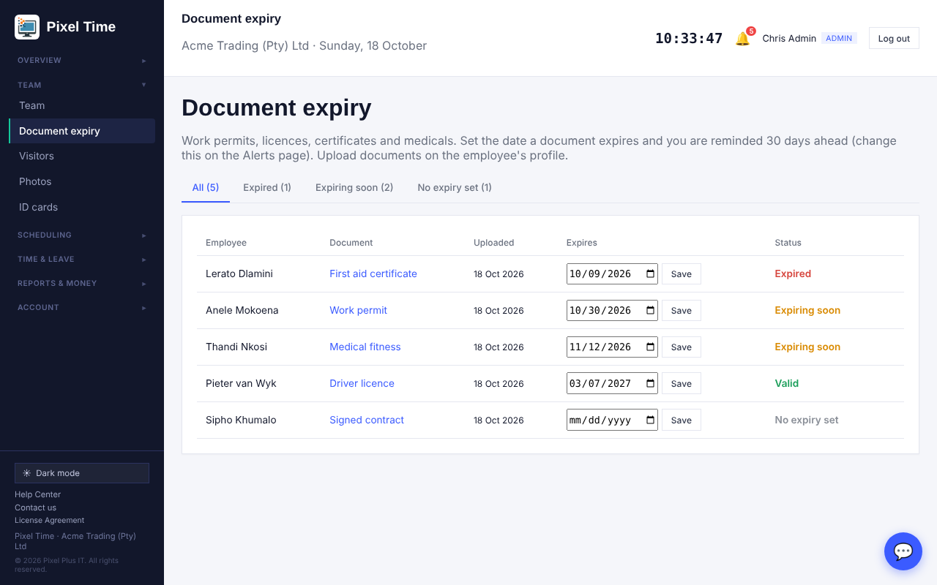
Document expiry: every document with its date and status.
- You are alerted 30 days ahead, and again if it has expired. Change the days on the Alerts page (Employee document expiring). Managers only see their own department.
- Reports > More reports > Management > Employee documents: expiry gives the same list for printing.

Actual hours and payable hours
- Reports > More reports > Reconciliation > Actual hours and payable hours separates what the clock recorded from what is payable (clocked time plus approved manual adjustments), with approved overtime and overtime still awaiting approval shown separately.
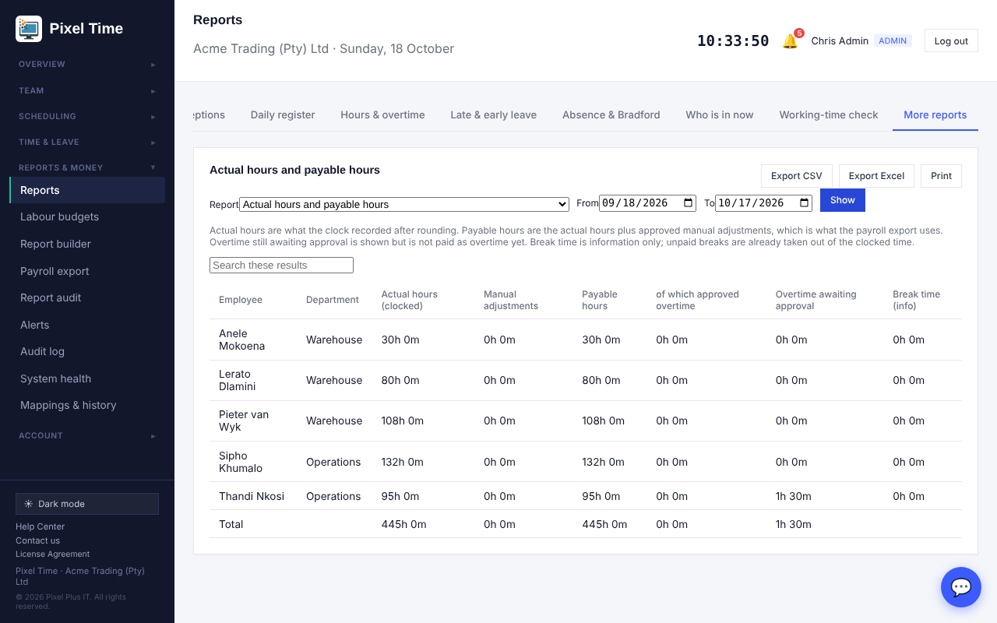
Actual hours, adjustments and payable hours for each employee.

Declining overtime
- Declining an overtime request now needs a reason. It is shown to the employee and kept in the history.

20. PDF reports, sign-in and device history, offline clocking, leave value
Who: administrators and managers unless stated. Where: Reports > More reports, and the Clock page.

Download as PDF
- Open any report, including More reports, and press Export PDF beside Export CSV and Export Excel.
- You get a landscape A4 document with the title, company, dates, a header row repeated on every page and page numbers.

Failed sign-in history
- Reports > More reports > Audit & security > Failed sign-in history (administrators and auditors).
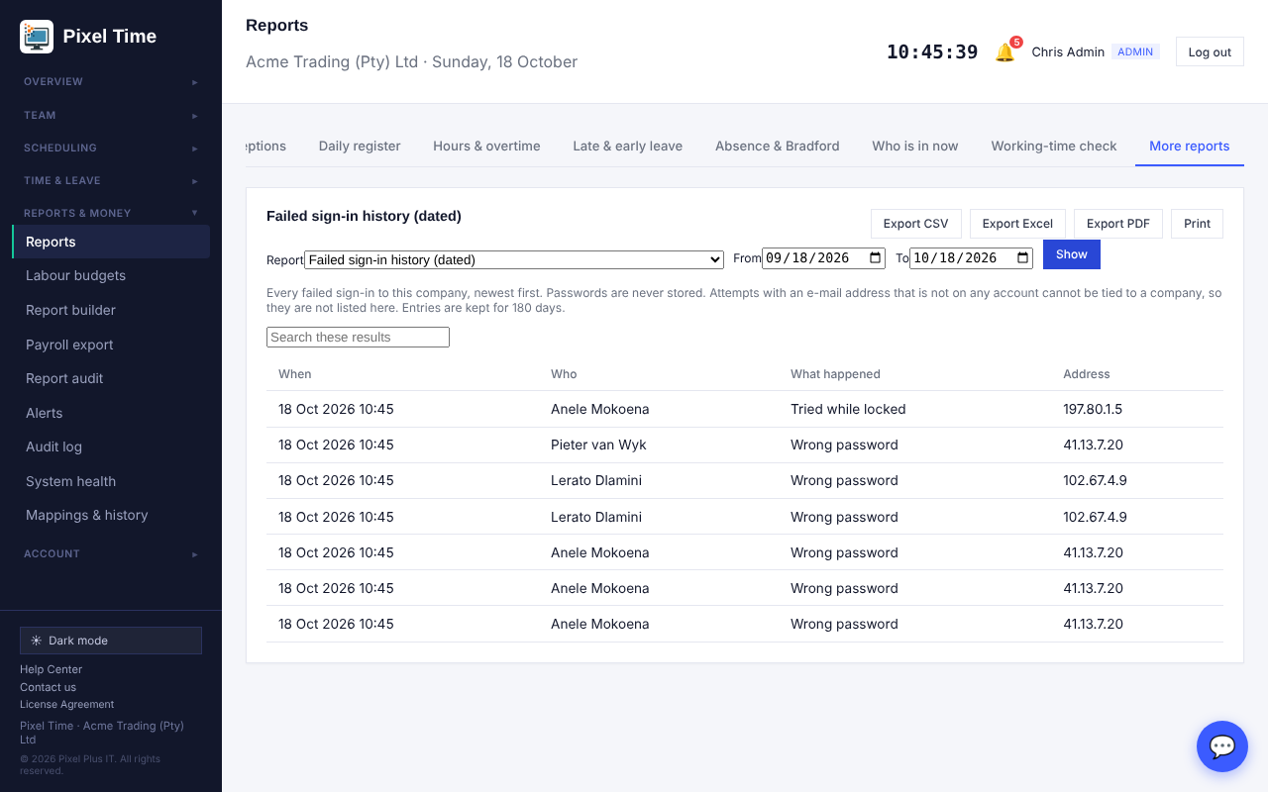
Failed sign-ins: wrong password, unknown e-mail, locked account, with the address.
- Unknown e-mail addresses are partly hidden. You are alerted when ten failures come from one address, or five for one person, within an hour (Alerts page: Repeated failed sign-ins).

Device reports
- Device synchronisation and failures shows when each device last made contact and how many punches were received, skipped, rejected or from an unknown Device ID.
- Attendance by device and Device failures show the same detail per punch.
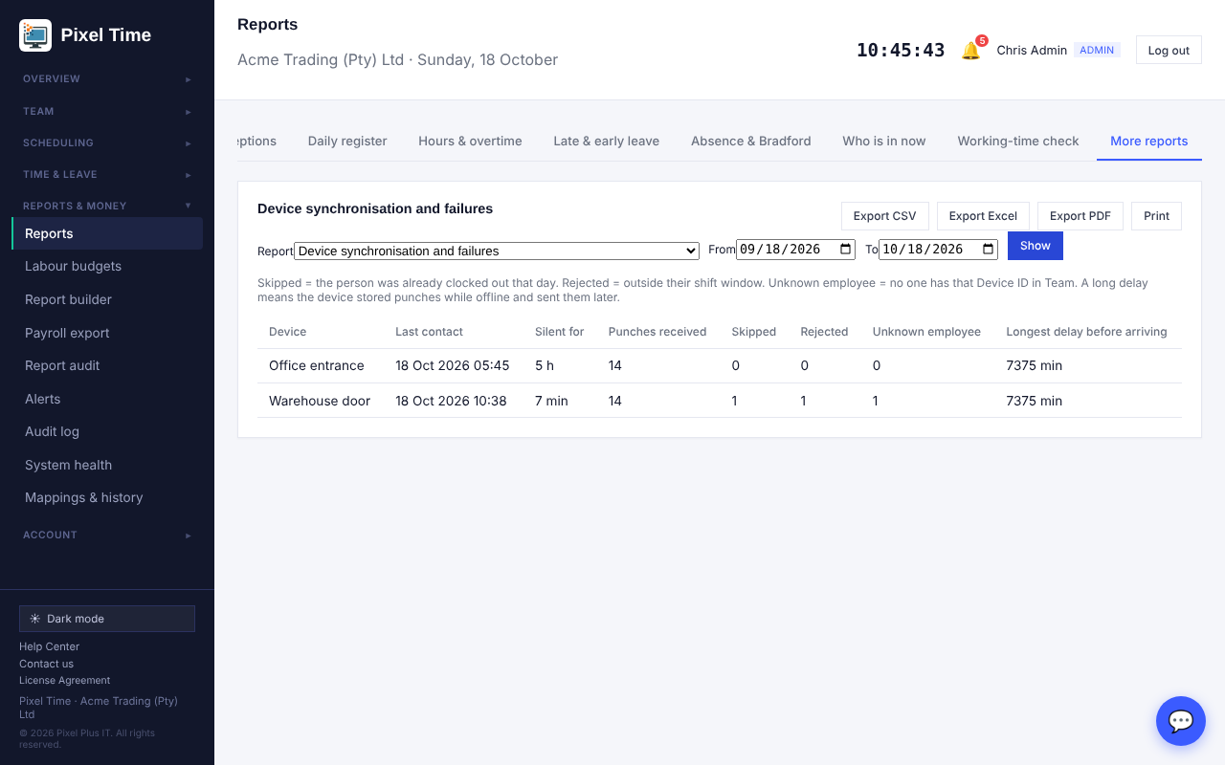
Each device: last contact, punches, skipped, rejected and unknown employees.
- Device records start from the day this update is uploaded. Earlier punches are not tagged with a device.

Offline clocking
- Open the Clock page while you still have a signal and leave it open.
- If the signal drops, press the button as normal. The punch is saved on the phone with the time you pressed it.
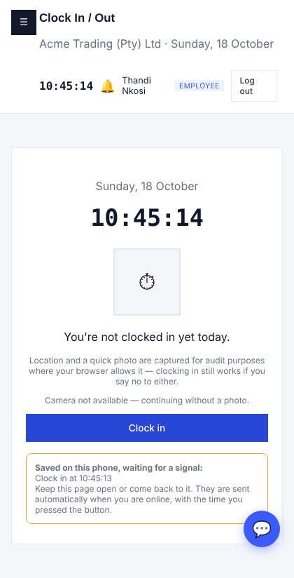
Saved on this phone, waiting for a signal.
- When the phone is back online the punch is sent by itself and the page refreshes.
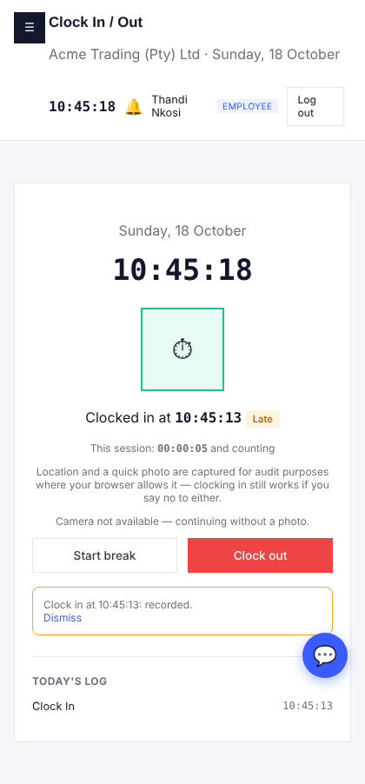
Synced: the punch is recorded at the time it was pressed.
- The server checks every punch again (locked periods, order, shift window, location). Punches older than 48 hours are refused. The phone clock is corrected if it is wrong.
- The page must already have been open before the signal was lost. If the phone is switched off, or the browser data is cleared, a waiting punch can be lost.
- Reports > More reports > Audit & security > Offline clockings lists each one with the delay and result.
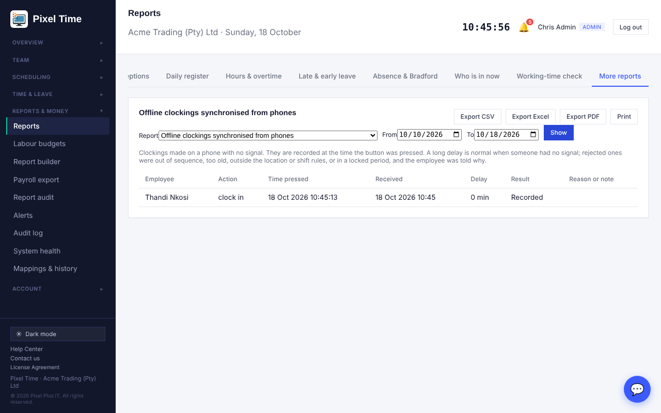
Offline clockings: time pressed, time received, delay and result.

More reports
- Clock sessions: each in-and-out pair, breaks and time between.
- Approver activity: leave, corrections and overtime each manager approved or declined, and how long overtime waited.
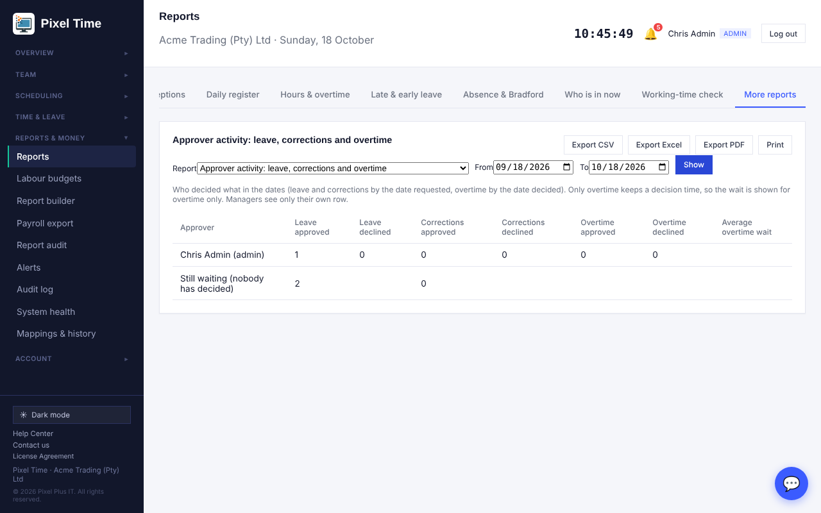
Approver activity.
- Leave liability now shows the Rand value (days owed x hourly rate x 8-hour day). Employees without a rate are flagged. Leave ledger shows every movement behind a balance.
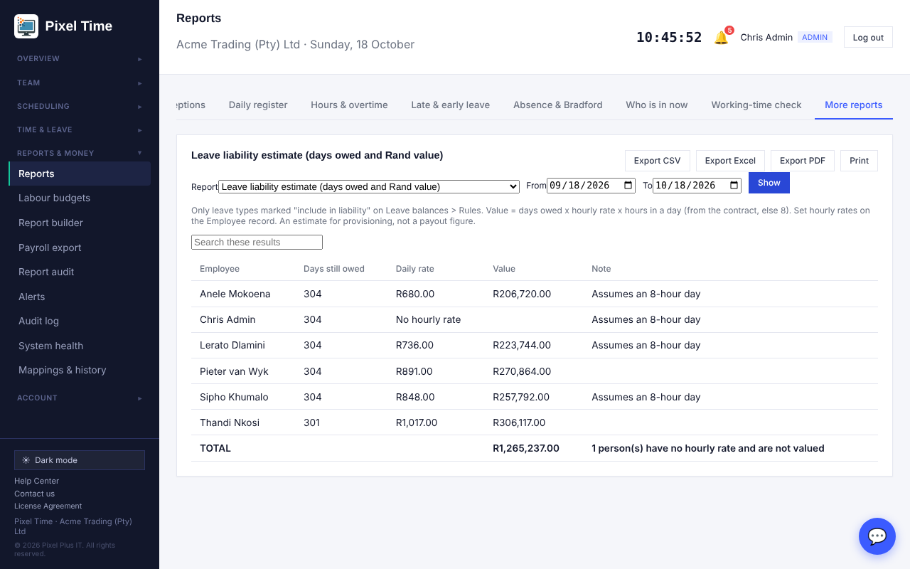
Leave liability in Rand.

21. Approval rules, hours of leave and allowances
Who: administrators set these up (auditors can view). Where: Reports & money > Approval rules.

Roster changes that need approval
- Open Approval rules and tick that a manager's roster changes wait for an administrator, then Save.
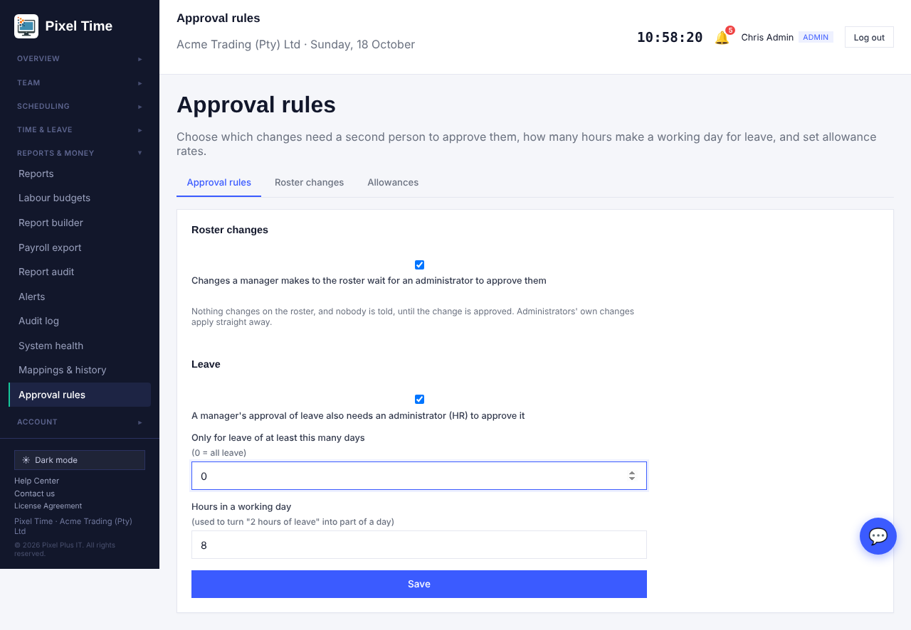
Approval rules: roster approval, second leave approval and the length of a working day.
- When a manager saves the roster they are told the changes were sent for approval. Nothing changes on the roster yet.
- Open the Roster changes tab. Each waiting change shows the day, the employee, what they have now and what is proposed.
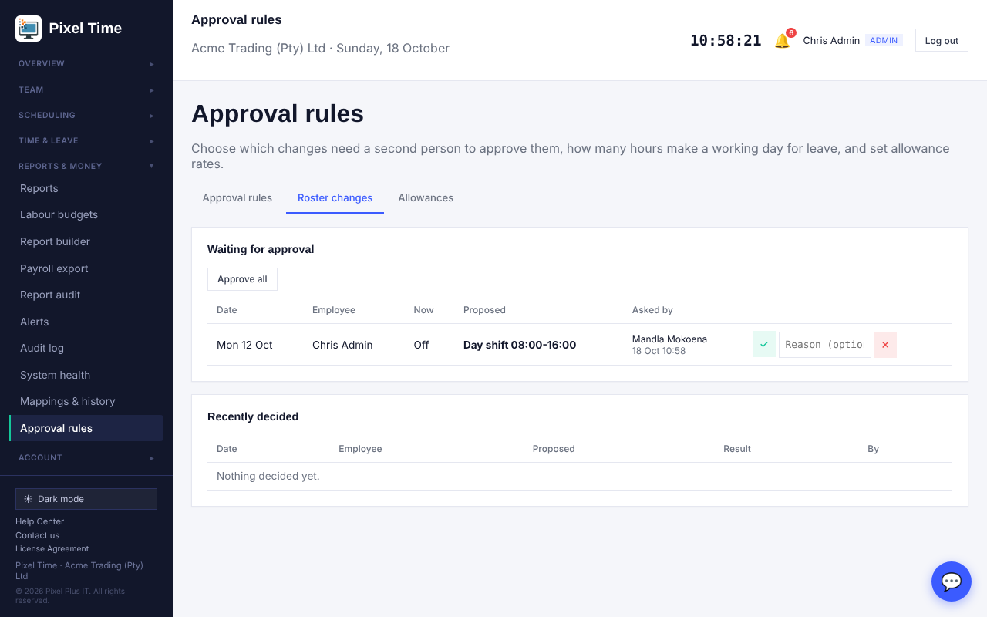
Roster changes waiting for an administrator.
- Approve or decline each one, or choose Approve all. The employee is told only when a change is approved.
- Administrators' own changes apply straight away. A newer proposal for the same person and day replaces the waiting one. Every step is in the audit log.

Second approval for leave
- In Approval rules tick that a manager's approval of leave also needs an administrator (HR). Choose from how many days it applies; 0 means all leave.
- When the manager approves, the request shows Waiting for second approval and administrators are notified.
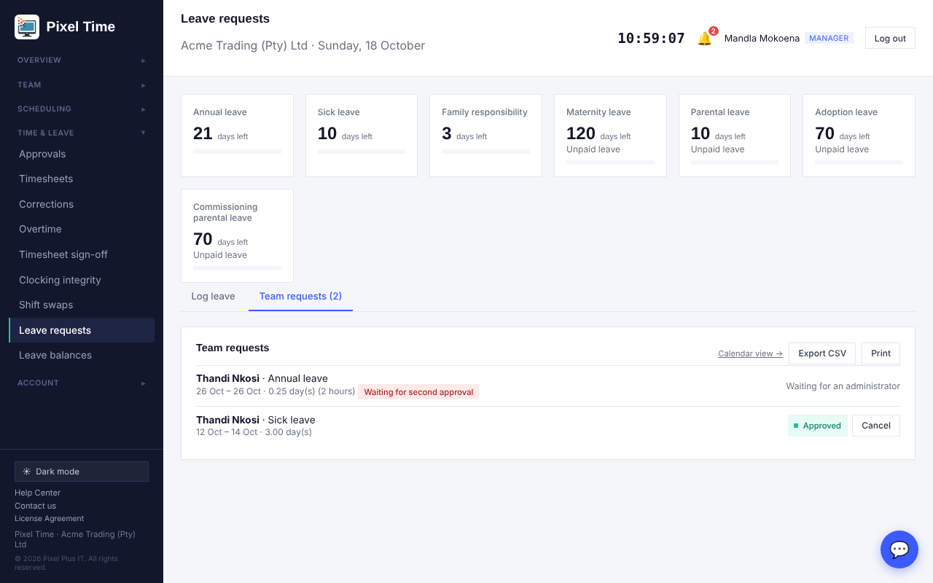
The manager has approved; an administrator must approve too.
- The administrator approves or declines on the Leave page. Balances change only at the final approval.

Leave for a few hours
- On the Leave page choose the same start and end date and type the hours, for example 2.
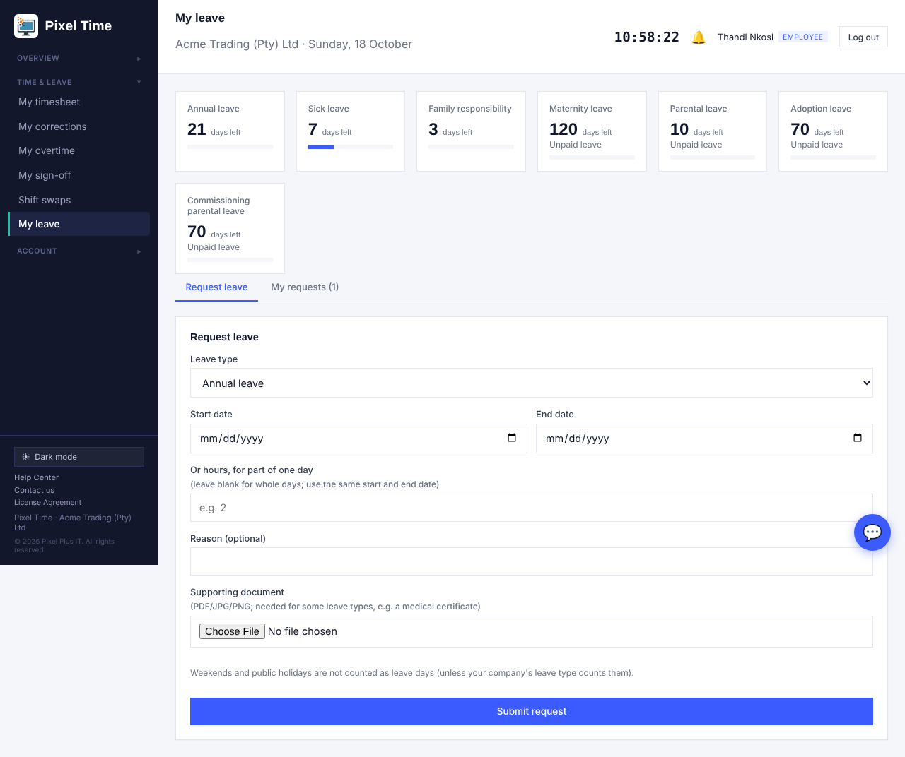
Request leave: use the hours box for part of one day.
- Hours become part of a day using the length of a working day (8 hours unless you change it in Approval rules): 2 hours is 0.25 of a day. It is shown as 0.25 day(s) (2 hours) on the request.
- Part-day requests can share a day as long as they total no more than one day. More hours than a working day is refused.
- Leave balances and requests now keep two decimals, so quarter days are exact.

Allowance rates
- Open Approval rules > Allowances. Add a name, what it is paid for (night hour, Sunday hour, public holiday hour or per day worked), the rate in Rand and the date it starts.
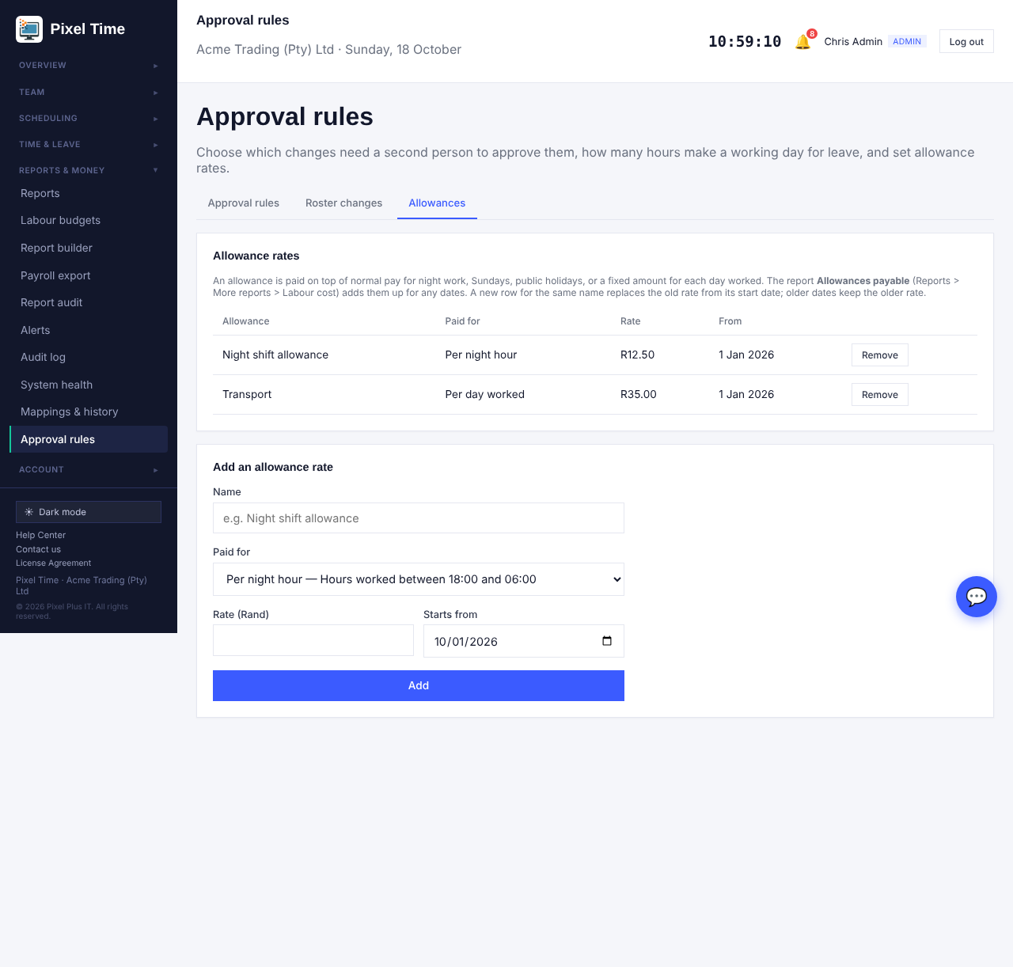
Allowance rates with the date each starts.
- Open Reports > More reports > Labour cost > Allowances payable and choose the dates.
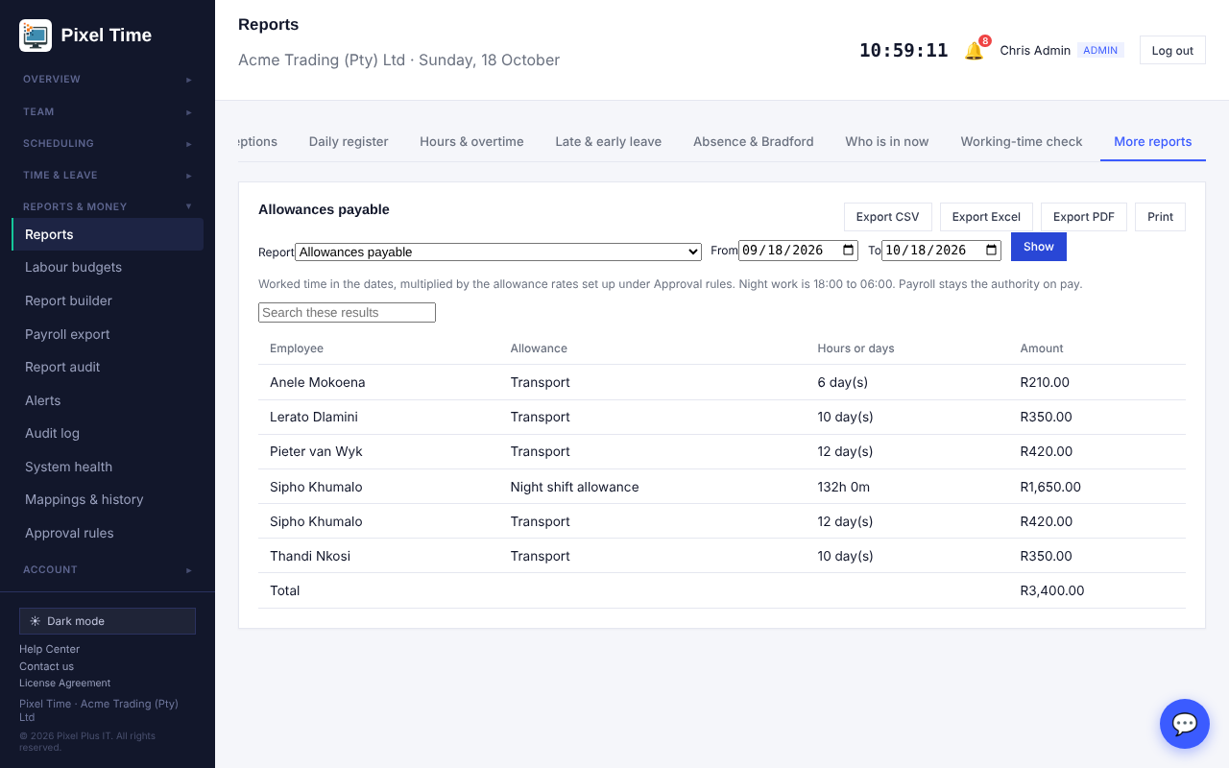
Allowances payable for each employee.
- Each day uses the rate in force on that date, so a rate change from 15 January does not change earlier days. Night work is 18:00 to 06:00. The report can also be exported to Excel and PDF.
- Allowances are shown to administrators and auditors only. Payroll stays the authority on pay.

22. Original clockings, BCEA starting points, payroll approval and checklists
Who: administrators; managers where stated. Where: Reports, Working-time rules, Payroll export, Team.

Original clockings are kept
- When a time correction is approved, or an administrator or manager sets a day's times directly, the punches that were there before are copied away first.
- Open Reports > More reports > Audit & security > Original clockings before correction and choose the dates.
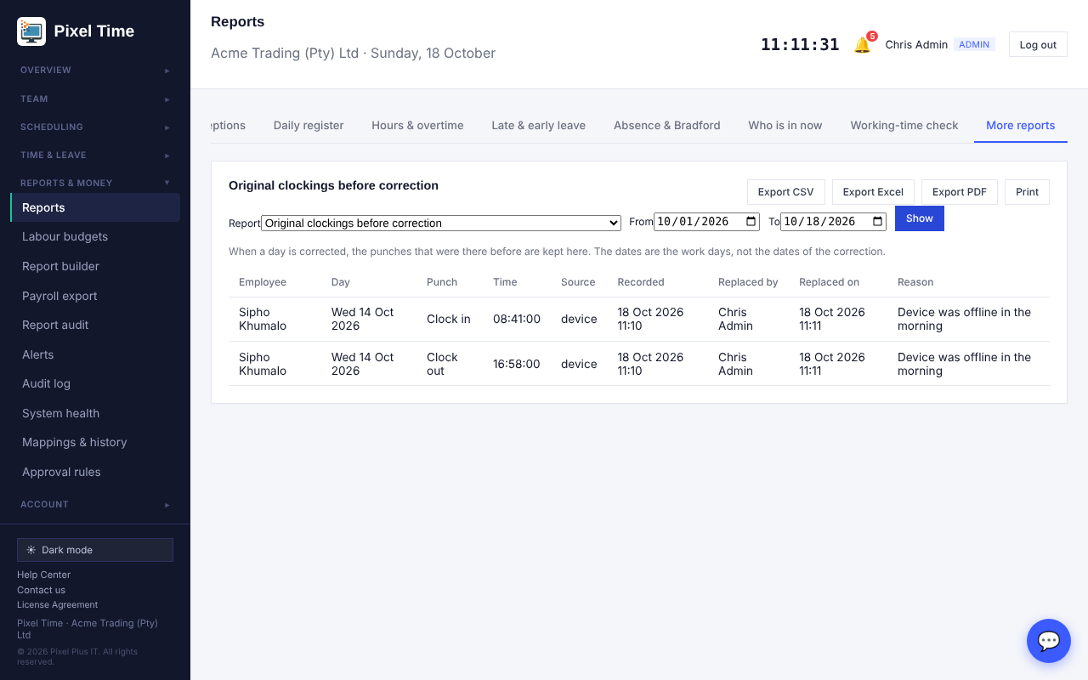
Original clockings: what was recorded, who replaced it, when and why.
- Each line shows the punch, where it came from (device, web, kiosk), when it was recorded, who replaced it and the reason. Managers see their own department.
- Only punches replaced from this update onward are kept. Earlier corrections cannot be recovered.

BCEA starting points
- Open Working-time rules > Rule sets and use Start from the BCEA.
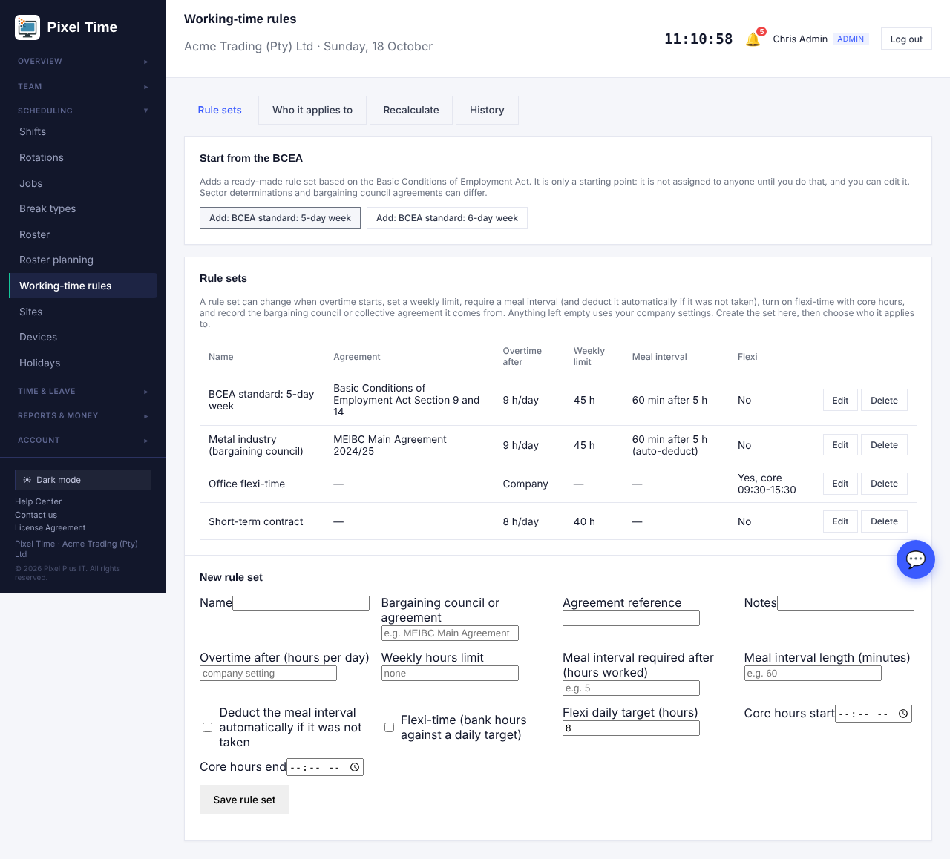
Rule sets: add a ready-made BCEA rule set.
- Choose the 5-day week (up to 9 ordinary hours a day) or the 6-day week (up to 8), both with 45 hours a week and a one-hour meal interval after 5 hours.
- Assign the set on the Who it applies to tab. Nothing is assigned automatically, and you can edit the set like any other.
- These are starting points only. Sector determinations and bargaining council agreements can differ, so check them against your contracts.

Approve a pay period before it is exported
- Open Approval rules and tick that a pay period must be approved before it can be exported. Leave the second box ticked if the person who asks must not approve their own request. Save.
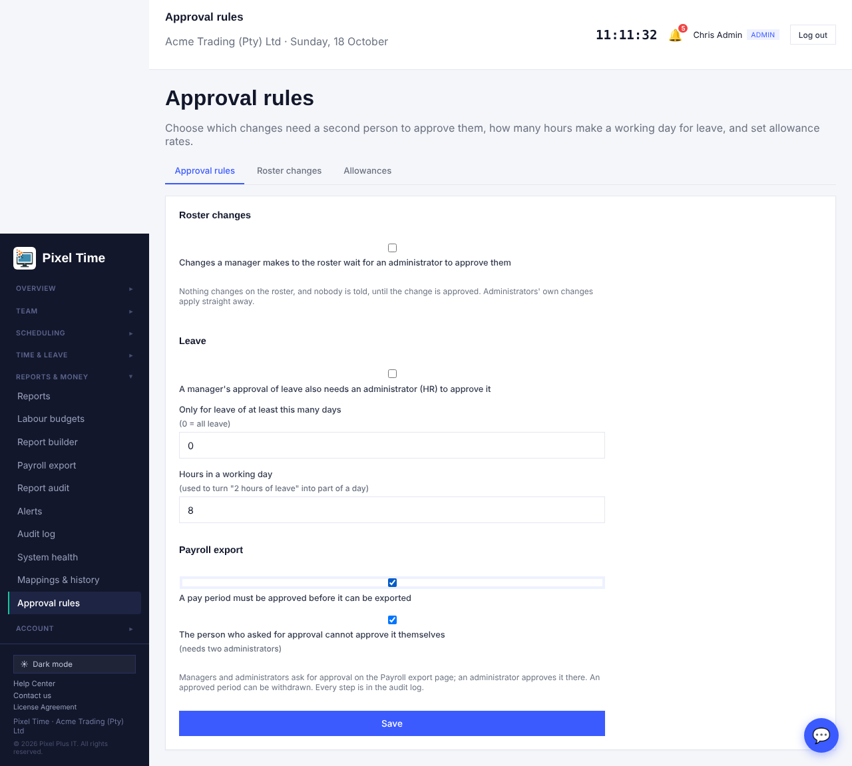
Approval rules: payroll export approval.
- On Payroll export, a manager or administrator presses Ask for approval for the dates chosen.
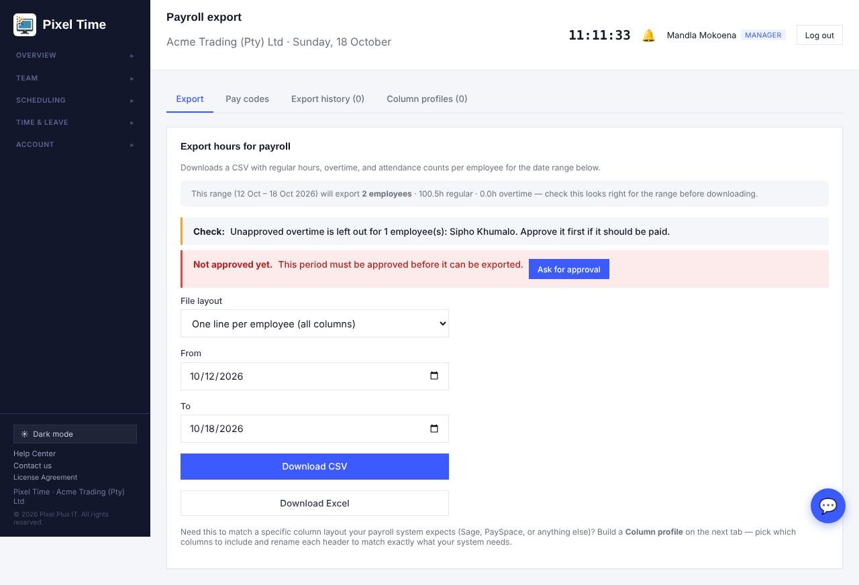
Not approved yet: the period cannot be exported.
- An administrator opens the same dates and presses Approve (or Decline). Administrators are notified when a request is made.
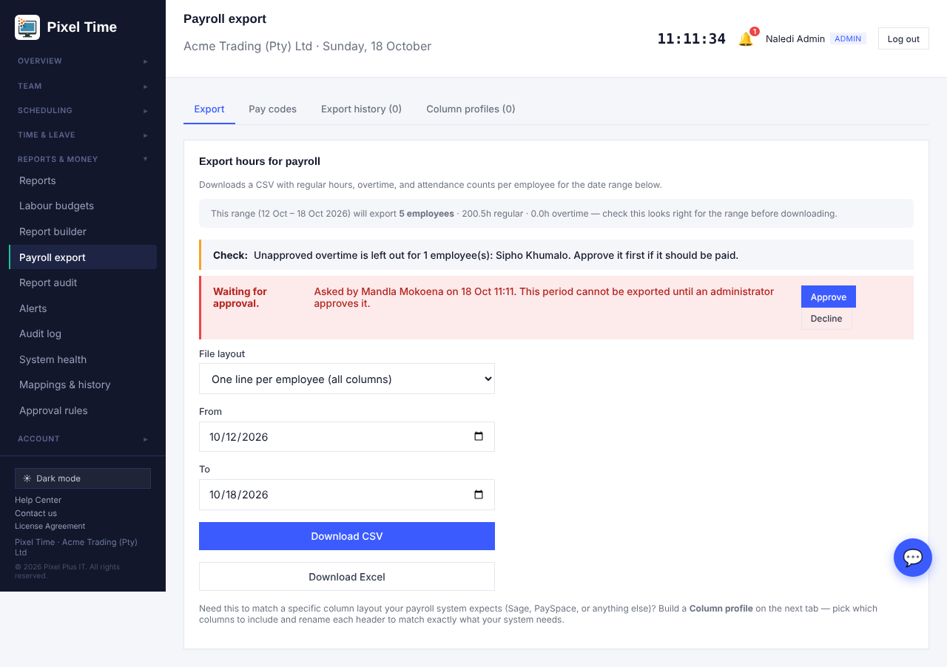
Waiting for approval.
- Once approved the page says so and the download works. Withdraw approval puts the block back.
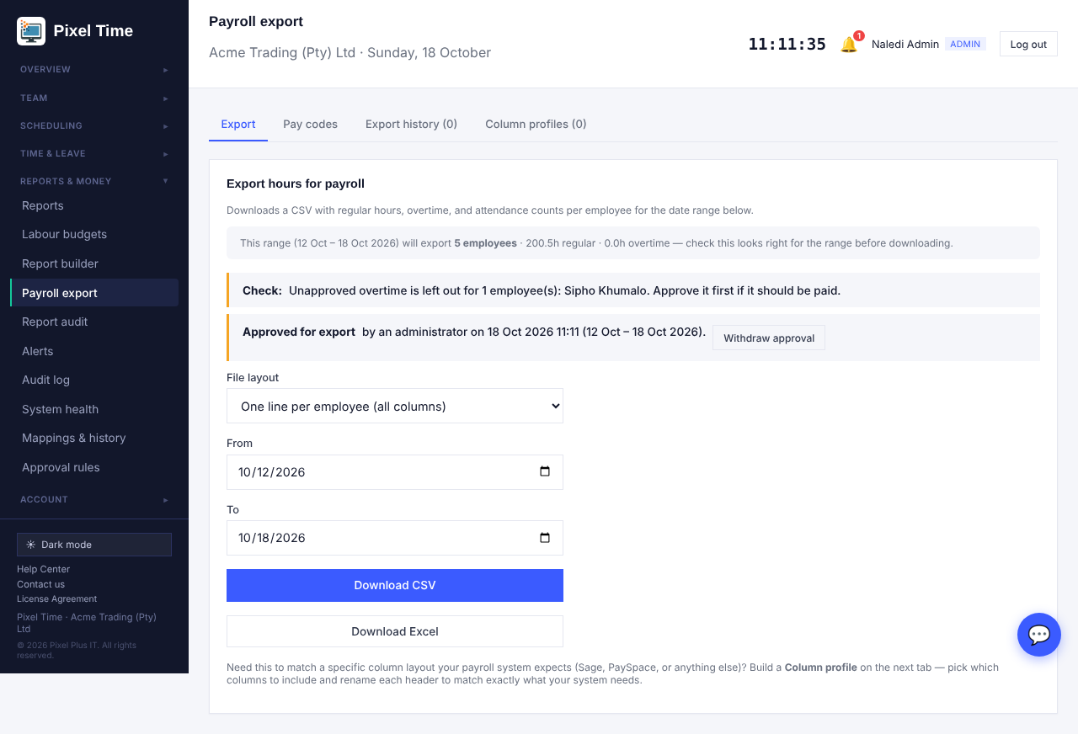
Approved for export.
- An approval for a longer period covers any shorter period inside it. The Payroll export approvals report (Audit & security) lists every request and decision.
- If you have only one administrator, untick the second box so that administrator can approve their own request.

Onboarding and offboarding checklists
- Open Team > Onboarding & offboarding. A checklist starts by itself when you add an employee (onboarding) or offboard one (offboarding).
- Open a person on the One person tab and tick each step as it is done. Who ticked it and when is kept.
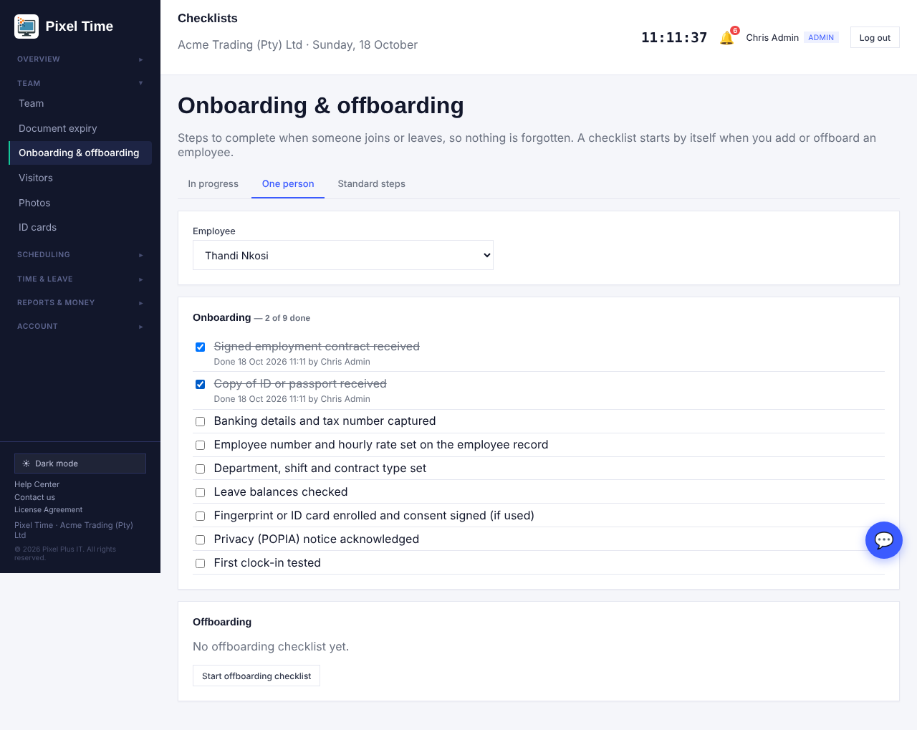
A person's onboarding checklist.
- The In progress tab shows everyone with open steps, how far they are and whether they are overdue.
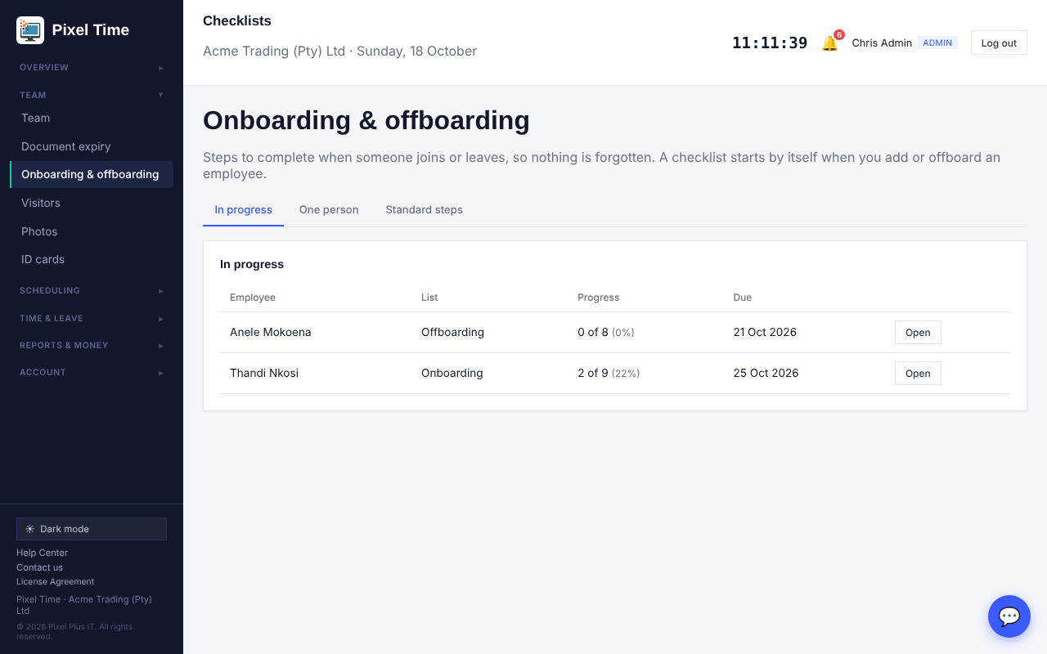
Checklists in progress.
- Administrators change the standard steps on the Standard steps tab. Lists already started are not changed.
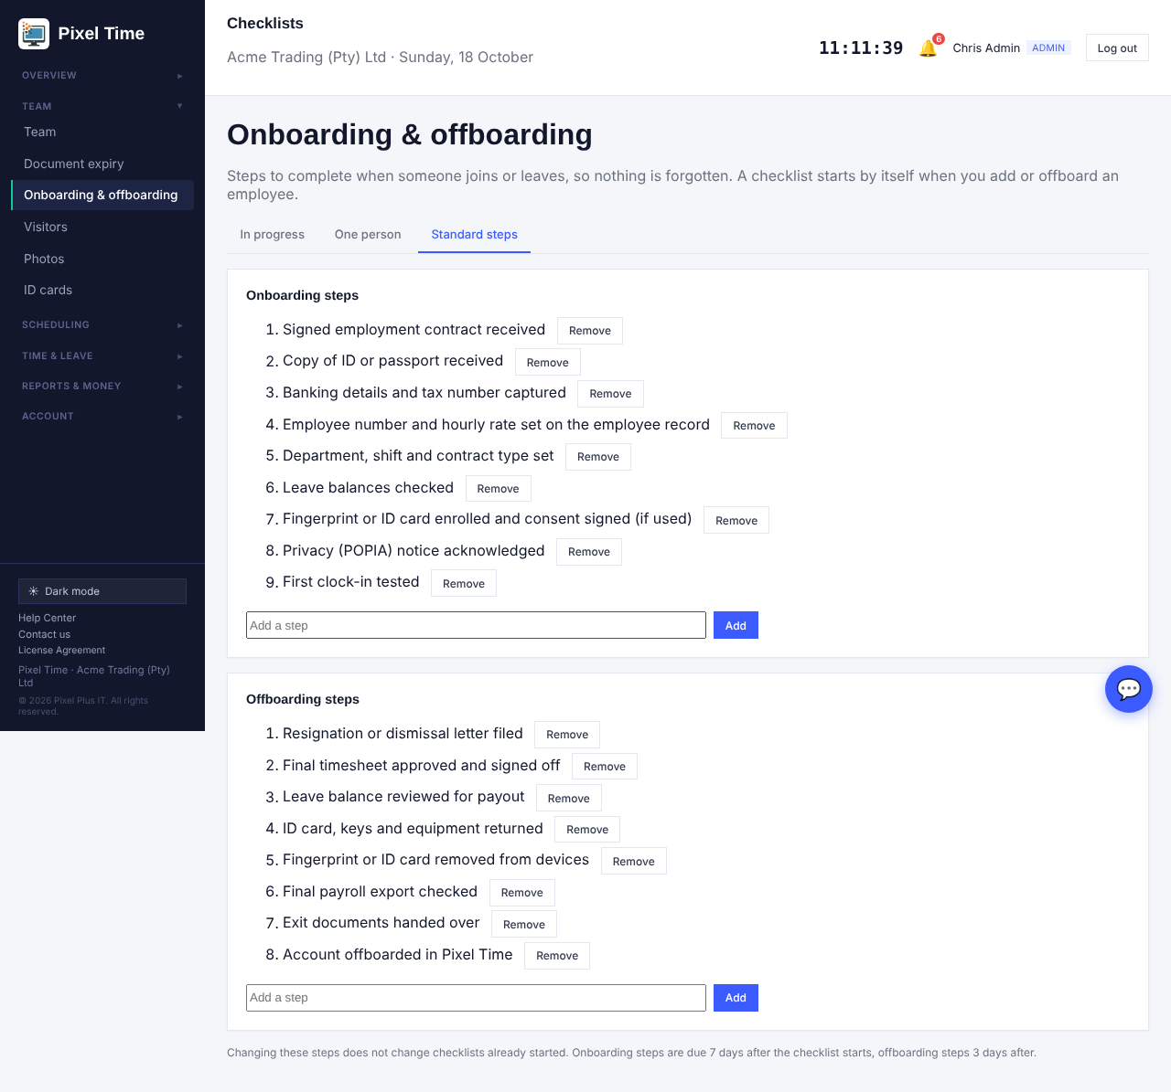
Standard steps for onboarding and offboarding.
- Onboarding steps are due 7 days after the list starts, offboarding steps 3 days. You are alerted when steps stay open past their due date (Alerts page: Onboarding or offboarding steps overdue).
- Reports > More reports > Management > Onboarding and offboarding progress lists every checklist.

23. Live board, profile photos and reports on screen
Who: administrators, managers (own department) and auditors for the live board and shared reports; every person for their own photo. Where: Overview > Live board, Account > My photo, Reports & money > Report builder and Shared reports.

The live board
- Open Overview > Live board. It shows who is in right now and refreshes by itself every minute.
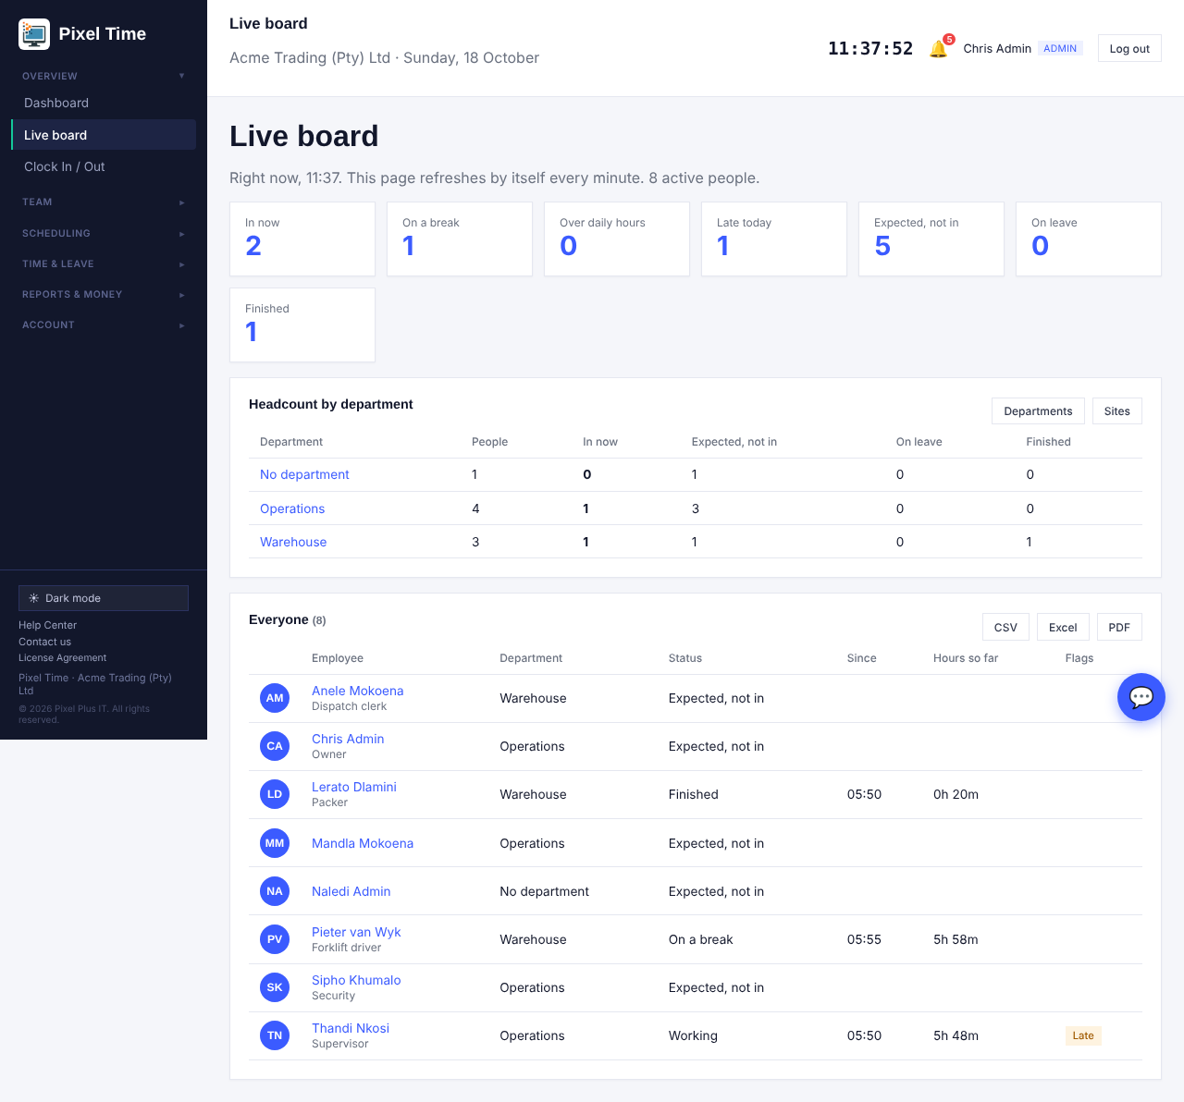
Live board: counts, headcount by department and everyone in scope.
- Press a number card (for example Late today or Expected, not in) to list only those people.
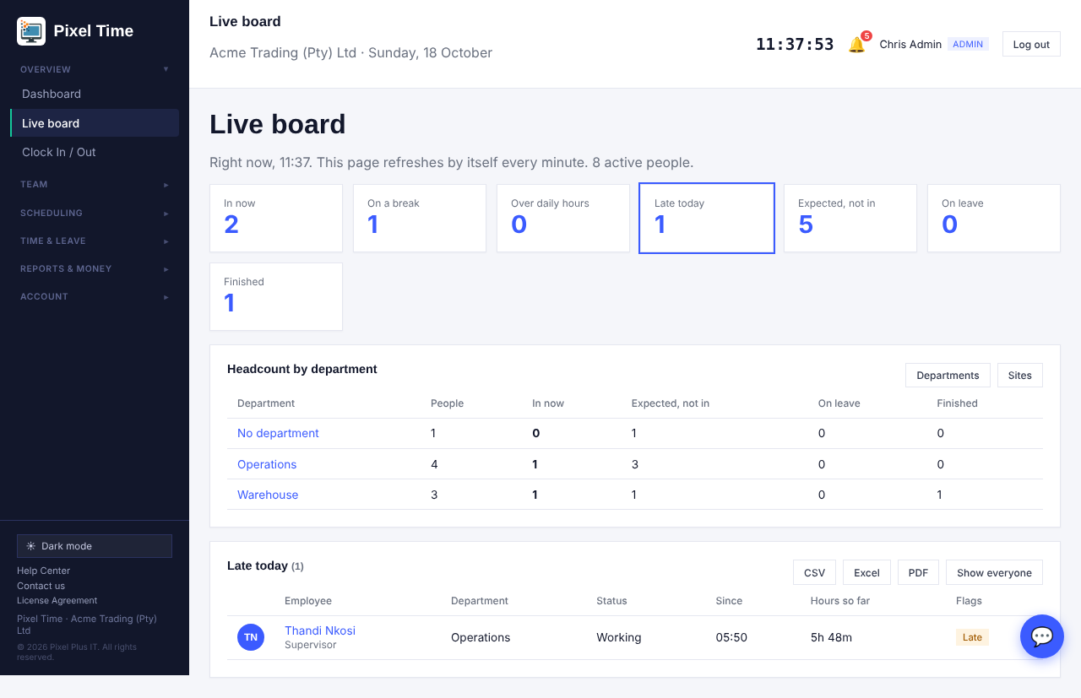
Filtered to the people who are late today.
- The Headcount table can be switched between Departments and Sites. Press a department or site name to see its people.
- Use CSV, Excel or PDF to download the list you are looking at.
- Over daily hours is an estimate for people still clocked in. It is judged against their working-time rule, or the company daily limit, and is confirmed when the day closes.
- Managers see their own department only. Auditors can look but not change anything.

Timesheet downloads
- On Timesheets, next to Export this view (CSV), press Excel for a spreadsheet or PDF for a printable attendance statement.
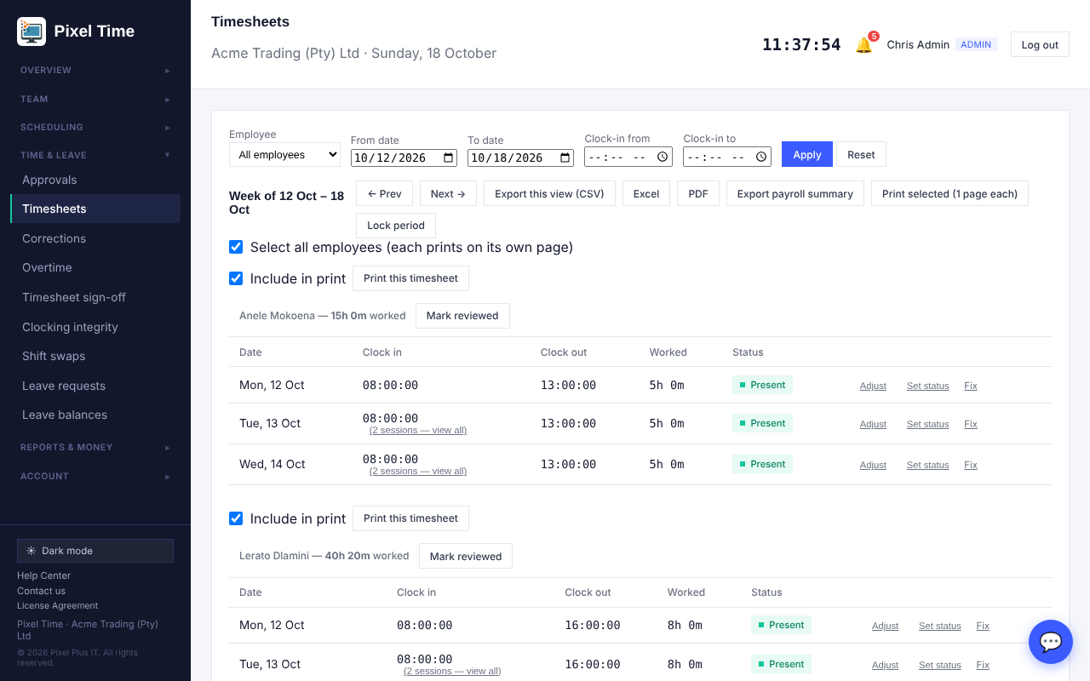
Timesheets: CSV, Excel and PDF.
- The Excel and PDF have the same lines as the CSV for the week and people you are viewing.

Profile photos
- Open Account > My photo, choose a JPG or PNG (at least 100 x 100 pixels, up to 6 MB) and press Save photo.
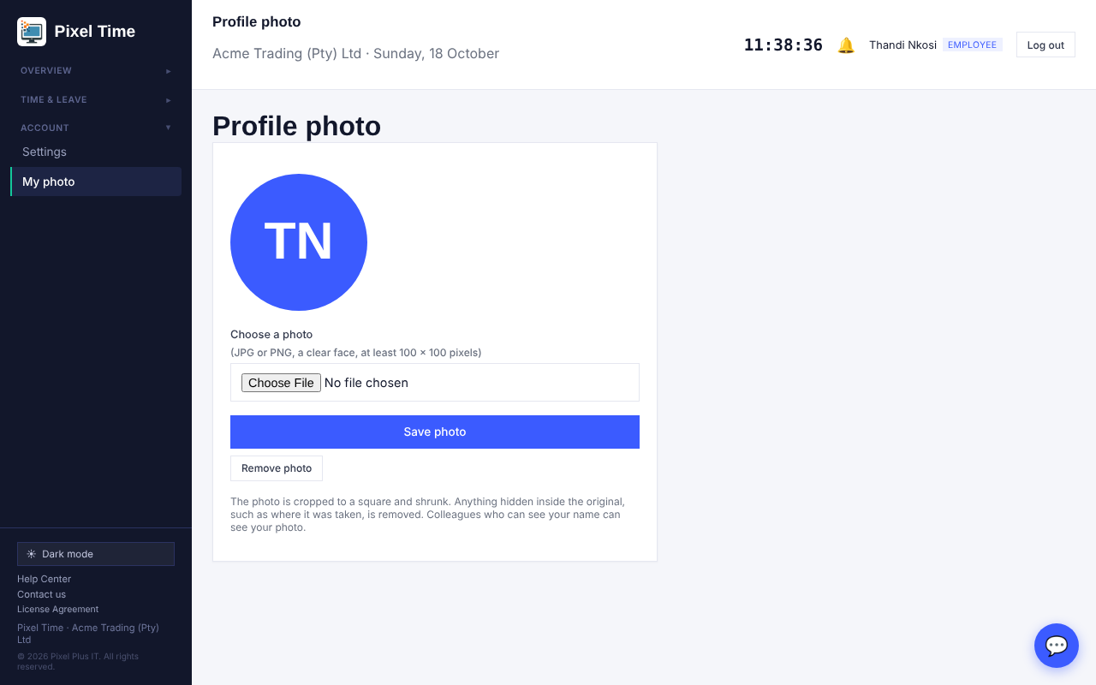
My photo page.
- The photo is cropped to a square and shrunk. Anything hidden inside the original, such as where it was taken, is dropped.
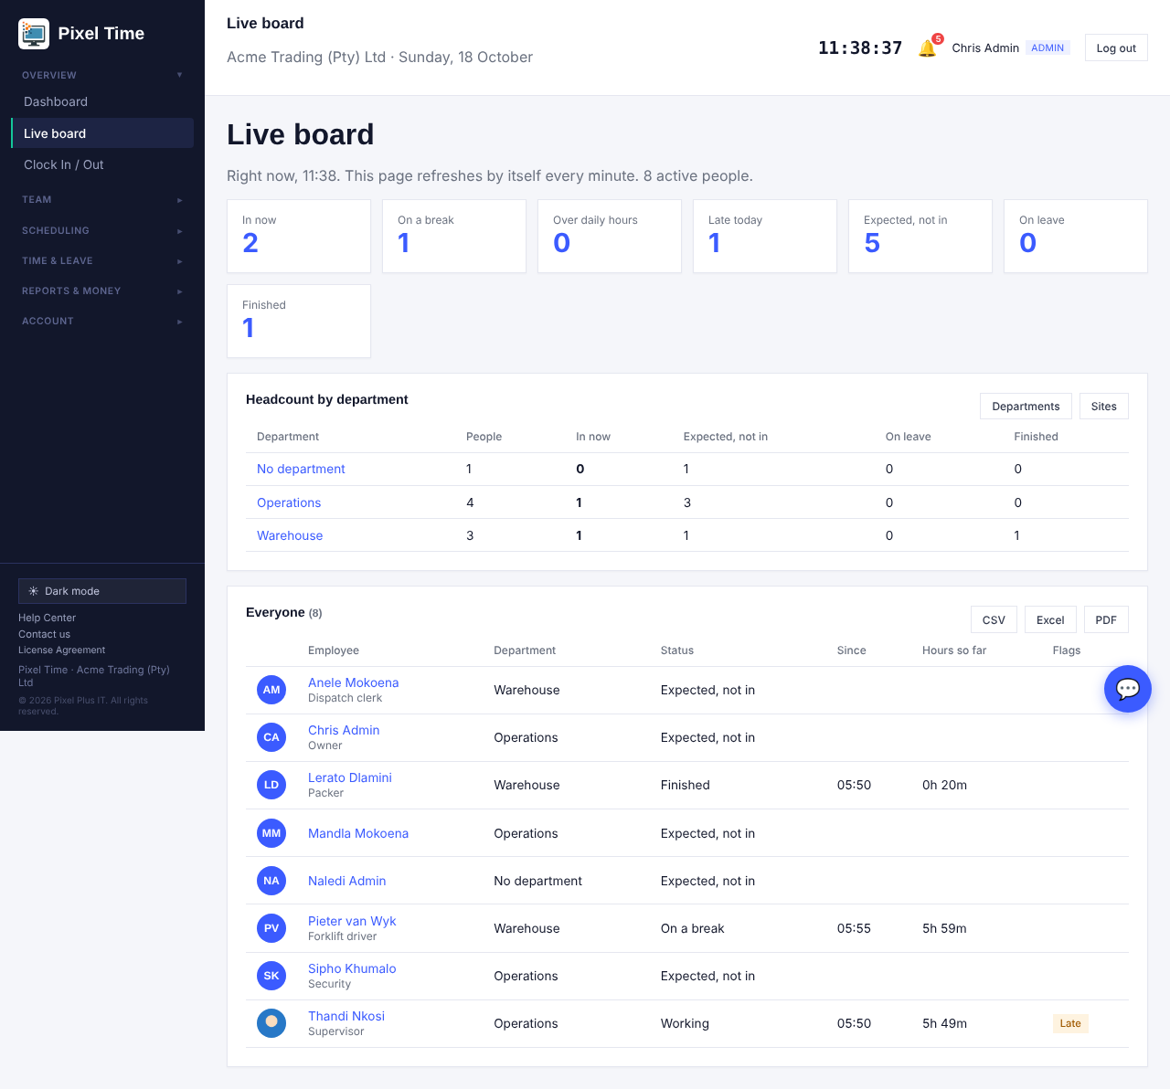
The photo appears next to the name on the live board. People without one show their initials.
- Administrators can change anyone's photo, managers their own people's. Remove photo returns to initials. Photos are only shown to people in the same company.
- Adding an employee: the Add employee form has an optional Photo box, so the photo goes in with the new person. If the photo is not suitable, the employee is still added and you are told why.
- One person later: Team > Everyone shows each person's picture and a Photo button on their row.
- Many at once (administrators): Team > Bulk import > Upload many photos at once. Name each photo after the person's employee number or Device ID, for example E1042.jpg, and choose them all together. A table then shows which were saved and which were not, and why. Most servers accept about 20 files at a time, so send bigger groups in batches.
- A bulk CSV import cannot carry photos. Import the people first with their employee numbers, then upload the photos named by those numbers. Photos only ever match people in your own company.

Reports on screen
- Open Report builder and press View beside a saved report, or open Reports & money > Shared reports.
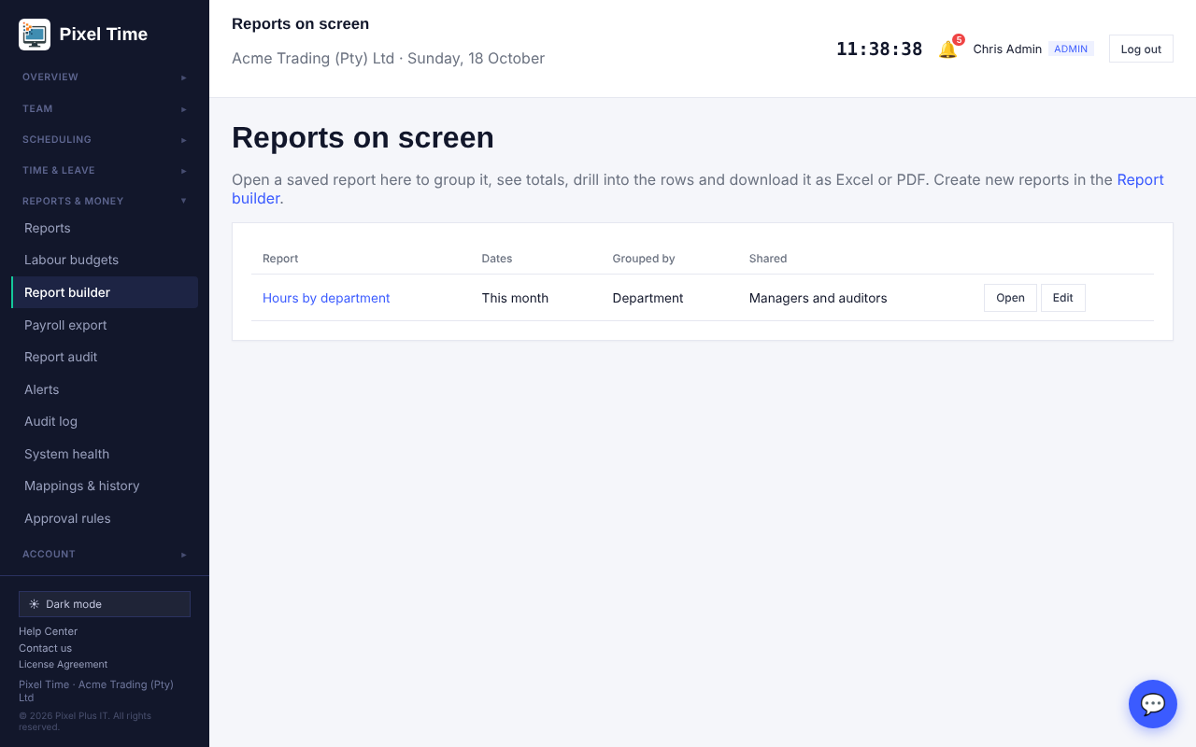
Saved reports you can open.
- A report set to group by department, employee, site, day or month shows one line per group with the number of rows and the totals of every minutes column.
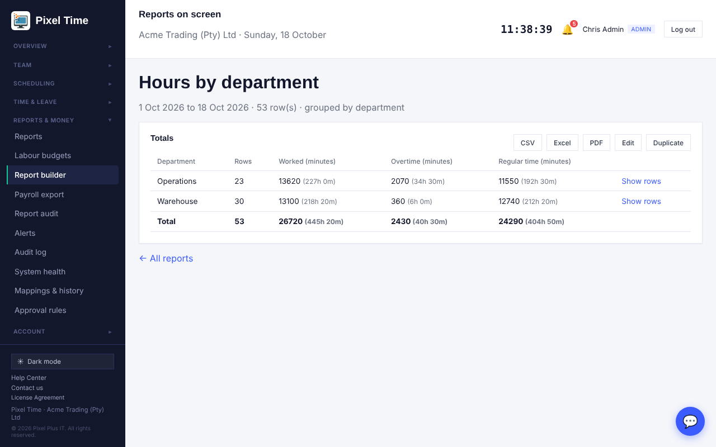
A report grouped by department, with totals.
- Press Show rows on a group to see the lines behind it, and back to the totals to return.
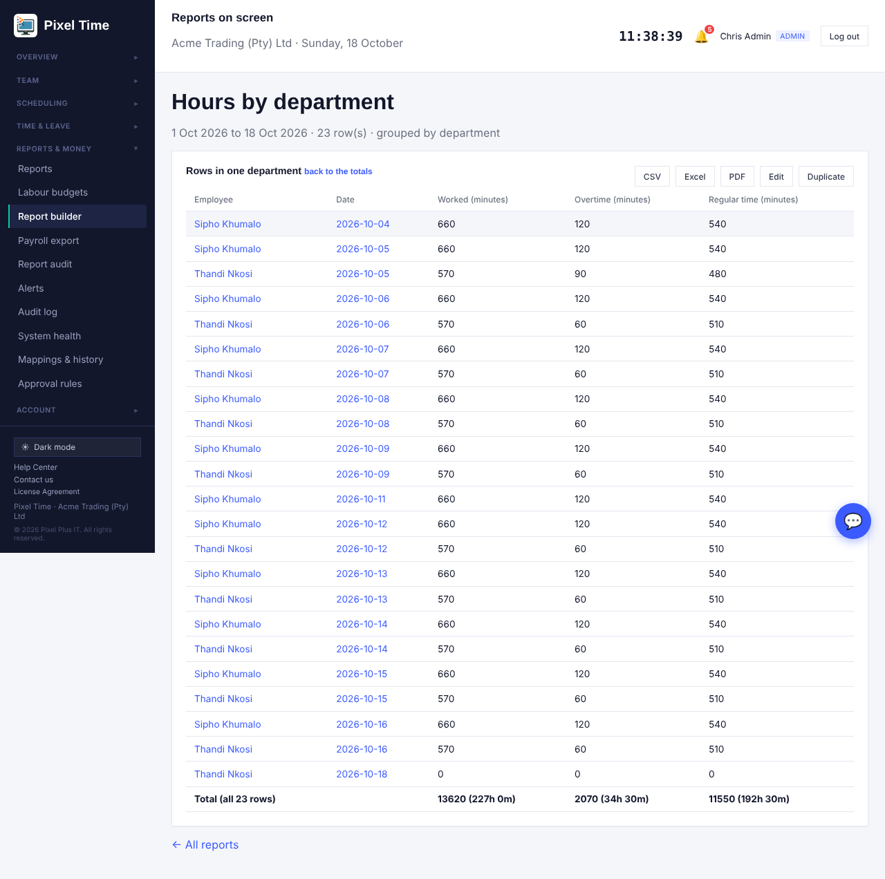
The rows inside one department.
- CSV, Excel and PDF download exactly what is on screen: the totals, or the rows of the group you opened.
- Administrators press Edit to change the name, columns, dates, filters, grouping, sorting and who may see it.
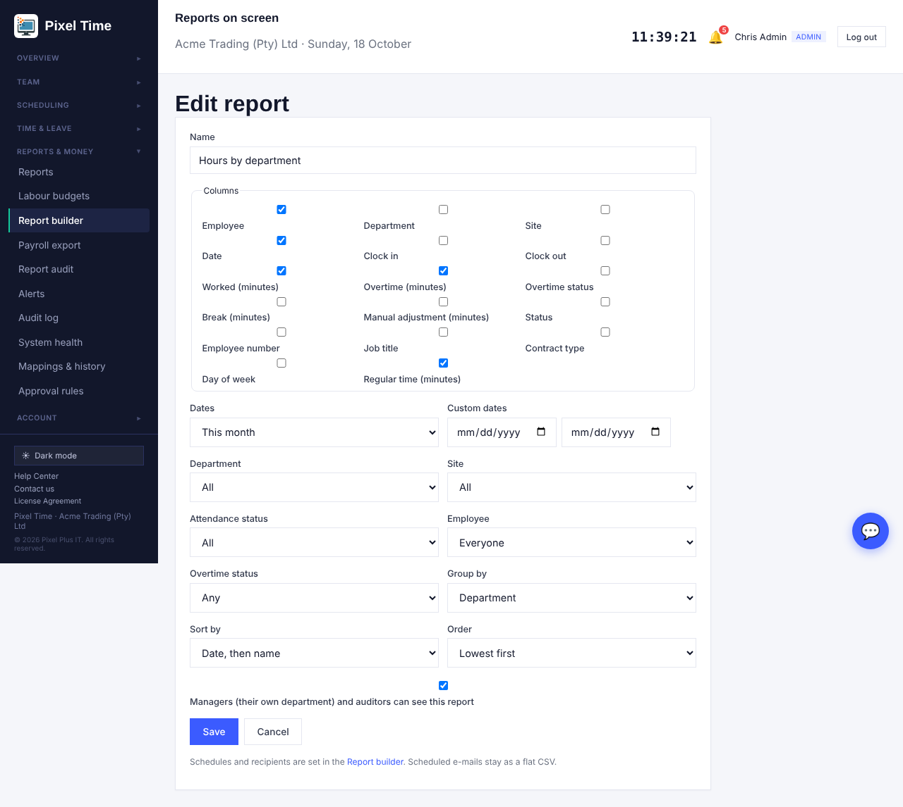
Editing a saved report.
- Duplicate makes a copy called Copy of ..., which starts private and unscheduled.
- Tick Managers and auditors can see this report to share it. Managers then see only their own department's lines.
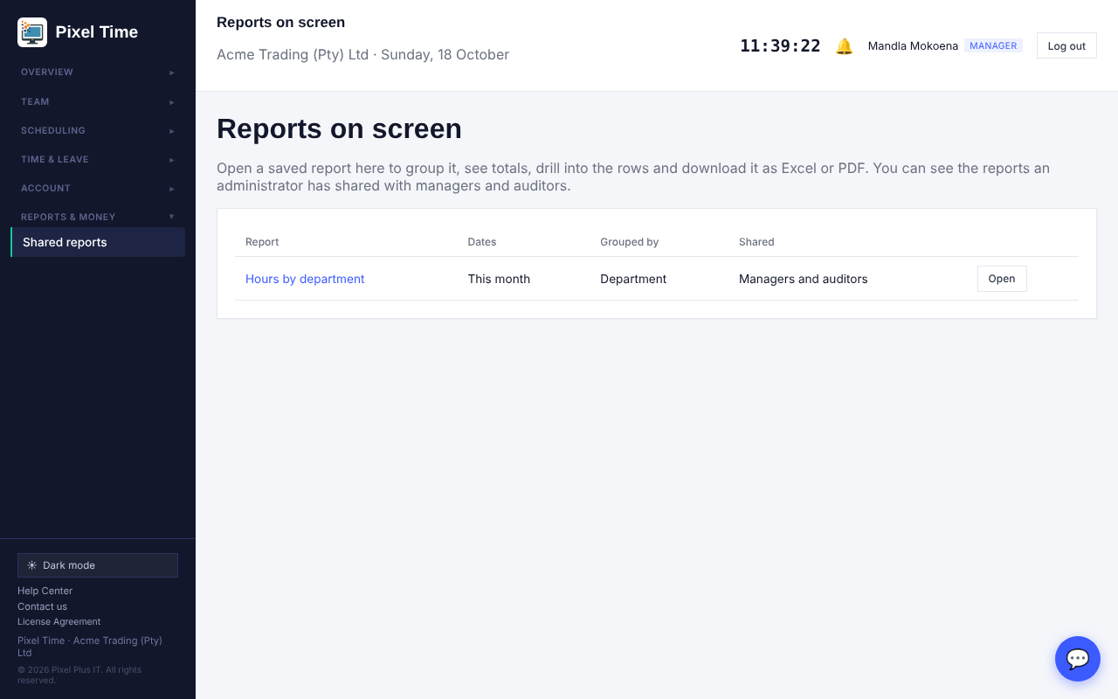
What a manager sees: only shared reports.
- New reports are still made in the Report builder, which now also offers Employee number, Job title, Contract type, Day of week and Regular time columns.
- Scheduled report e-mails stay as a flat CSV and are set up in the Report builder.
- On screen, a report uses up to 20 000 rows. Downloads take up to 100 000. Narrow the dates if you hit the limit.

24. Calculation breakdown, bulk overtime approval and new reports
Who: administrators, managers (own department) and auditors; employees for their own hours. Where: Time & leave > Calculation breakdown, Overtime, Reports > More reports.

Calculation breakdown
- Open Time & leave > Calculation breakdown, choose the employee and the dates (up to 62 days) and press Show.
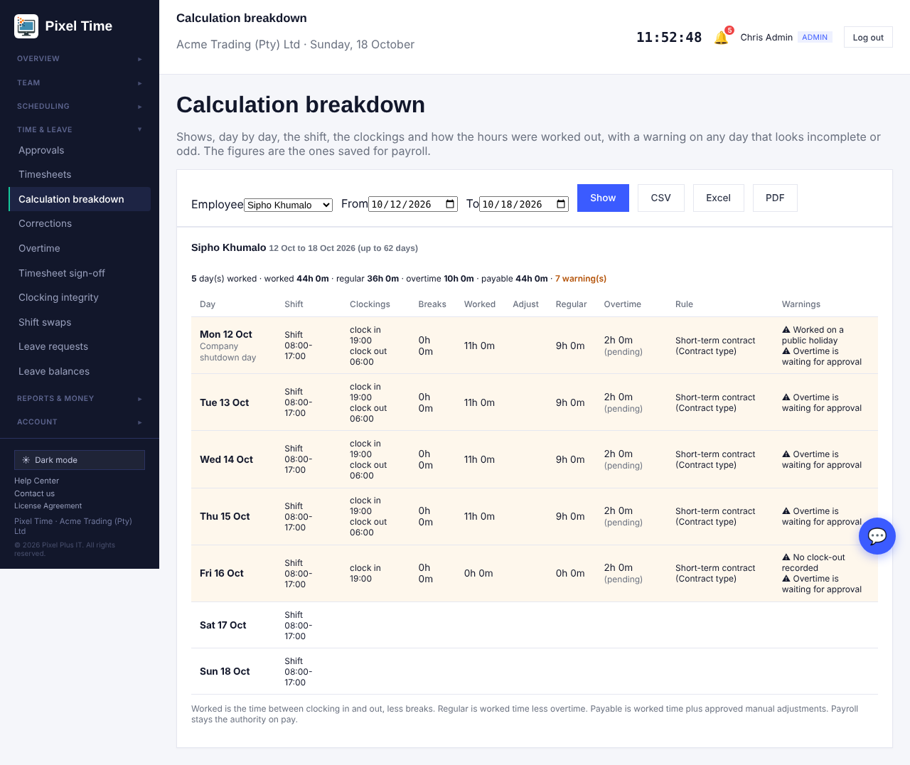
Calculation breakdown for one person.
- Each day shows the shift, every clocking, breaks, time worked, any approved adjustment, regular time, overtime and its approval status, and the working-time rule that applied.
- A warning appears on a day that looks incomplete or odd: no clock-out, clockings out of order, a break never ended, more than 16 hours, work on a day with no shift, work on a public holiday, or an adjustment or overtime still waiting for approval.
- Where a day was corrected, it says how many original punches were kept.
- CSV, Excel and PDF download the same table.
- Employees open My hours explained to see the same for themselves.
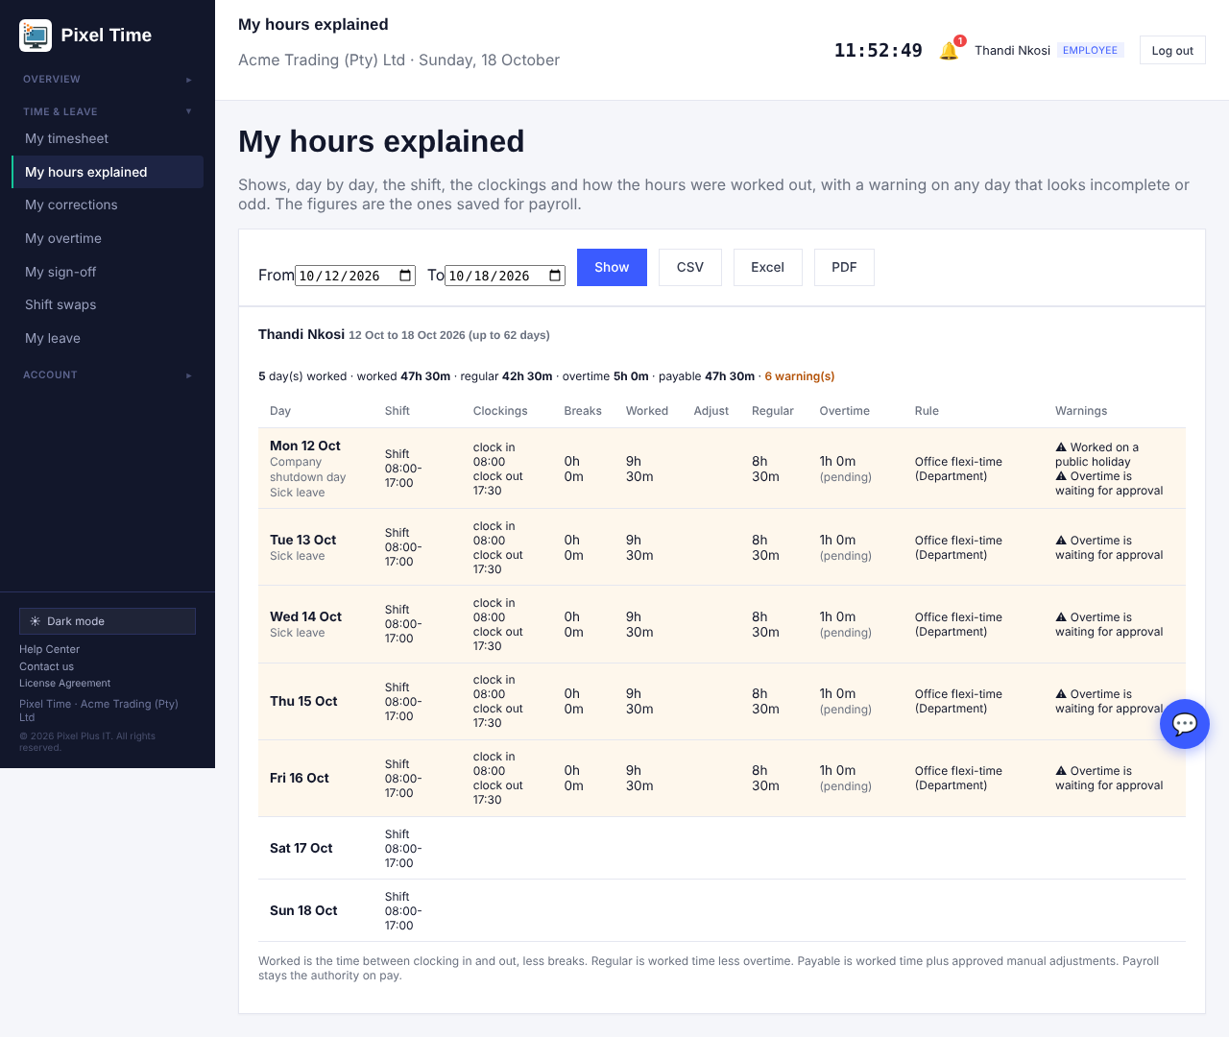
What an employee sees: only their own days.
- Worked is the time between clocking in and out less breaks. Regular is worked time less overtime. Payable is worked time plus approved adjustments. Payroll stays the authority on pay.

Approve overtime in bulk
- Open Overtime > Requests. Requests that are safe to approve are marked fine to approve: the person really worked at least that much overtime, stays inside their monthly limit, and the date is not in a locked pay period.
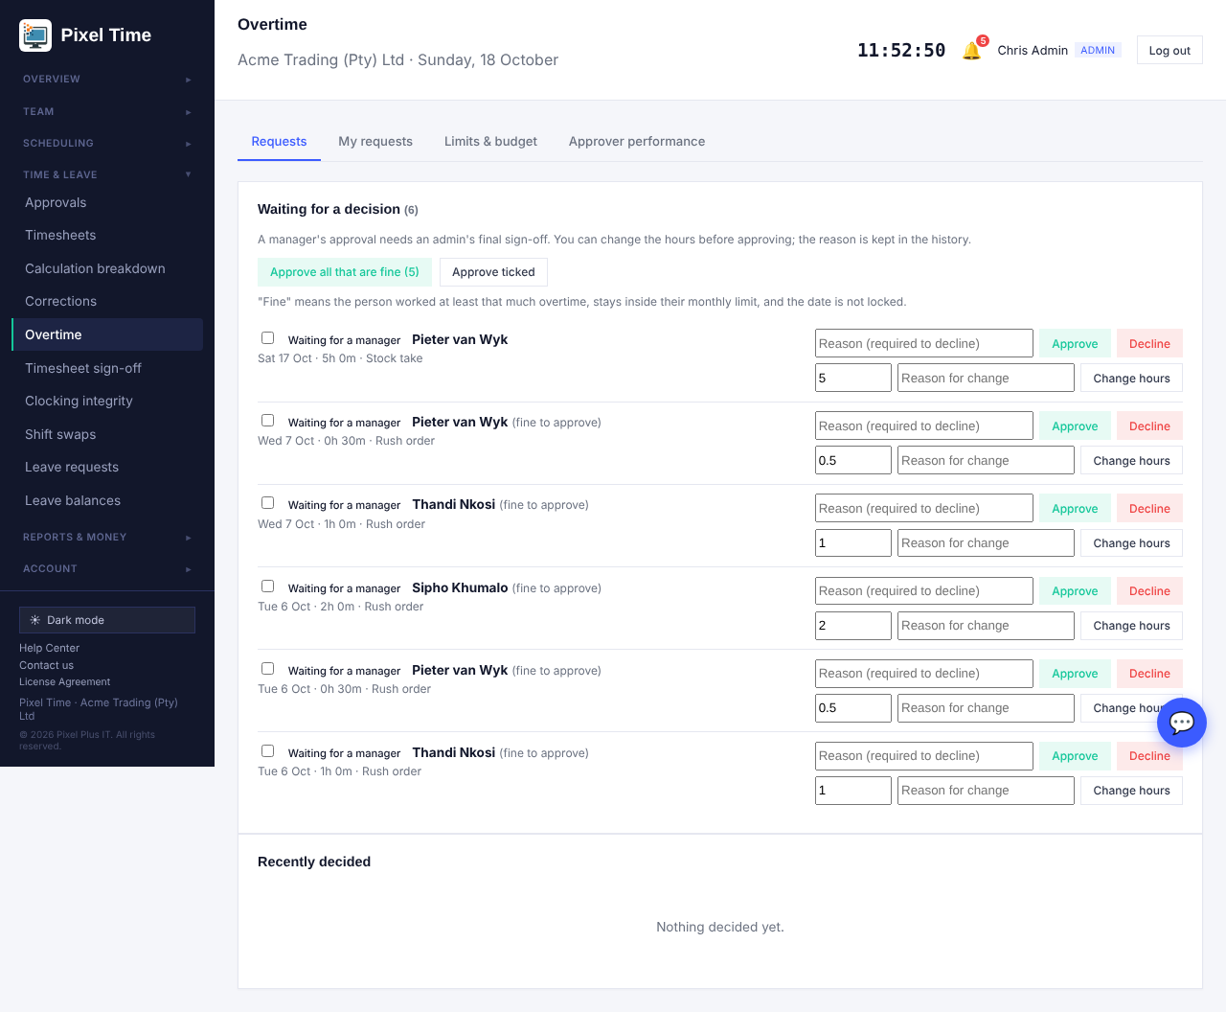
Overtime requests with bulk approval.
- Press Approve all that are fine to approve every such request in your scope, or tick some and press Approve ticked.
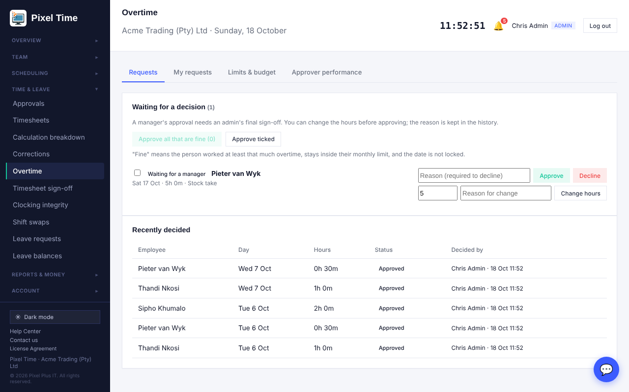
After bulk approval: only the request that needs a person is left.
- Anything not fine is left for you to look at one by one. Managers still need an administrator's final sign-off where two-level approval is on.

New reports
- Reports > More reports now also has: Calculation warnings (Audit & security), Overtime by pay week and employee, Ordinary (regular) hours per employee, and Leave usage by employee and leave type.
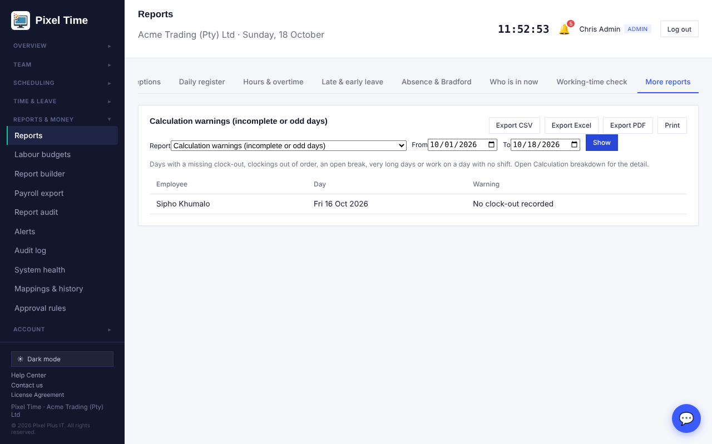
Calculation warnings.
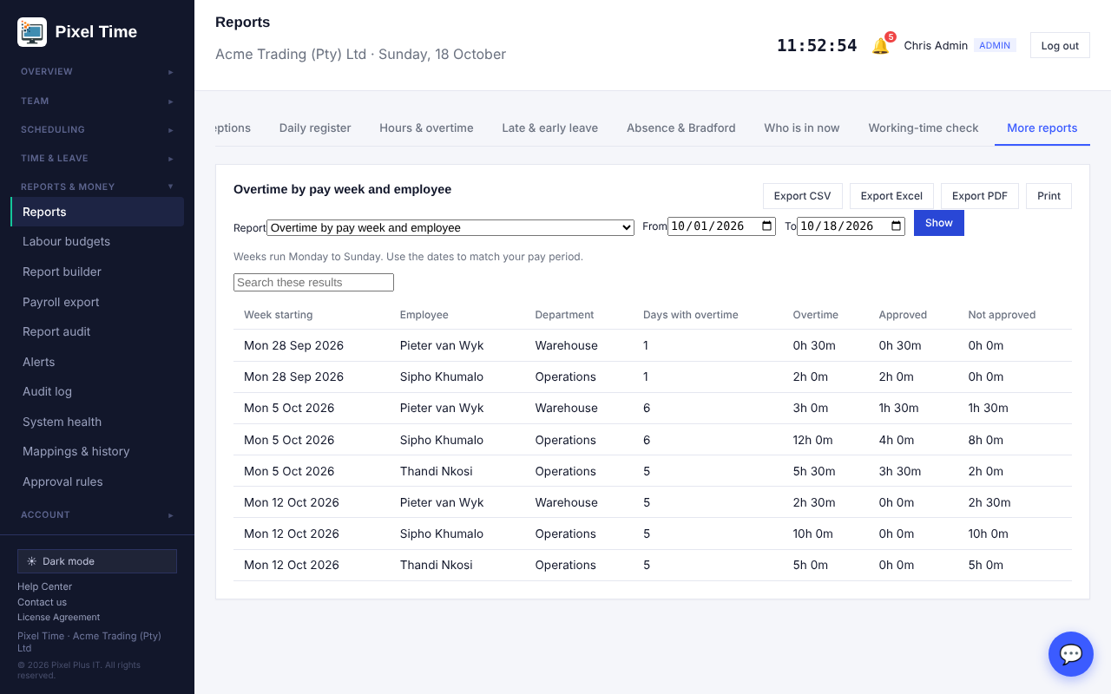
Overtime by pay week and employee.
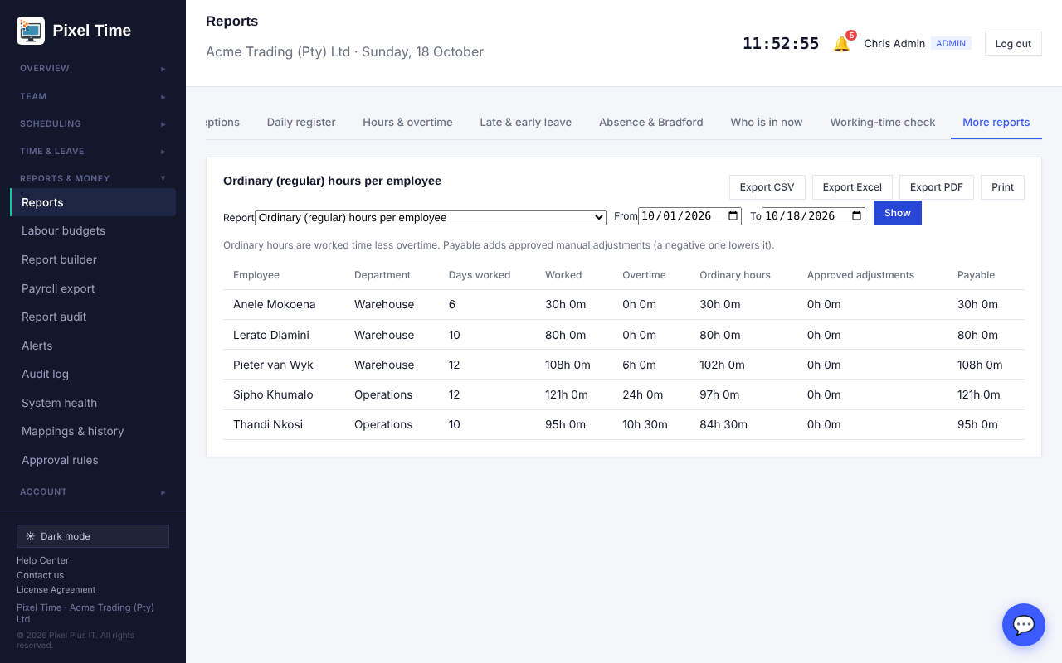
Ordinary hours per employee.
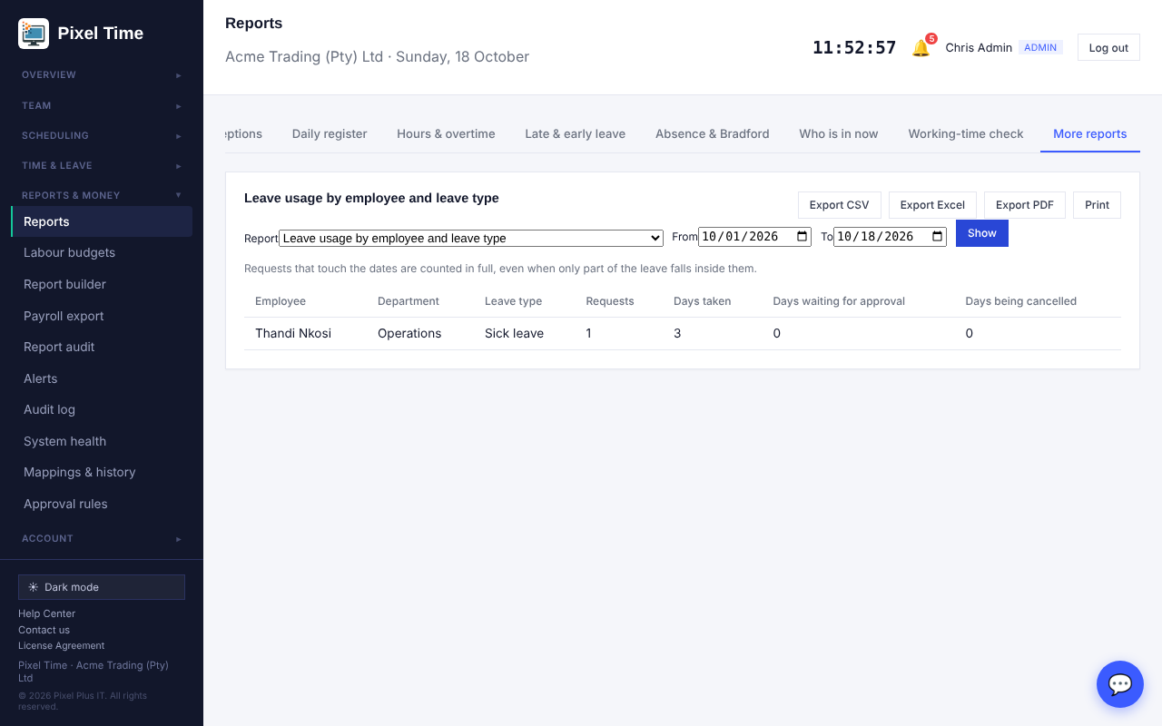
Leave usage by employee and leave type.
- Managers see their own department. Download any of them with the CSV, Excel and PDF buttons.

25. Printing ID cards with a barcode
Who: administrators; managers for their own department. Where: Team > ID cards > Print ID cards with a barcode.
- Open Team > ID cards and press Print ID cards with a barcode. Choose a department if you like, and tick the people.
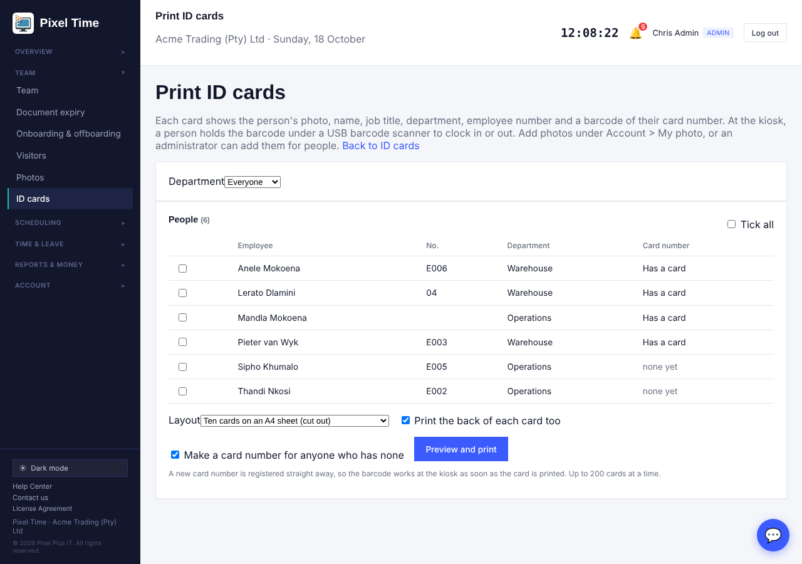
Choose the people, the layout and the options.
- Choose the layout: ten cards on an A4 sheet to cut out, or one card per page for a card printer (85.6 x 54 mm).
- Leave Print the back of each card too ticked if you want the back, and leave Make a card number for anyone who has none ticked so that everyone gets a working barcode.
- Press Preview and print, then Print. In the print window turn off headers and footers and set the scale to 100%.
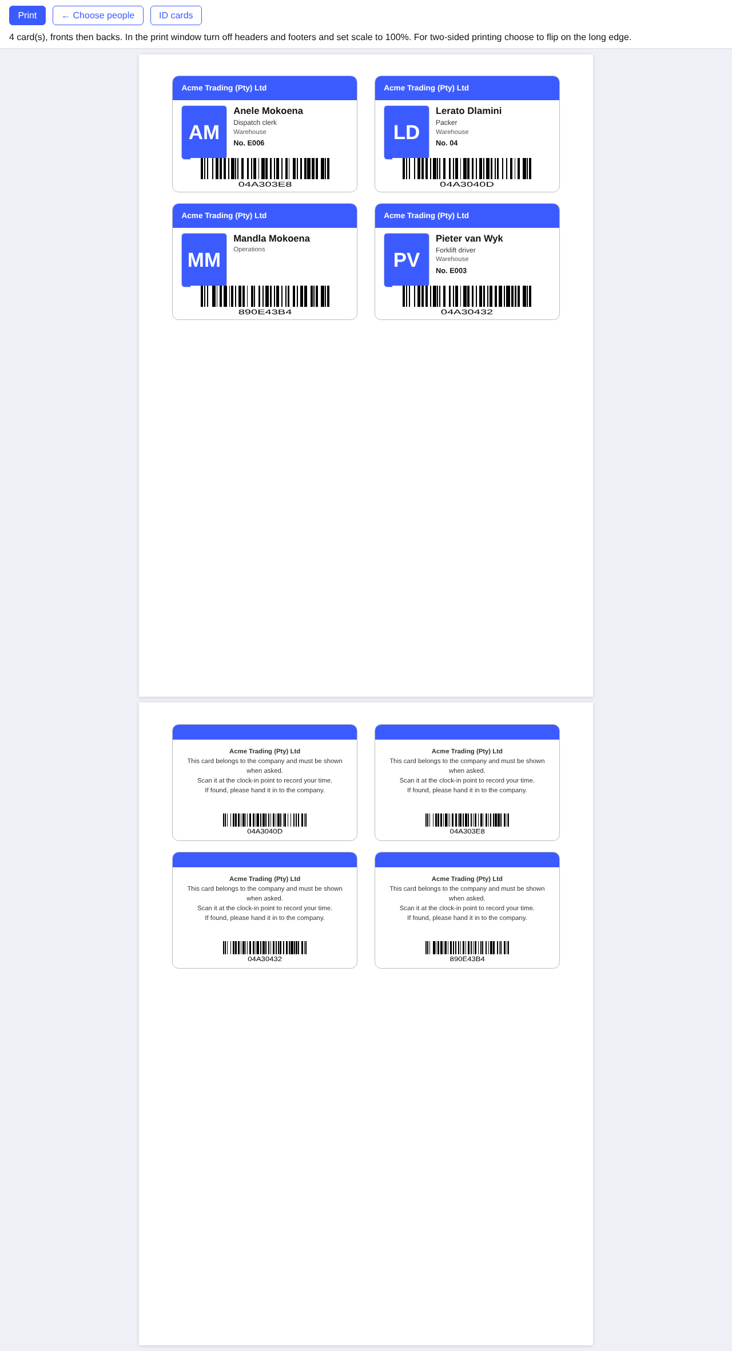
A4 sheet preview: photo, name, job title, department, employee number and barcode.
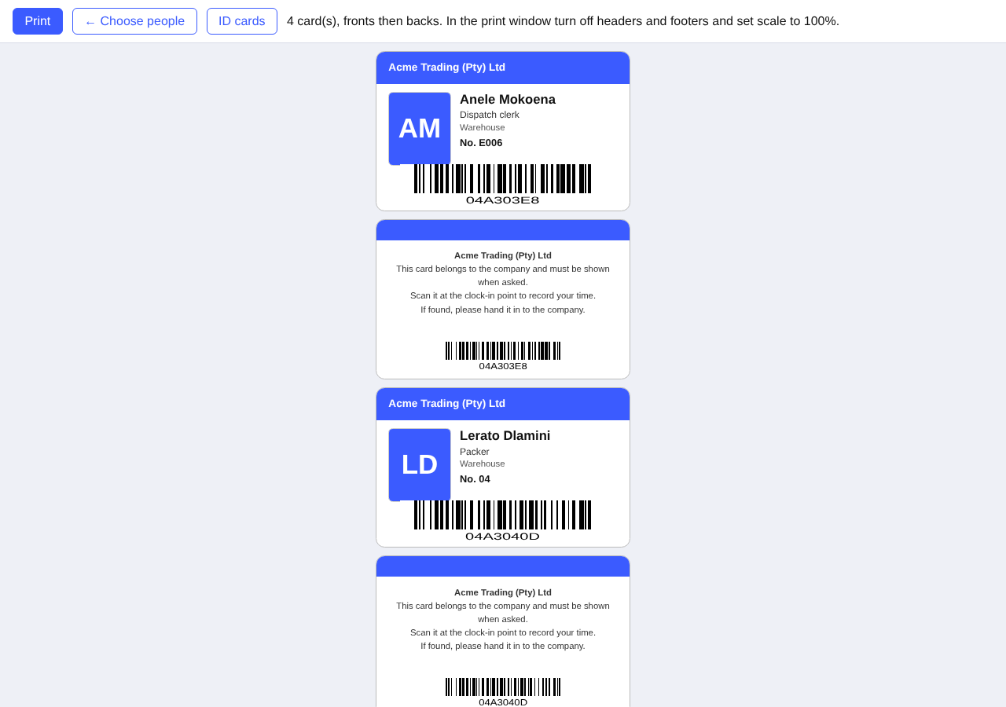
One card per page for a card printer.
- The card shows the photo from Account > My photo (initials if there is none), the name, job title, department, employee number, your logo and brand colour, and a barcode of the card number.
- At the kiosk, click in the name box and hold the barcode under a USB barcode scanner. The scanner types the number and the person clocks in or out, the same as a proximity card. If you have chosen that cards also need a PIN, the PIN is still asked.
- A new card number is registered on the ID cards page as soon as you print, so you can mark it lost or disabled later. If a card is lost, mark it lost and print a new one: the old barcode stops working.
- Two-sided sheets: print the fronts and backs on both sides of the paper, flipping on the long edge. The backs are already arranged to line up.
- Use a scanner that reads Code 128 barcodes (almost all do) and set it to add Enter after each scan.

26. E-mail notification settings
Who: everyone for their own settings; administrators for the company defaults. Where: Account > Notification settings (or E-mail settings on the Notifications page).
- The bell at the top always shows every notification. Open Account > Notification settings to choose which topics are also sent to your e-mail address.
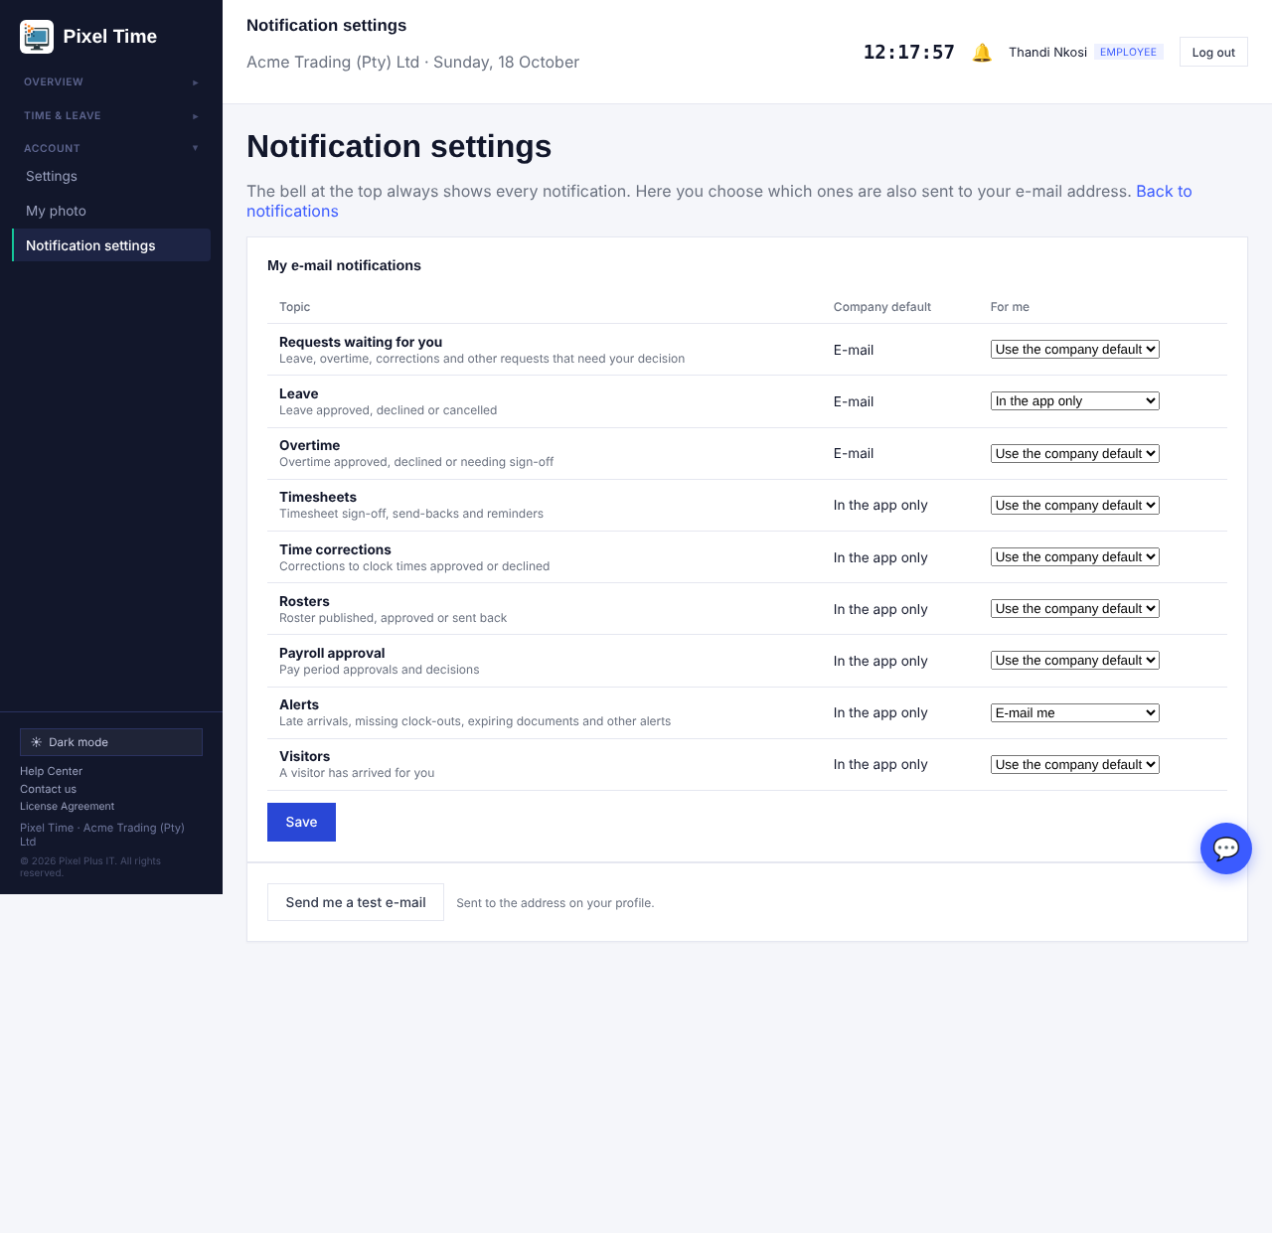
My e-mail notifications: use the company default, e-mail me, or in the app only.
- For each topic (requests waiting for you, leave, overtime, timesheets, time corrections, rosters, payroll approval, alerts, visitors) choose Use the company default, E-mail me, or In the app only, then press Save.
- Press Send me a test e-mail to check that e-mail reaches you. Check the spam folder the first time.
- Administrators set the company defaults at the bottom: tick the topics that should be e-mailed to everyone who has not chosen. Untick Let each person choose for themselves to make the defaults apply to everyone.
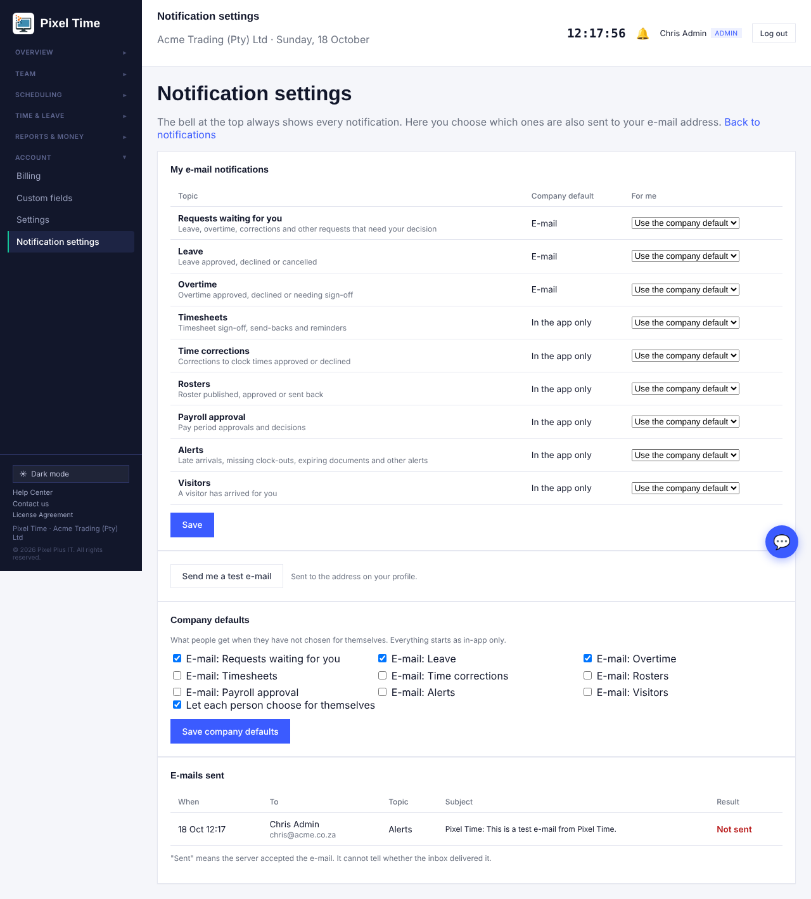
Company defaults and the list of e-mails sent.
- The E-mails sent list shows each e-mail, who it went to and whether the server accepted it. Not sent means the server refused it: contact Pixel Plus support.
- Everything starts as in the app only, so nothing is e-mailed until an administrator or the person turns a topic on.
- A person with no valid e-mail address on their profile, or who is suspended, is never e-mailed.
- Sent means the server accepted the e-mail. It cannot tell whether the inbox delivered it.

27. Clocking methods
Who: administrators. Where: Team > Clocking methods.
- Open Team > Clocking methods. Tick the ways people may clock: web or phone, kiosk with name and PIN, ID card or barcode at the kiosk, QR code poster, and fingerprint, face or card devices. Press Save.
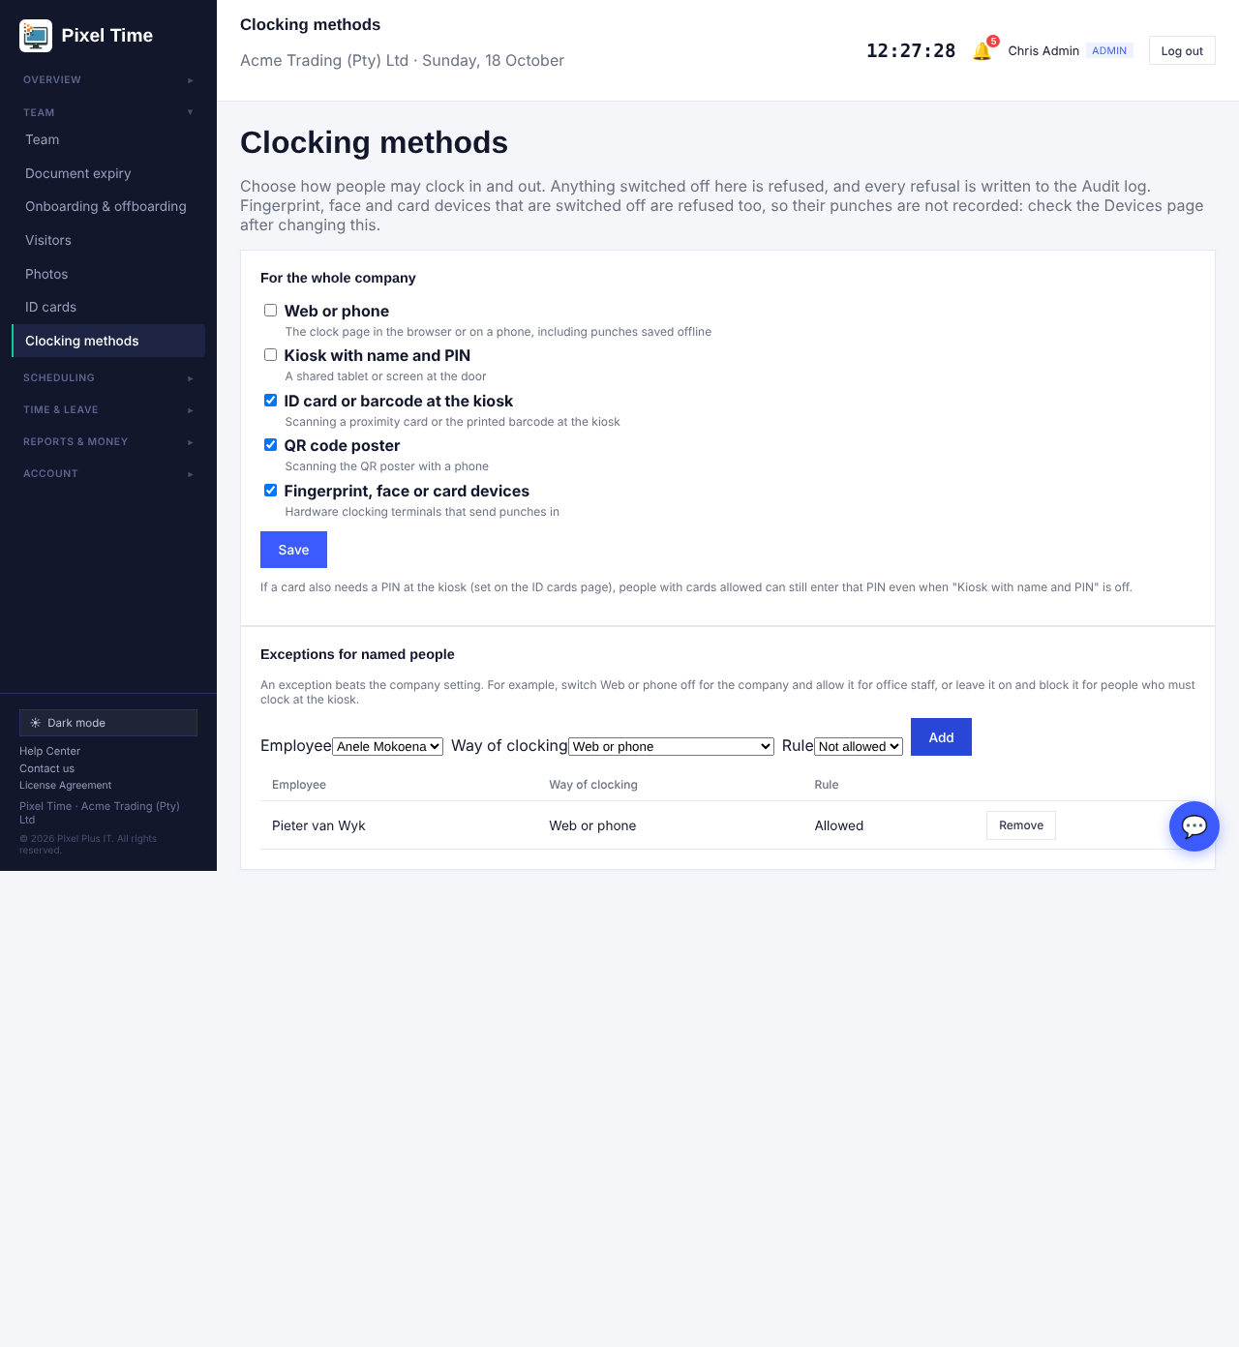
Clocking methods: company switches and exceptions for named people.
- To make an exception for a person, choose the employee, the way of clocking and Allowed or Not allowed, and press Add. An exception beats the company setting. Press Remove to go back to the company setting.
- Example: switch Web or phone off for the company and allow it for office staff, or leave it on and block it for people who must clock at the kiosk.
- A person who tries a way that is not allowed sees a message, nothing is recorded, and the attempt is written to the Audit log (clock method blocked).
- At least one way must stay on, so that nobody is locked out.
- Devices that are switched off are refused too and their punches are lost, so check the Devices page after changing this. Punches already recorded are not affected.
- If cards also need a PIN at the kiosk, people with cards allowed can still enter that PIN when Kiosk with name and PIN is off.

28. Calculation history, timezone and team filters
Who: administrators, managers (own department) and auditors for history; administrators for the timezone.
- Calculation history: when a finished day is calculated again and its figures change (a recalculation under new rules, a correction or an added clocking), the earlier figures are kept. Open Time and leave > My hours explained, choose the person and dates, and look at Earlier figures that were replaced. It shows who changed it, when, why, and the figures before and after.
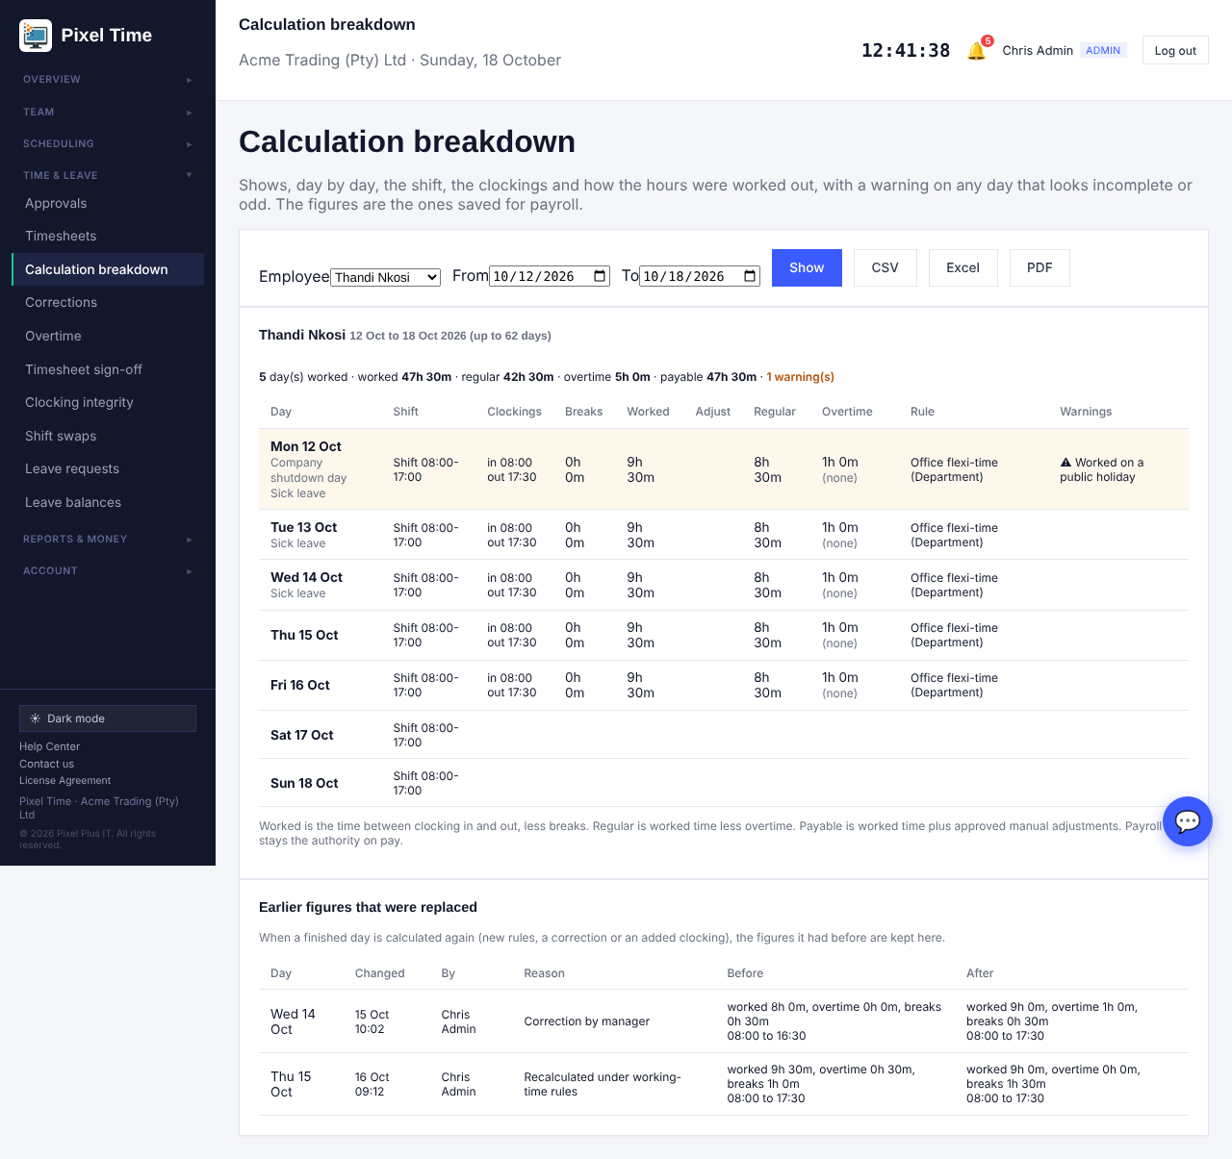
Earlier figures that were replaced, shown under My hours explained.
- For all people at once, open Reports > More reports > Calculation history (figures that were replaced).
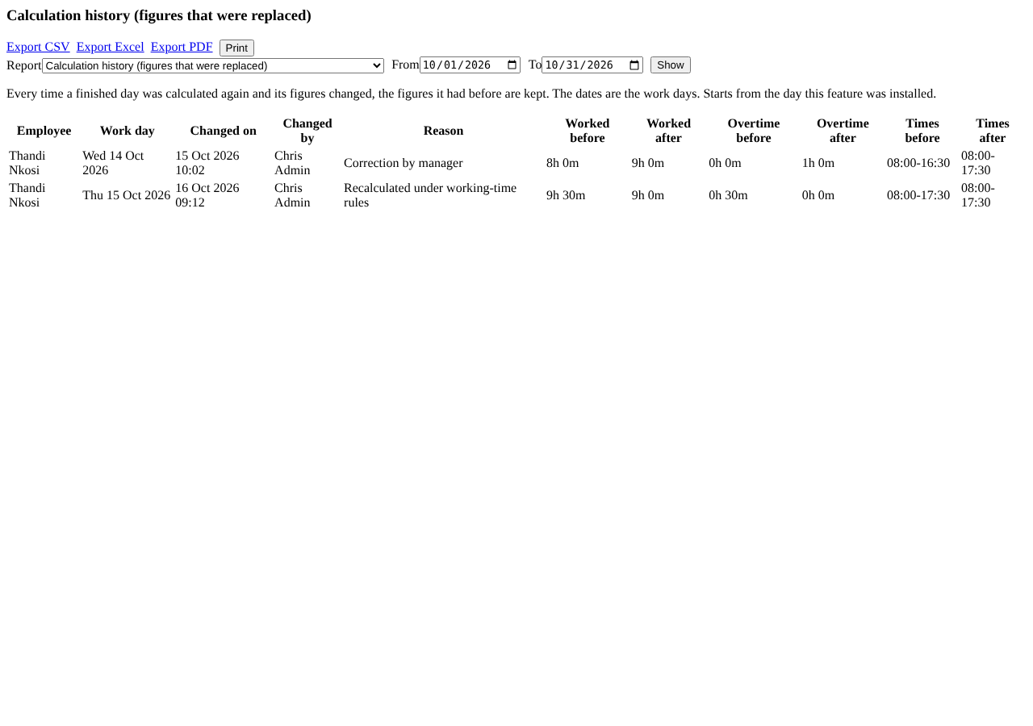
The Calculation history report.
- Days still open are not logged, and neither are days that did not change. History starts from the day this update was installed.
- Timezone: open Settings > Company. Timezone is now a list with South Africa first. The time shown beside it is the current time there. Pick the right one and press Save changes. A timezone that is not on the list is refused and the old one is kept.
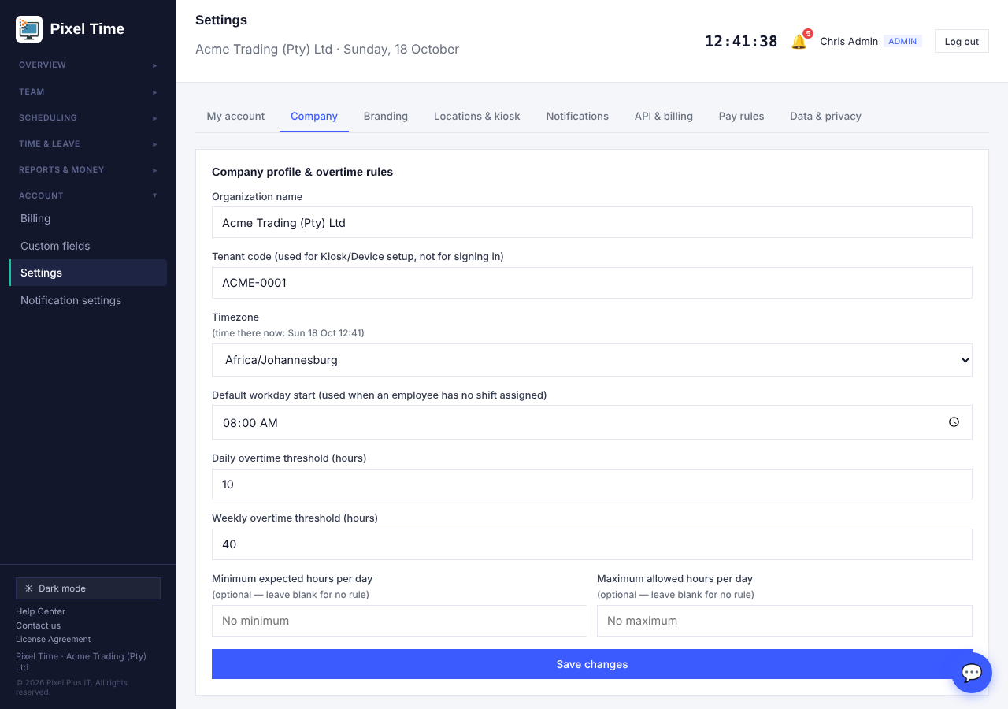
Choosing the company timezone.
- Team filters: on Team > Everyone, use the lists beside the search box to show one department, site, employment type or access level. The number beside the lists shows how many people match.
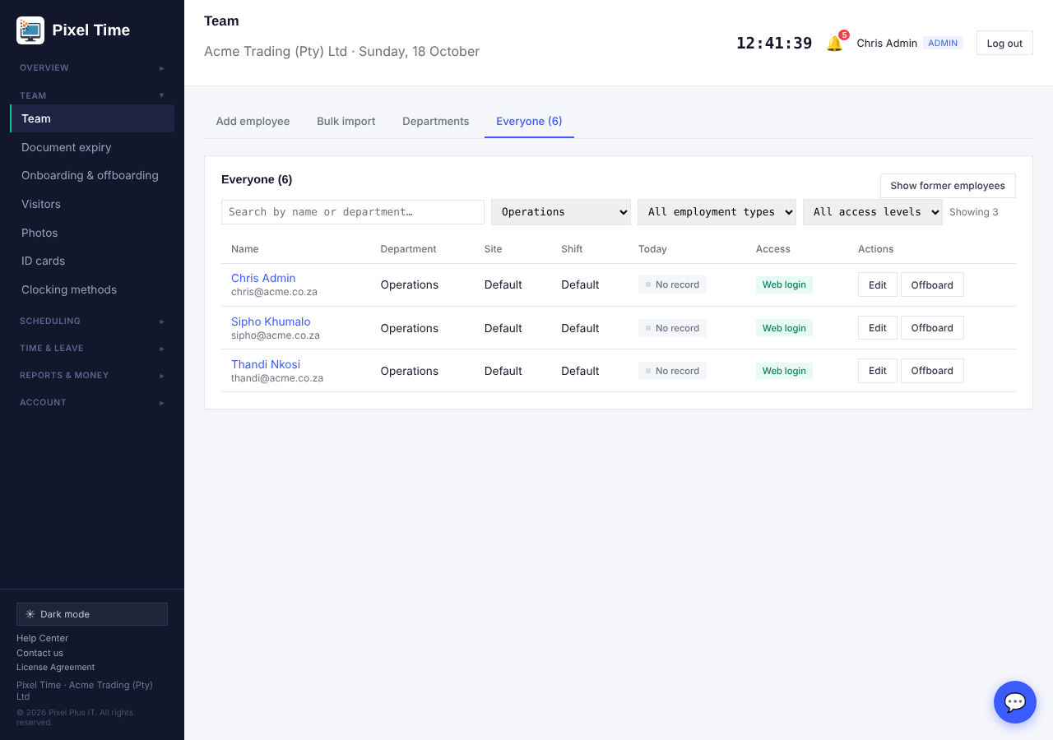
Filtering the team list by department.

29. Compliance and pay reports
Who: administrators and auditors see everyone; managers see their own department. Where: Reports > More reports.
- Open Reports > More reports, choose the report, set the dates and press Show. Every report can be printed or downloaded as CSV, Excel or PDF.
- Excessive hours warning (group Working-time rules): lists days longer than the company maximum hours per day (Settings > Company, or 12 hours when none is set) and weeks longer than 55 hours.
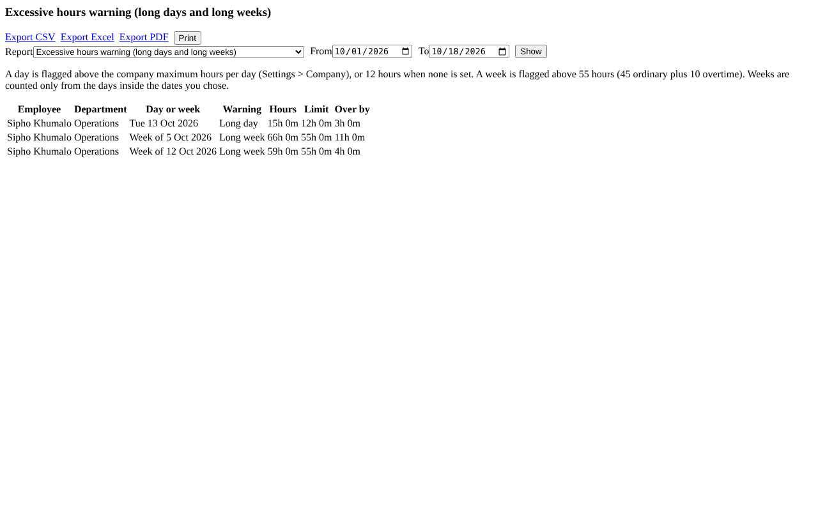
Excessive hours warning.
- Rest-period exceptions (Working-time rules): lists people who started a shift less than 12 hours after finishing the previous one, and by how much it was short. The day before your first date is also checked.
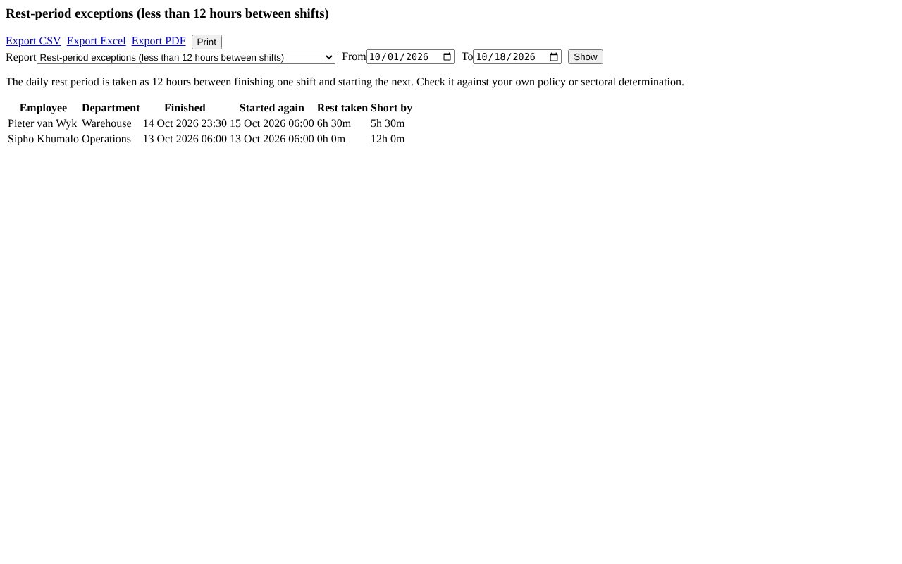
Rest-period exceptions.
- Unauthorised overtime (Overtime and public holidays): overtime that was worked but has no request, was declined, or is still waiting for approval.
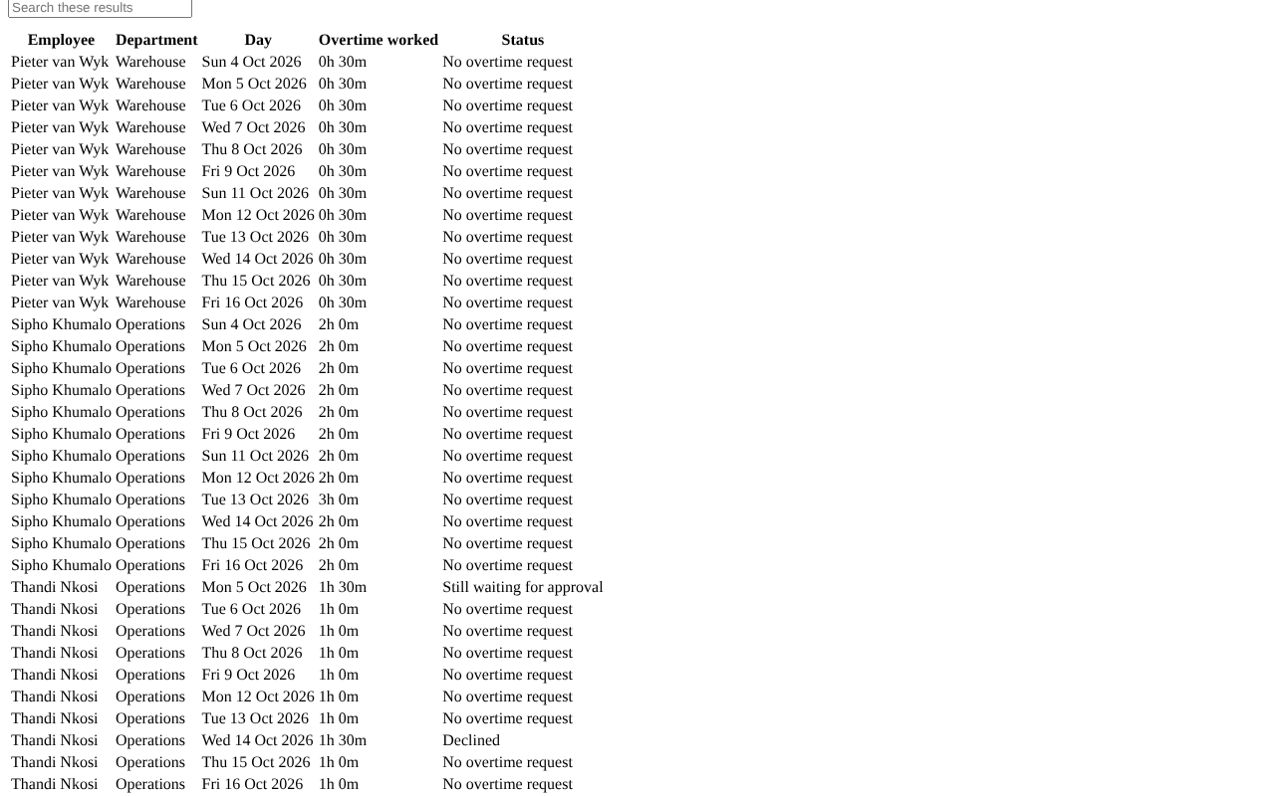
Unauthorised overtime.
- Paid and unpaid hours per employee (Hours and timesheets): time at work, paid hours, unpaid time such as unpaid breaks, and unpaid leave days.
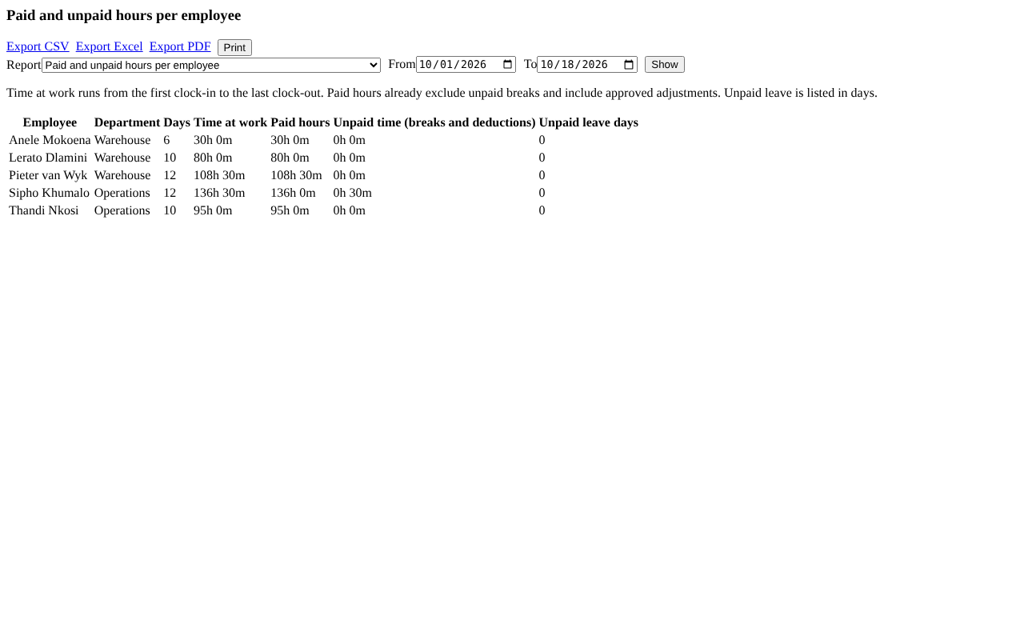
Paid and unpaid hours.
- The 12-hour rest and 55-hour week are guides. Check them against your own policy, contracts and current labour law.

30. Keep times and removing old personal details
Who: administrators change and remove; auditors can look. Where: System health > Retention & audit.
- Open System health > Retention & audit. Under Keep times for logs and former employees, set how long sent e-mail records, resolved alerts and calculation history are kept, and after how many years a former employee is reviewed. Press Save.
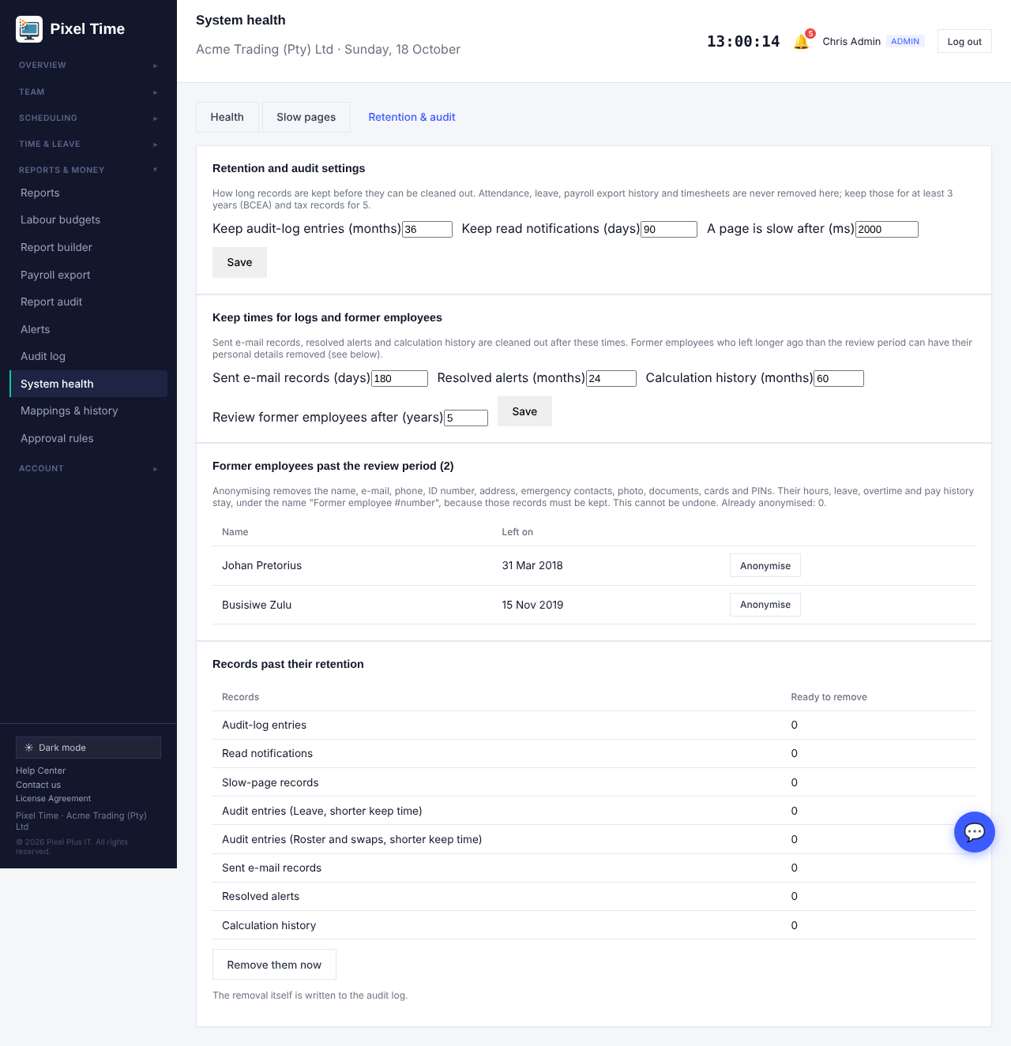
Keep times and former employees past the review period.
- Records past their keep time are listed under Records past their retention. Press Remove them now to clean them out. This is written to the Audit log.
- Former employees who left longer ago than the review period are listed. Press Anonymise to remove the name, e-mail, phone, ID number, address, emergency contacts, photo, documents, cards and PINs.
- Their hours, leave, overtime and pay history stay, under the name Former employee and a number, because those records must be kept.
- Anonymising cannot be undone. Administrators and people who are still active are never listed.
- Attendance, leave, overtime, timesheets and payroll export history are never deleted here. Keep time records at least 3 years and tax records 5, and confirm your own legal advice.

31. Manager access, branch rules and overtime rules
Who: administrators. Where: Team > Manager access, Scheduling > Working-time rules, and Overtime > Limits and budget.
- Manager access: a manager always sees and approves for their own department. Open Team > Manager access, choose the manager, choose a branch or a department and press Add access. From then on that manager sees those people in the Team list, approvals, reports, rosters and alerts. Press Remove to take it back.
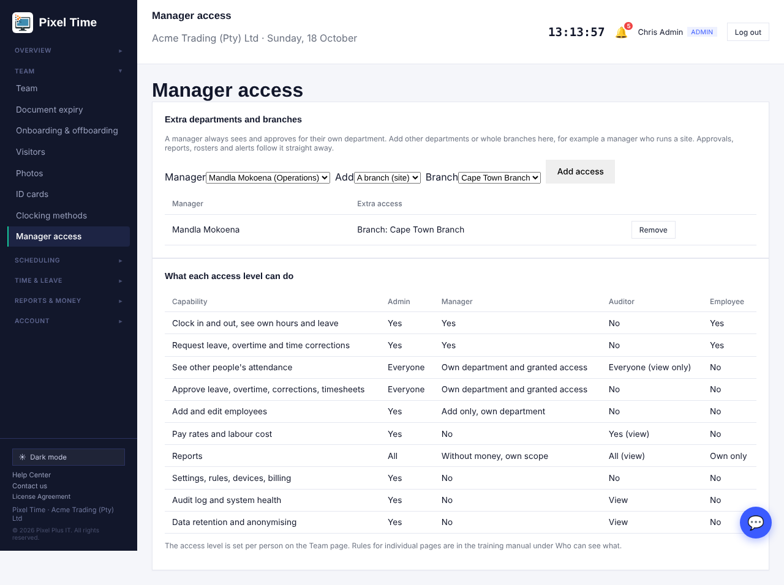
Giving a manager extra branches or departments, and the overview of what each access level can do.
- Only people with the Manager access level can be given extra access. Every change is written to the Audit log.
- Branch rules: open Working-time rules, choose a rule set, set Applies to as Branch (site), pick the branch and the start date, and press Assign. The most specific rule wins: employee, then contract type, then branch, then department, then the whole company.
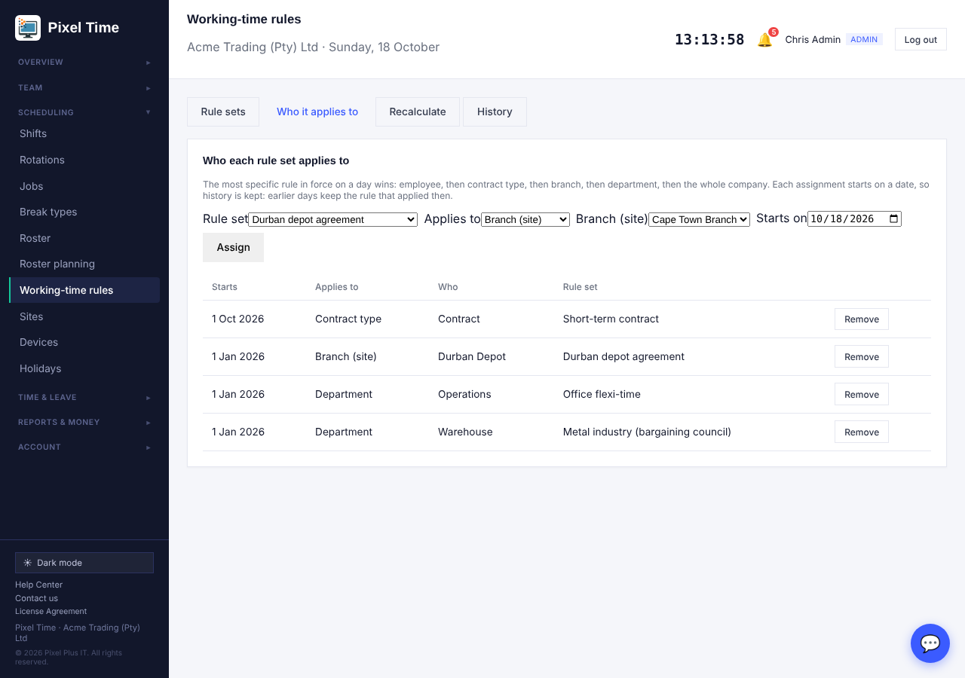
Assigning a working-time rule set to a branch.
- Overtime authorisation rules: open Overtime > Limits and budget. Approve automatically up to sets a number of minutes that need no sign-off. Needs an administrator above sets the length a manager cannot finish alone. Use 0 to switch a rule off.
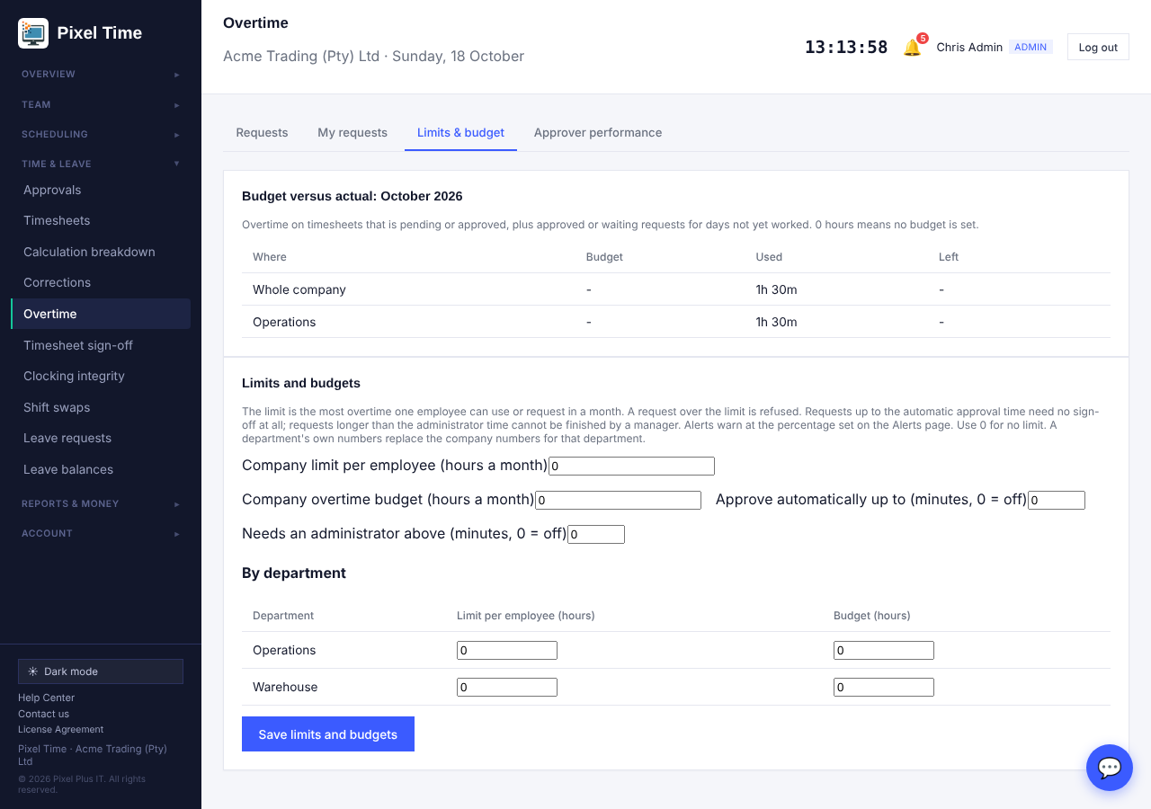
Overtime authorisation rules.
- Automatic approval still applies the monthly limit and refuses locked pay periods. Automatic approvals are marked in the request history and the Audit log.

32. Protecting and checking data
Who: administrators; managers for the roster; everyone allowed to see reports for the reports.
- Encryption: open System health > Data protection. ID or passport numbers, home addresses and emergency contacts are stored encrypted, so a copy of the database or a backup file cannot be read. Pixel Time shows them normally to people who are allowed to see them.
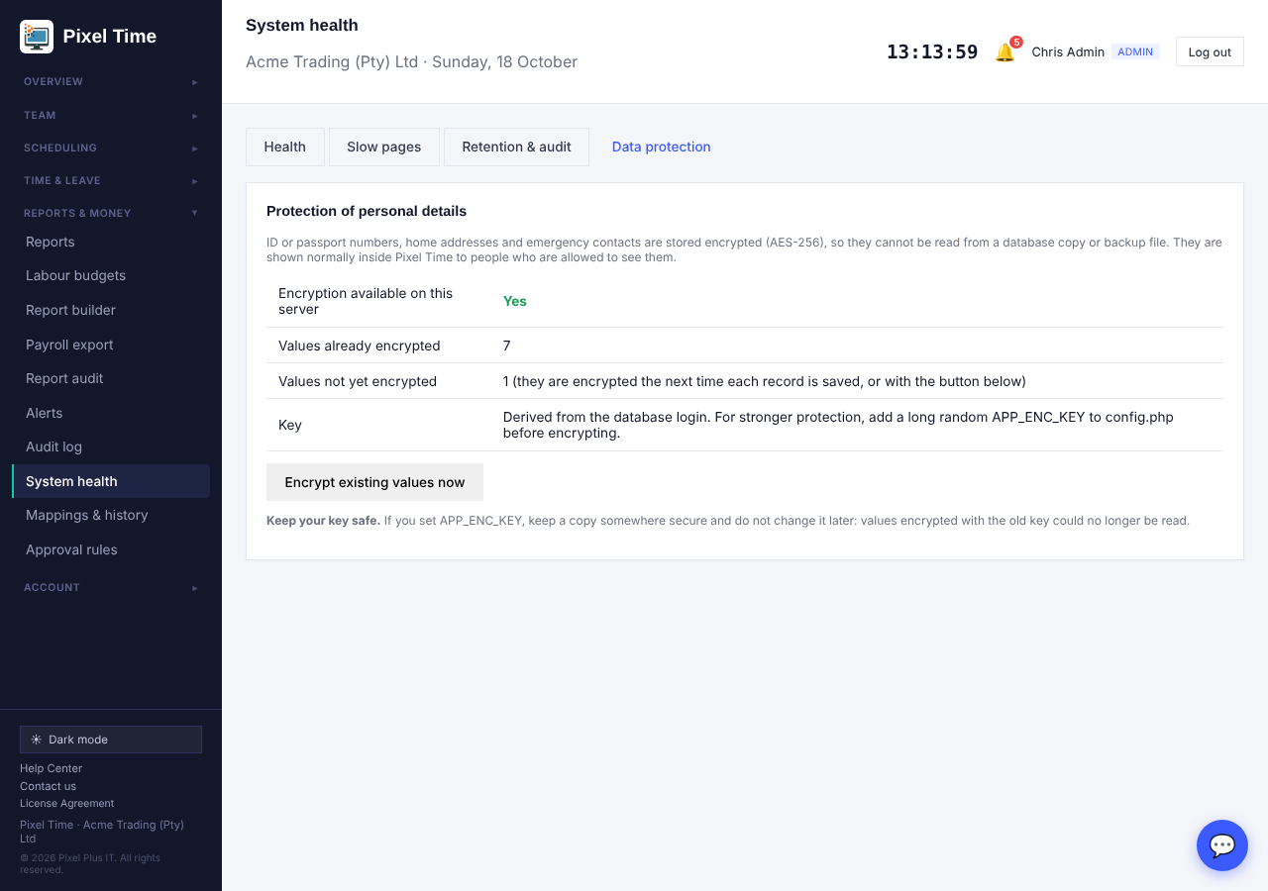
Data protection: how many values are encrypted.
- Press Encrypt existing values now once after installing this update. New and edited records are encrypted automatically.
- Checking an import: on Team > Bulk import, tick Check the file only (nothing is saved) before pressing Import. You get the list of rows with problems, such as an email already in use, a device ID already used, or the same person twice in the file. Fix the file and check again, then import for real.
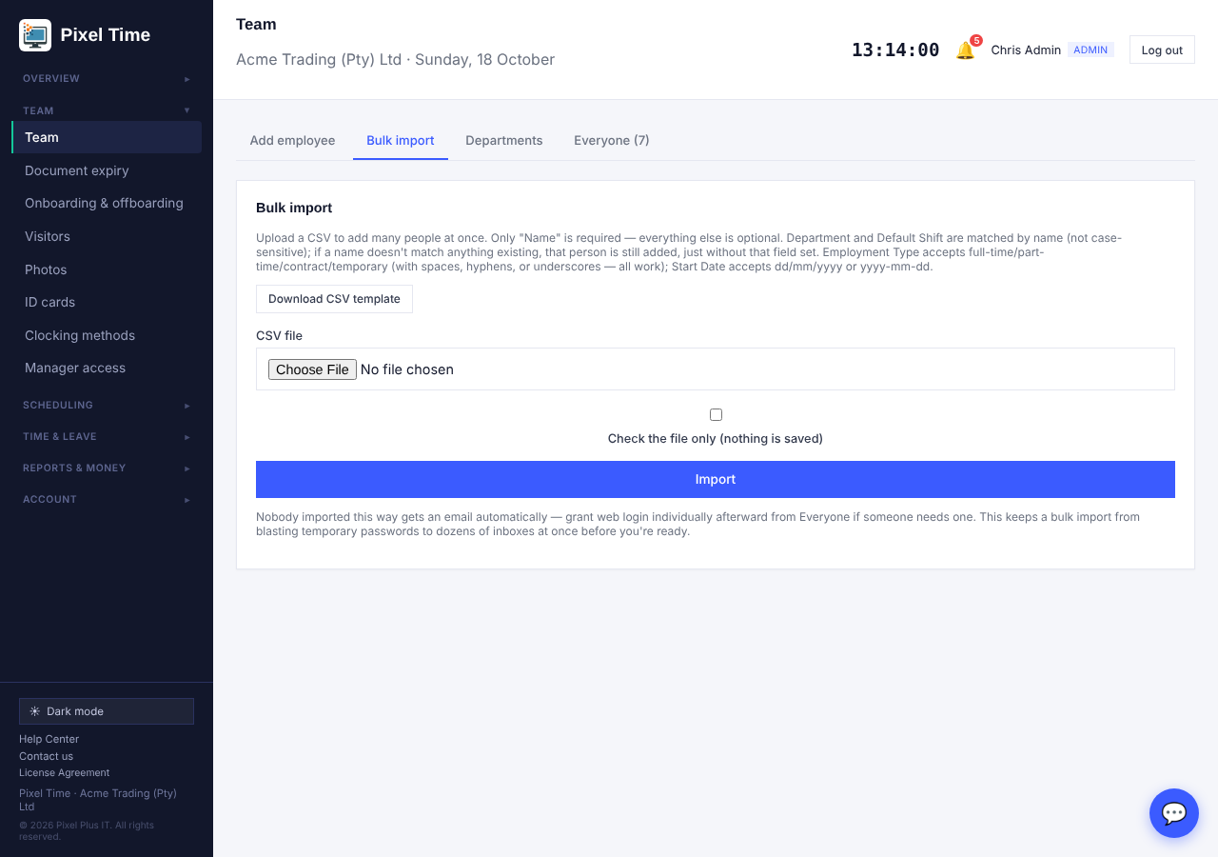
Bulk import with the check-only option.
- Roster filters: on Scheduling > Roster use Find a person, Department and Branch, then press Show. Only the people shown are on the page, and saving changes only those people.
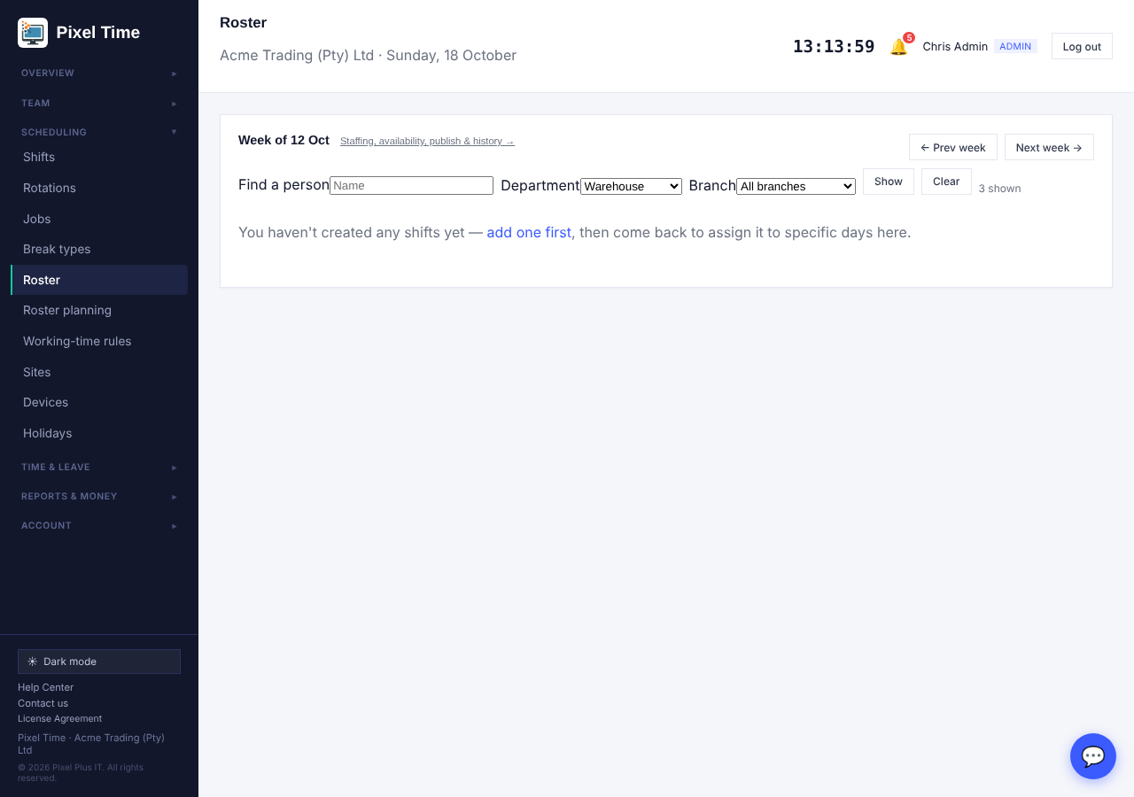
Roster filtered by department.
- Duplicate employees: a second person with the same ID or passport number is refused. Reports > More reports > Possible duplicate employees also finds the same phone, device ID or name.
- Workforce utilisation by department (Management): scheduled hours against ordinary hours, overtime, Sunday and public holiday hours, leave days and hours not worked.
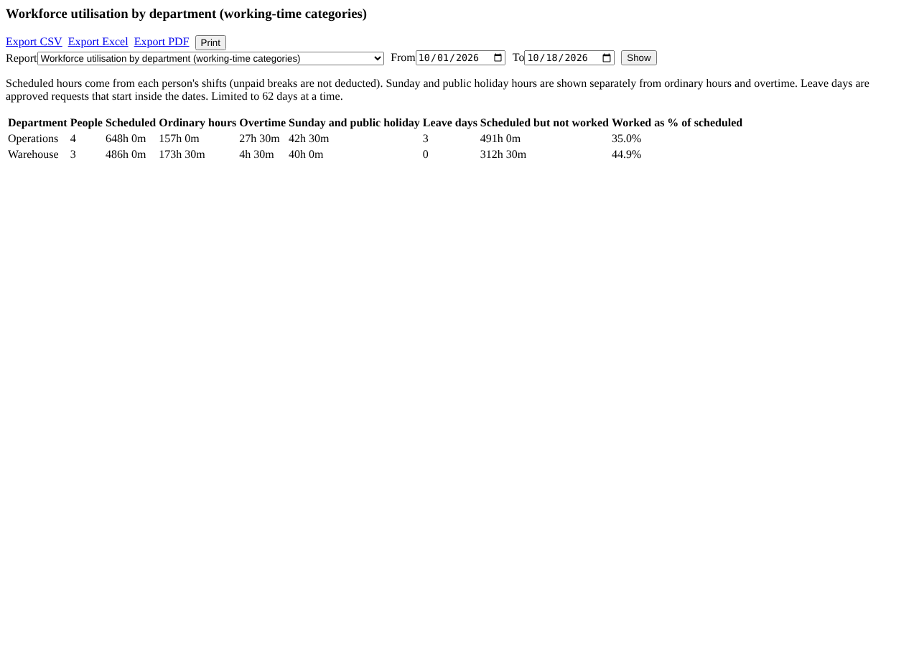
Workforce utilisation by department.
- Overtime and which rule applied (Overtime and public holidays): each overtime day with its day type, the working-time rule in force and why it counted as overtime.
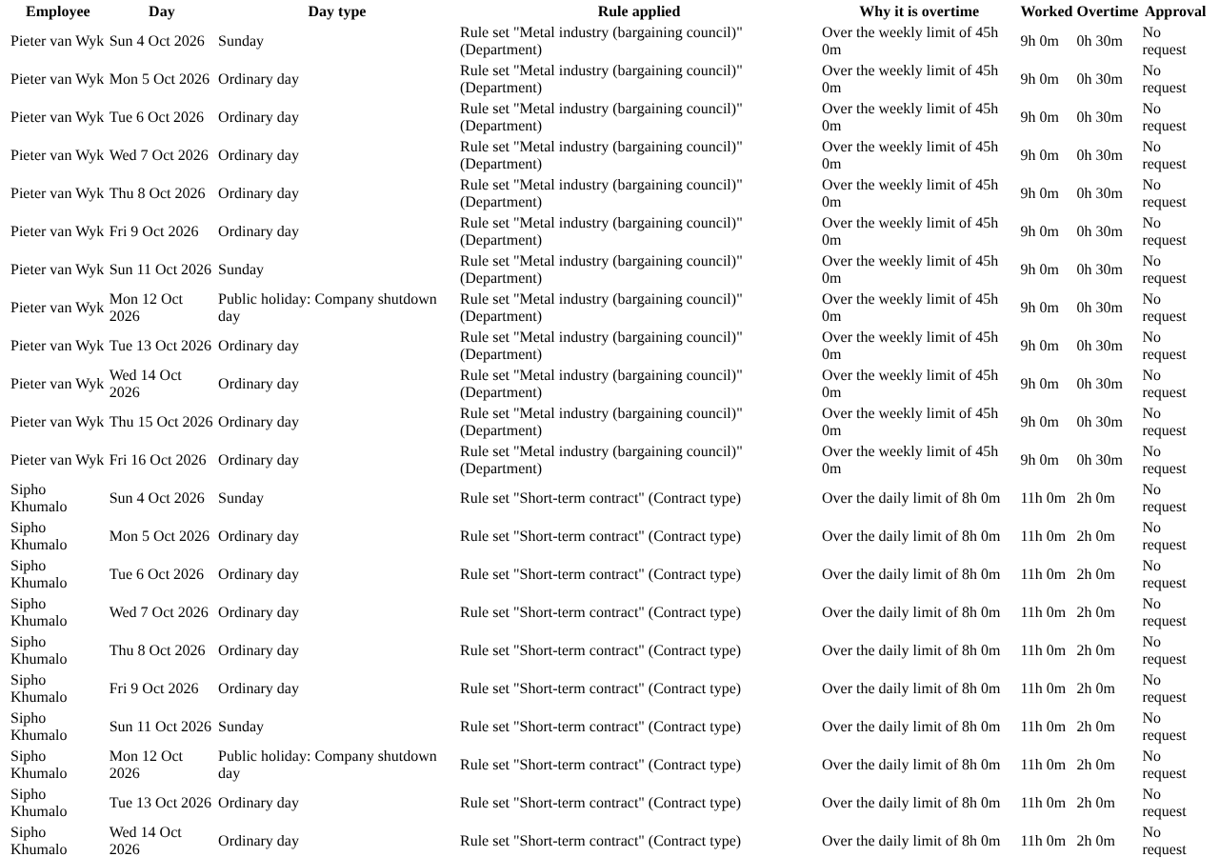
Overtime and which rule applied.

33. Data checks
Who: administrators and auditors. Where: System health > Data checks.
- Open System health > Data checks, choose how many days to look back (up to 62) and press Run the checks. Nothing is changed: the page only reads your data and tells you what looks wrong.
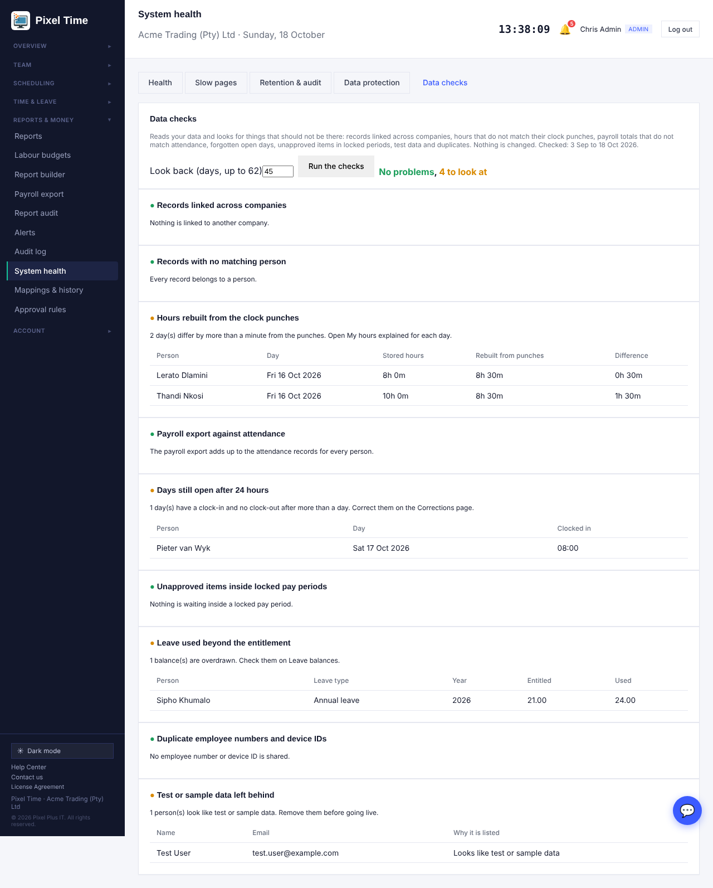
Data checks with a few findings listed.
- Records linked across companies and Records with no matching person: should always be fine. A red result means contact support.
- Hours rebuilt from the clock punches: every finished day is worked out again from its original punches (unpaid breaks taken off, paid breaks kept) and compared with the stored hours. Days that differ by more than a minute are listed. This check is skipped when clock rounding is on, or for days under a meal-deduction rule, because those hours legitimately differ.
- Payroll export against attendance: the payroll export total for each person must equal their attendance total.
- Days still open after 24 hours, Unapproved items inside locked pay periods, Leave used beyond the entitlement, Duplicate employee numbers and device IDs, and Test or sample data left behind: things to tidy up before payroll or before going live.
- Run the checks before locking a pay period and again before the first real payroll.

34. Personal leave rules, payroll reconciliation, prepared reports and backup check

Personal leave rules
Who: administrators change them; managers and auditors can see them for the people they can see. Where: Time & leave > Leave balances > Personal rules.
- Open Leave balances and choose the Personal rules tab. Pick the person and the leave type, then fill in only what is different for that person: days per year, carry-over maximum, or months of service before they may take it. Leave a box empty to keep the company rule.
- Write why the person has their own rule, for example the contract clause. This is required and is kept in the audit log.
- Press Save personal rule. If you changed the days, this year's balance moves by the difference straight away and the change shows on the person's balance history. Next year's balance is created from the personal days and carry-over limit.
- To remove a personal rule, clear all three boxes and save again. The balance goes back to the company days.
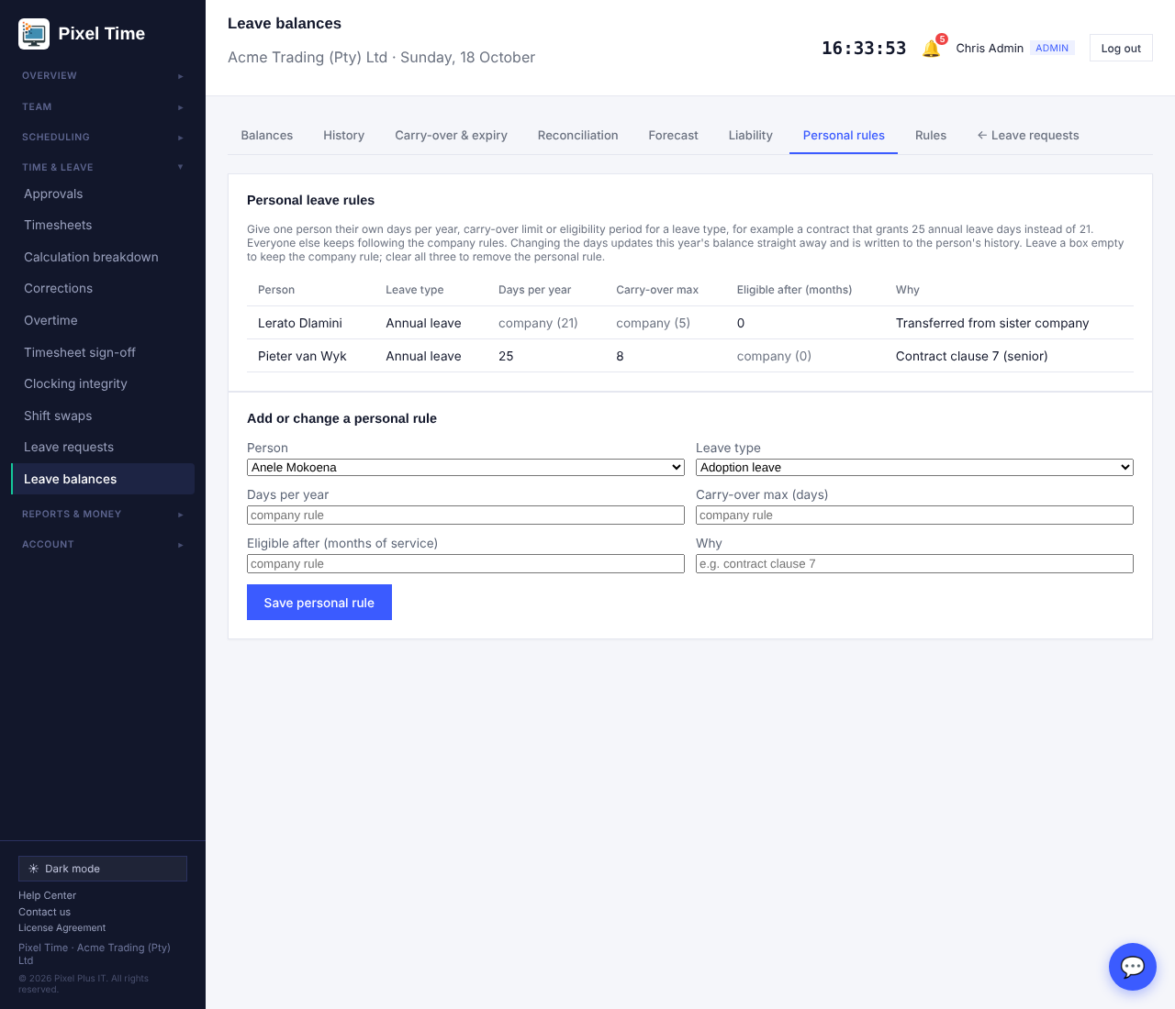
Personal leave rules: one person with 25 days and a carry-over of 8, another eligible straight away.

Reconcile with your payroll system
Who: administrators, managers (own department) and auditors. Where: Reports & money > Payroll export > Reconcile.
- Choose the dates on the Export tab first. Open the Reconcile tab and choose the CSV your payroll system holds for the same dates. The first row must have an employee number (or name) column and an hours column, for example Employee No,Hours. Hours may be 7.5, 7,5 or 7:30.
- Choose whether to compare against regular hours plus approved overtime, or regular hours only, and press Compare.
- The page lists everyone who differs first, then people only in the payroll file, people only in Pixel Time, and those that agree, with the totals. Nothing is saved or changed. Fix the cause in Pixel Time or the payroll system, then compare again.
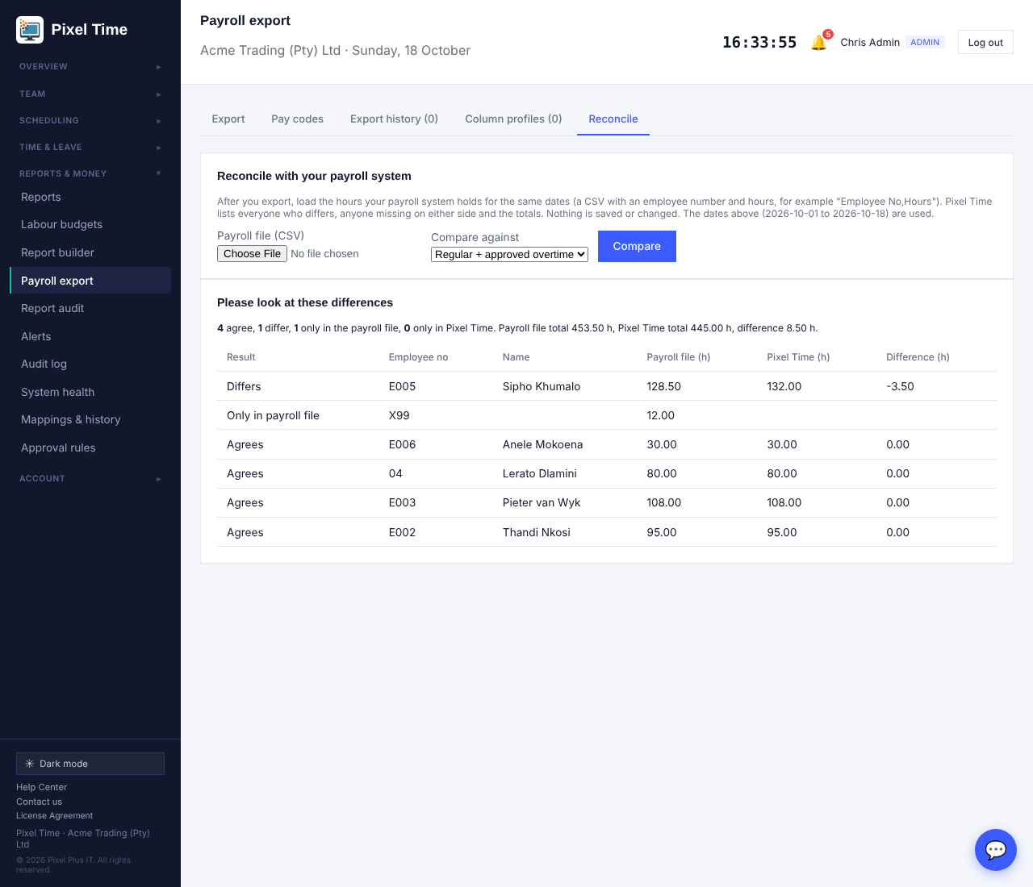
Reconcile: one person differs by 3.5 hours and one number exists only in the payroll file.

Prepared reports (background reports)
Who: administrators, managers and auditors. Where: Reports & money > Reports, then Prepare in background on any More report, or open Prepared reports directly.
- Choose a report, the dates (up to 400 days) and Excel or CSV, then press Prepare report. You can carry on working or close the page.
- The report is built in the background with exactly the people and figures you would see on screen, then appears in your list with a Download button. Files are kept for seven days. You may have up to ten waiting at a time.
- Administrators can see and download everyone's prepared reports; everyone else sees only their own.
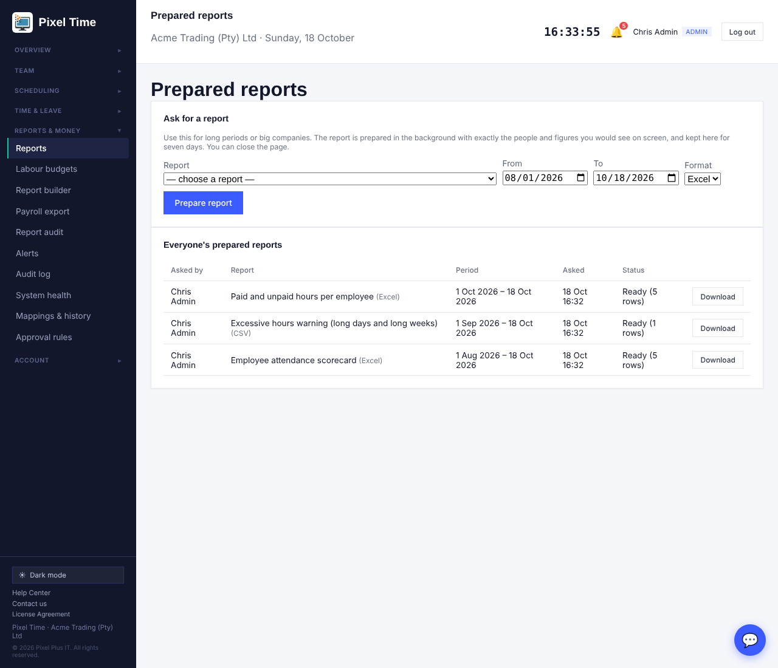
Prepared reports with three finished reports ready to download.

Payroll feed for other software
Settings > API & billing shows your API key. Payroll software or a spreadsheet can ask /api/v1/payroll.php?start=YYYY-MM-DD&end=YYYY-MM-DD with the key in an X-Api-Key header and receives one line per person: regular, overtime, Sunday and public holiday hours, cost centre, category, a checksum and whether the period is locked. It only reads, so asking twice never duplicates anything. Up to 92 days per request.

35. Night shifts, form checks and speed

Night shifts that run past midnight
Who: everyone who clocks. Where: Clock page, kiosk, QR clocking, card terminals and the phone app.
- Clock in as normal, for example at 22:00. Clock out after midnight, for example at 06:00. Pixel Time keeps the whole shift on the day you started it, so it shows as one day with the right hours.
- Breaks taken after midnight are counted on the same shift.
- While the shift is running, the Clock page, the dashboard and the live board show you as clocked in.
- A clock-in older than 14 hours is treated as forgotten. It is not counted as live time and is flagged as a missing clock-out. If nobody fixes it, the nightly auto clock-out closes it at 23:59 of its start day with the note Auto clocked-out by system.
- Late and early-departure checks for a shift such as 22:00 to 06:00 use the next morning as the end time.
- Offline phones and terminals that send punches later follow the same rule, so sending twice does not double count.

Held clockings: nothing goes missing
Who: administrators and managers (own department). Where: Time & leave > Clocking integrity > Held clockings.
- When a terminal, card reader or phone sends a clocking and a rule refuses it (outside the shift window, that clocking method switched off, a locked pay period, or out of sequence), Pixel Time keeps it instead of dropping it. The number appears on the tab and in a Clockings need attention box on the dashboard.
- Open Held clockings and read why it was held. Press Accept to add it to the day exactly as received, or write a reason and press Dismiss. Nothing counts towards hours until it is accepted.
- Clock-ins with no clock-out after 14 hours are listed on the Exceptions tab as Missing clock-out, on the dashboard, and in Data checks. Add the clock-out in Corrections.
- The dashboard, reports, timesheets and payroll export now bring people who are still on the clock up to date before they add up, so Total hours today matches the live board. Present now includes people who are late.
- Corrections and Fix a day now keep real clockings: a future date, an impossible time or a clock-out that is not later than the clock-in is refused with a clear message, and giving only a clock-out for a day with an open clock-in keeps the original clock-in. The clock page keeps showing the original clock-in time after a break.
- Terminals: a punch that arrives twice, or a second touch within a minute, is counted once. A terminal that was offline and sends a backlog out of order is read in the order the punches happened. Hikvision terminals that send the face picture with the event are read as well.
- Punches from a device for a Device ID nobody has are still only in the device log. Add the Device ID in Team and the next punch will work, or use People found on devices (next).
- A punch whose time cannot be right is refused: more than a day in the future, or over a year old. This protects your hours from a terminal with a wrong clock. It shows in the device log as rejected, with the reason. Fix the terminal clock and the next punches are accepted.

Standard shifts for every new company
- A new company now starts with the shifts most businesses use: Day Shift 08:00 to 17:00, Office Hours 08:00 to 16:30, Early Shift 06:00 to 14:00, Late Shift 14:00 to 22:00, Night Shift 22:00 to 06:00 (Monday to Friday), Retail / Shop 09:00 to 18:00 (Monday to Saturday) and Weekend Shift 08:00 to 16:00 (Saturday and Sunday).
- They are ordinary shifts. Open Shifts to change the hours or the days, or delete the ones you do not use.
- A company that already exists can press Add the standard shifts on the Shifts page. Shifts you already have, matched by name, are skipped and keep their own hours.

People enrolled on the terminal
- Open Devices > People found on devices. When someone is enrolled on a ZKTeco, eSSL, Realtime or Biomax terminal, the terminal sends their Device ID, name and card number here. Nothing is created until you accept it.
- Press Ask now to make a device send everyone enrolled on it, instead of waiting for new enrolments.
- Create employee makes a clock-only employee with that Device ID, so their punches count straight away. Link to the selected employee attaches the Device ID to someone already in Team. Dismiss hides a person for good.
- You must tick the consent box first: a Device ID links a person to fingerprint or face enrolment, and POPIA needs their written consent. A person who is already linked is not offered again, and a full plan stops new employees with a clear message.
- Any brand: when someone punches on a terminal with a Device ID nobody has (Hikvision, ZKTeco or any other), they also appear here, with their name when the terminal sends one. A bridge for another brand can send its whole list of people to the same place.
- Hikvision terminals cannot be asked for their list, and they do not announce people when they are enrolled. Each person appears here the first time they clock in (with their name if the terminal sends it), so a full list builds up over the first day. Face data stays on the terminal and is not copied to Pixel Time. To avoid accepting people one by one, add the employees in Team first with the same number as the terminal's Employee No.; their first punch then counts straight away.

Setting up a Hikvision MinMoe face terminal (DS-K1T342MFWX-E1)
- Devices > Register a device > Hikvision, with a name and the terminal serial number. Under Your devices press Download setup file and save it on a Windows PC that is on the same Wi-Fi or network as the terminal. This PC is needed once only.
- If the PC has no Python, install it free from python.org and tick Add Python to PATH. On the terminal, find its IP address under Communication Settings > Wi-Fi.
- On the PC open the folder with the file, click the address bar, type cmd and press Enter, then type python pixel_time_terminal_setup.py and press Enter. Enter the terminal IP address, admin user and admin password. It should say Done.
- On the terminal switch ISUP off (Communication Settings > ISUP) and check its date and time. Add each person under User Management > Add with an Employee No. of digits only, their name and face, and enter the same number as their Device ID in Team.
- Have someone clock in. The terminal shows Online in Devices and the clocking appears in Team and Timesheets. After this one-time setup the terminal works from any network with internet.

12-hour days, overtime and the timesheet
- Working-time rules > Rule sets: add a rule set, for example 12-hour shift. Set Overtime after (hours per day) to 12 and Paid at the overtime rate after (hours per day) to 9. Assign it on the Who it applies to tab.
- On the timesheet all 12 hours show as Normal hours and only time after 12 hours shows as Overtime. For pay, hours 9 to 12 are paid at the overtime rate (the multiplier in Settings > Pay rules).
- Payroll export: a column Normal-day hours paid at the overtime rate appears when a rule uses this. On the Pay codes tab give those hours their own code; the Regular hours code then covers only the first 9 hours.
- The printed timesheet shows the Employee No., name, days worked, and for every day the Normal hours, Overtime and Total worked, with totals for the period. Below the days is a Notes box and the signature lines. Type a note on the timesheet page and press Save notes; it prints above the signatures.

Sage Pastel Payroll export and 30-minute rounding
- Pastel Payroll: set up a batch layout in Pastel that lists the items to import in order. In Pixel Time open Payroll export > Pay codes > Sage Pastel Payroll batch file, enter the Pastel company code and batch number and choose the same items as Value 1 to Value 6. Save.
- On the Export tab choose File layout > Sage Pastel Payroll batch file, pick the dates and download the .txt file. Every person needs an Employee No that matches their Pastel employee code (up to 8 letters or numbers). Try one person in a test company first.
- Rounding: Settings > Clock rounding > 30 minutes, Nearest. The first clock-in and last clock-out of the day round to the closest half hour (06:29 to 06:30, 06:59 to 07:00). Timesheets, the monthly sheet and paid hours use the rounded times; the exact punch stays on record and shows when you hold the mouse over the time.

Monthly time sheet on one page
- Timesheets > choose the person and the dates > Print this timesheet. A full month prints on one A4 page. Press Preview printed sheet to see it on screen first.
- The sheet shows Employee ID, name, title, department and start date; every day with In and Out; Normal hours; overtime on weekdays, Saturday and Sunday; and public holiday hours.
- The total hours worked for the period are at the bottom, then the Notes box and the employee and supervisor signature lines with dates.

Shifts with an overtime window
- Shifts > add or edit a shift. Enter the start and end time; a night shift may end the next morning, for example 18:00 to 06:00.
- Overtime window from and to: time worked inside this window is paid at the overtime rate, for example 15:00 to 18:00 on a day shift. A window after midnight on a night shift is understood.
- Tick Time after the shift ends is also overtime when work after the end time must count as overtime as well. Leave the window empty to keep the normal hours-based rule.
- The timesheet, payroll export and labour-cost reports use these times automatically. Use Recalculate on the working-time rules page for days already recorded.

Sick leave over 3 years, and new leave types
- Sick leave is now 36 days over a 3-year cycle (12 a year). All 36 days are available at any time, so a person who needs them all in one year can take them. Each year the balance shows 36 days minus the sick leave taken earlier in the same cycle. A new cycle starts every 3 years.
- To change it: Leave > Leave types > Sick leave. Set Days per year (or per cycle) and Cycle in years. A cycle of 0 means a normal yearly entitlement.
- Press Add South African statutory types to add Maternity, Parental, Adoption, Commissioning parental, Study, Unpaid and Other leave. Study starts at 5 days; Unpaid and Other have no set limit, so the days taken are recorded and never run out. Tick No set limit on any leave type of your own to get the same.

Other brands now have their own URL
- Devices > Register a device > Other brand now gives each device its own Push URL (like Hikvision does). Paste it into the terminal, its vendor software or a small script. Last seen, the device log and Event history then work the same as for every other device.
- The URL accepts a single punch, a list of punches, a form post, or lines such as 12,2026-10-19 08:00:00. Common field names from Dahua, Suprema and Anviz are understood, and a call with nothing in it counts as a heartbeat.
- A punch by someone with an unknown Device ID, or a list of people sent to the URL, appears on People found on devices. Every safeguard applies: a repeated punch or a second touch within a minute counts once, shift windows and clocking methods are checked, and refused punches are held, not lost.
- Regenerate key replaces the URL if it ever leaks. Update the device afterwards.
- Security: the site now tells browsers to always use https (HSTS) and limits the camera and location to Pixel Time itself. Nothing changes for staff; terminals that use plain http keep working.
- The Push URL also works over plain http, for terminals that cannot use https. The site address itself stays https only.

Stricter checks on forms
- Sites: latitude must be between -90 and 90, longitude between -180 and 180, radius a whole number of metres, and latitude and longitude must be given together.
- Corrections: the date must be a real date that has already happened, and times must be HH:MM.
- Team: a valid e-mail address is needed when the person gets web login. A department name that already exists (in any letter case) is refused.

Large reports
Reports for hundreds of people over a quarter are much quicker. In our test with 500 employees over 90 days the whole report catalogue went from about three minutes to under 30 seconds, and a hours report opens in under a second. For very long reports you can still use Prepare in background.

36. Who can see what
Feature | Admin | Manager | Auditor | Employee
Employee record (edit) | Yes | No | No | No
Request and cancel own leave | Yes | Yes | No | Yes
Approve, decline, cancel others' leave | Yes | Own department | No | No
Leave types | Yes | No | No | No
Pay rules | Yes | No | No | No
Labour cost reports (pay rates) | Yes | No | Yes | No
Other More reports | Yes | Own department | Yes | No
Payroll export: pay codes | Yes | No | View only | No
Payroll export: download | Yes | Own department | Yes | No
Overtime: ask for overtime | Yes | Yes | No | Yes
Overtime: approve, decline, change | Yes | Own department (admin signs off) | No | No
Overtime: limits and budgets | Yes (change) | View | No | No
Leave balances: view | Yes | Own department | Yes | No
Leave balances: adjust, rules, expire | Yes | No | No | No
Leave liability (money) | Yes | No | Yes | No
Timesheet sign-off: submit own week | Yes | Yes | No | Yes
Timesheet sign-off: approve or send back | Yes | Own department (admin signs off) | No | No
Timesheet sign-off: levels, deadlines, reopen | Yes | No | No | No
Management reports with money | Yes | No | Yes | No
Management reports without money | Yes | Own department | Yes | No
Labour budgets (set) | Yes | No | No | No
Hours reconciliation | Yes | Own department | Yes | No
Data retention review | Yes | No | Yes | No
Working-time rules: change | Yes | No | No | No
Working-time rules: view and reports | Yes | Own department | Yes | No
Recalculate attendance | Yes | No | No | No
System health: view | Yes | No | Yes | No
System health: settings and removal | Yes | No | No | No
ID cards: register, lost, disable | Yes | Own department | No | No
ID cards: delete | Yes | No | No | No
Mappings & history: change or restore | Yes | No | No | No
Document expiry: set dates | Yes | Own department | No | No
Document expiry: view | Yes | Own department | Yes | No
Excel and CSV downloads | Same people as the report or export they come from
Mappings & history: view | Yes | No | Yes | No
Alerts: rules and all alerts | Yes | No | No | No
Roster planning: view and publish | Yes | Own department | No | No
Roster planning: staffing levels | Yes | No | No | No
Report audit | Yes | No | No | No
Clocking integrity | Yes | Own department | No | No
Live board | Yes | Own department | Yes | No
Profile photo: own | Yes | Yes | Yes | Yes
Profile photo: someone else | Yes | Own department | View only | No
Reports on screen: open shared reports | Yes | Own department | Yes | No
Reports on screen: edit, duplicate, share | Yes | No | No | No
Calculation breakdown: anyone | Yes | Own department | Yes | No
Calculation breakdown: own days | Yes | Yes | No | Yes
Overtime: approve in bulk | Yes | Own department (admin signs off) | No | No
Print ID cards | Yes | Own department | No | No
Clocking methods: company and exceptions | Yes | No | No | No
Data checks | Yes | No | Yes | No
Held clockings: accept or dismiss | Yes | Own department | No | No
Personal leave rules | Yes (change) | View own department | View | No
Payroll reconcile | Yes | Own department | Yes | No
Prepared reports | Yes (everyone's) | Own | Own | No
Manager access (extra branches and departments) | Yes | No | No | No
Overtime authorisation rules (automatic approval, administrator above) | Yes (change) | View | No | No
Encrypt personal details | Yes | No | View | No
Bulk import check | Yes | No | No | No
Roster filters | Yes | Own scope | No | No
Keep times and anonymise former employees | Yes | No | View only | No
Compliance and pay reports (excessive hours, rest period, unauthorised overtime, paid/unpaid) | Yes | Own department | Yes | No
Calculation history: view | Yes | Own department | Yes | No
Timezone: change | Yes | No | No | No
Team filters | Yes | Own department | No | No
Notification settings: own e-mail choices | Yes | Yes | Yes | Yes
Notification settings: company defaults and sent list | Yes | No | No | No

37. Good to know
- The leave type days (maternity, parental, adoption and so on) are starting points. Confirm them against your own policy, contracts and current labour law.
- Leave days are now working days. Leave requested before this update keeps the days it was saved with.
- A suspended employee can still clock in. Use Offboard to remove access.
- Profile photos need photo processing to be available. If the My photo page says it is unavailable, contact Pixel Plus support.
- Reconcile totals tells you when two numbers differ; it does not change anything.
- Labour cost is an estimate. Check payroll against your payroll system before paying anyone.

